SECTION 16: HEALTH
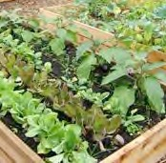
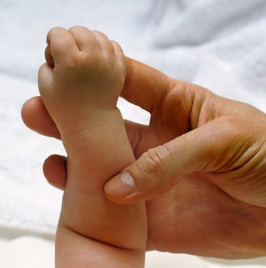
Primary Numbers: 7800 – 8299

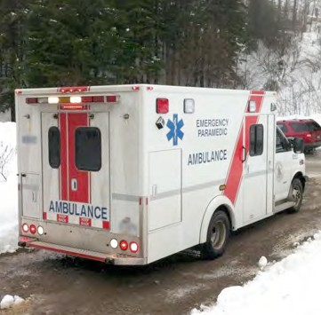

Section 16 includes the subjects relating to the administration and management of health care services with the First Nation organization.

PRIMARY NUMBERS AND PRIMARY SUBJECTS

7810 Health Care - General

7820 Child and Family Health Programs - General
7830 - pre-natal and Post-natal Program
7840 - Infant Development Program
7850 - Outreach

7900 Chronic Disease Program - General
7920 - Individual

7950 Emergency Services - General

7980 Environmental Health - General

8000 Health Care Administration - General
8020 - Non-Insured Health Benefits
8040 - Member Information and Benefits

8100 Home and Community Care Programs - General
8120 - Community Health Care Nurse - General
8130 - Community Health Care Nurse - Immunization Program

8150 Mental Health and Addictions Program - General

8200 Training and Workshops

8220 Youth Programs

A SA FD
7810 HEALTH CARE – GENERAL

Includes records of a general nature relating to the administration, development, operation and maintenance of health care services within the First Nation organization jurisdiction, which are found elsewhere in this section.

-01 General CY + 1 6y D

7820 CHILD AND FAMILY HEALTH PROGRAMS – GENERAL

Includes records relating to the child and family health programs offered through the Health Department of the First Nation organization.

-01 General CY + 1 6y D
-02 Work plan CY + 1 6y D
-03 Budgets and reports CY + 1 6y D

7830 CHILD AND FAMILY HEALTH PROGRAMS – PRE-NATAL & POST-NATAL PROGRAM

Includes records relating to the pre-natal and post-natal programs offered through the Health Department of the First Nation organization.

-01 General CY + 1 6y D
-02 Work plan CY + 1 6y D
-03 Budgets and reports CY + 1 6y D
-20 Participants, by name

7840 CHILD AND FAMILY HEALTH PROGRAMS – INFANT DEVELOPMENT PROGRAM

Includes records relating to the Infant Development Program offered through the Health Department of the First Nation organization.

-01 General CY + 1 6y D
-02 Work plan CY + 1 6y D
-03 Budgets and reports CY + 1 6y D

7850 CHILD AND FAMILY HEALTH PROGRAMS – OUTREACH

Includes records relating to the Outreach Program offered through the Health Department of the First Nation organization.

-01 General CY + 1 6y D

7900 CHRONIC DISEASE PROGRAMS – GENERAL

Includes records relating to the administration and operation of chronic disease programs including program proposals and funding.

-01 General CY + 1 6y D

A SA FD

7920 CHRONIC DISEASE PROGRAMS – INDIVIDUAL

Includes records relating to chronic disease programs such as diabetes education, nutrition management, healthy heart and obesity management.

-01 General CY + 1 6y D
-20 Chronic disease programs, by name SO* 6y D
- Diabetes
- Nutrition
- Healthy Heart
- Obesity
(*SO = when program ceases)

7950 EMERGENCY SERVICES – GENERAL

Includes records relating to emergency service plans coordinated by the Health Department of the First Nation organization.

-01 General CY + 1 6y D
-20 Pandemic Plan SO* 6y D
(*SO = when updated)

7980 ENVIRONMENTAL HEALTH – GENERAL

Includes records relating to the administration, development, operation and maintenance of environmental health issues such as drinking water testing and Healthy Home Assessments for mould.

-01 General CY + 1 6y D
-20 Programs, by name SO* 6y D
(*SO = until completed)

8000 HEALTH CARE ADMINISTRATION – GENERAL

Includes records relating to the administration, development, operation and maintenance of health care programs, including local clinics, operated by the Health Department of the First Nation organization, or delivered as services by contract agencies to the First Nation organization.

-01 General CY + 1 6y D

8020 HEALTH CARE ADMINISTRATION – NON-INSURED HEALTH BENEFITS (NIHB)

Includes records relating to the non-insured health benefits program, including patient travel and data entry into electronic system. Also includes quarterly reports to Health Canada.

-01 General CY + 1 6y D
-20 Reports, by month

A SA FD

8040 HEALTH CARE ADMINISTRATION – MEMBER INFORMATION AND BENEFITS

Includes records relating to First Nation organization members’ personal health information including benefits, Care cards, prescriptions and relating health information. Filed alphabetically by member name.

-01 General CY + 1 6y D
-20 First Nation organization members, by name SO* nil P
(*SO = until updated)

8100 HOME AND COMMUNITY CARE PROGRAMS – GENERAL

Includes records relating to the home and community care programs offered by the Health Department of the First Nation organization.

-01 General CY + 1 6y D

8120 HOME AND COMMUNITY CARE PROGRAMS – COMMUNITY HEALTH NURSE - GENERAL

Includes records relating to the functions of the community health nurse, including assessments for Extended Care, TB Testing, and Homemakers Program.

-01 General CY + 1 6y SR
-02 Work plan CY + 1 6y D
-03 Budgets and reports CY + 1 6y D
-20 Home and Community Care Program, by name CY + 1 6y D
- Assessments for Extended Care
- TB Testing
- Homemakers

8130 HOME AND COMMUNITY CARE PROGRAMS – COMMUNITY HEALTH NURSE – IMMUNIZATION PROGRAM

Includes records relating to the immunization programs operated by the community health nurse through the Home and Community Care Program.

-01 General CY + 1 6y D
-02 Work plan CY + 1 6y D
-03 Budgets and reports CY + 1 6y D
-20 Immunization programs, by name and date

8150 MENTAL HEALTH AND ADDICTIONS PROGRAM – GENERAL

Includes records relating to the Mental Health and Addictions Program offered by the Health Department of the First Nation organization.

-01 General CY + 1 6y D
-20 Programs, by name CY + 1 6y D
-30 Clients, by name CY + 1 6y D
-40 Treatment centres, by name CY +1 6y D

A SA FD

8200 TRAINING AND WORKSHOPS

Includes records relating to training and workshops offered to the staff of the Health Department as well as members of the band.

-01 General CY + 1 6y D

8250 YOUTH PROGRAMS

Includes records relating to administration and operation of youth programs offered through the Health Department of the First Nation organization. Also includes individual program records, such as Pulling Together and Senior Leadership.

-01 General CY + 1 6y D
-20 Programs, by name

