SECTION 13: PUBLIC WORKS AND
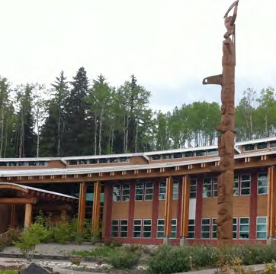
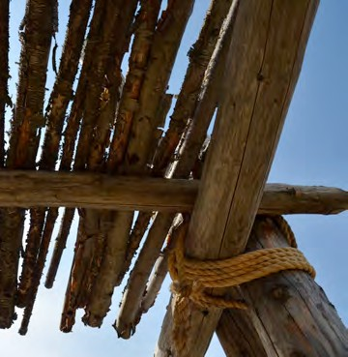
COMMUNITY INFRASTRUCTURE

Primary Numbers: 6000 – 6499

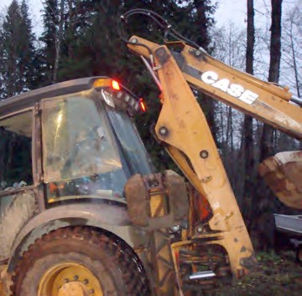

Section 13 includes subjects relating to the engineering, construction and maintenance of First Nation community infrastructure, including streets and roads, water service, septic systems, solid waste removal, etc.

PRIMARY NUMBERS AND PRIMARY SUBJECTS

6010 Public Works and Community Infrastructure - General

6025 Drainage and Flood Control

6100 Inspection and Testing

6130 Public Works Projects

6200 Septic Systems

6250 Solid Waste Disposal

6300 Streets and Roads

6350 Utilities - General

6400 Water Supply and Distribution

A SA FD

6010 PUBLIC WORKS AND COMMUNITY INFRASTRUCTURE – GENERAL

Includes general records relating to public works and community infrastructure services which are not found elsewhere in this section. Complaints about public works services are filed here.

-01 General CY + 1 6y D
-02 Complaints

6025 DRAINAGE AND FLOOD CONTROL

Includes records relating to the control of storm water, drainage, creek and river control, culverts, flood plains and flood damage, etc.

-01 General CY + 1 6y D
-02 Culverts CY + 1 6y P
-03 Creek control, by name SO* nil P
-04 Flood damage, by event CY + 1 6y P
-05 Ditches CY + 1 6y P
-06 Flood control/flood plains CY + 1 6y P
-07 Drainage jobs CY + 1 6y P
(*SO = until modified or updated)

6100 INSPECTION AND TESTING

Includes records relating to the procedures and guidelines for inspecting and testing services for capital works projects, etc.

-01 General CY + 1 6y D

6130 PUBLIC WORKS PROJECTS

Includes records relating to the planning, design and construction of public/capital works projects. Specific project files will include cost estimates, design, project authorization, land acquisition, meetings, reports, design engineering studies, consultants, contract award, purchase orders, etc.

-01 General CY + 1 6y D
-20 Projects, by name SO* nil P
(*SO = upon completion of project)

6200 SEPTIC SYSTEMS

Includes records relating to the administration, management and operation of septic systems.

-01 General CY + 1 6y D
-02 Septic Tanks and fields SO* nil P
(*SO = until modified or updated)

A SA FD

6250 SOLID WASTE DISPOSAL

Includes records relating to solid waste (garbage) collection and disposal, hazardous waste and waste paint. Also includes records relating to recycling of waste materials.

-01 General CY + 1 6y D
-02 Collection CY + 1 6y P
-03 Landfill sites SO* nil P
-04 Illegal dumping of rubbish CY + 1 6y SR*
-05 Hazardous waste CY + 1 6y P
-06 Recycling CY + 1 6y D
-07 Composting CY + 1 6y D
(*SR = retain all policy and program materials)
(*SO = until modified or updated)

6300 STREETS AND ROADS

Includes records relating to the planning, design, construction, operation and maintenance of roads, streets, highways and other public thoroughfares. Includes sidewalks and street lighting.

-01 General CY + 1 6y D
-02 Bridges SO* 6y P
-03 Street lighting SO* 6y P
-04 Closures SO* 6y P
-05 Road allowances SO* 6y P
-06 Highways SO* 6y P
-07 Sidewalks, walkways, and overpasses SO* 6y P
-08 Paving programs SO* 6y P
-09 Snow and ice removal CY + 1 6y D
-10 Roadway maintenance SO* 6y D
-20 Individual roads, alpha by name SO* 6y P
(*SO = until modified or updated)

6350 UTILITIES

Includes records relating to the planning, design, installation, operation, maintenance and repair of utility systems and facilities. For utility fees, see primary 1820.

-01 General CY + 1 6y D
-02 Electrical SO* nil P
-01 General
-02 Pole relocation
-03 Major transmission lines
-03 Telephone SO* nil P
-04 Cablevision SO* nil P
(*SO = until modified or updated)

A SA FD

6400 WATER SUPPLY AND MANAGEMENT

Includes records relating to the planning, design, construction, installation, operation and maintenance of water supply, including surface and ground water supply and distribution systems. For drinking water testing, see primary 6640.

-01 General CY + 1 6y D
-02 Fire hydrants, by location SO* nil P
-03 Water mains SO* nil P
-04 Water connections, by location SO* nil P
-05 Pumping stations SO* nil P
-06 Water consumption CY + 1 6y P
-07 Water pressure SO* nil P
-08 Wells SO* nil P
(*SO = until modified or updated)
(P for all records relating to infrastructure and facilities)

