SECTION 11: DAYCARE/CHILDCARE
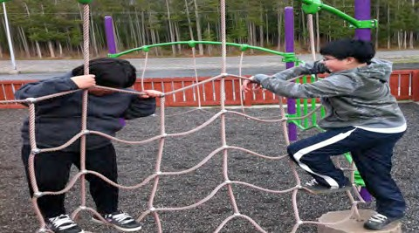
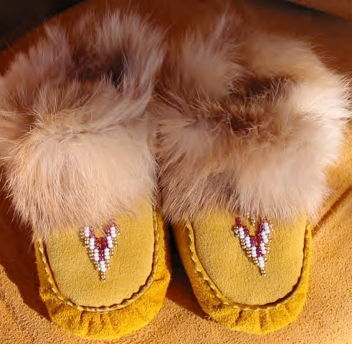
OPERATIONS

Primary Numbers: 5200 - 5499

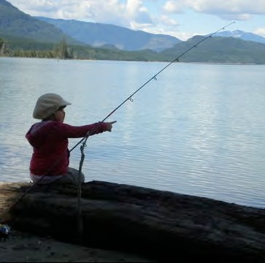

Section 11 includes subjects relating to the daycare and/or childcare services provided by the First Nation organization. These include the programs, children’s records, and the reports and funding information.

PRIMARY NUMBERS AND PRIMARY SUBJECTS

5210 Daycare Services - General

5220 Daycare Funding

5240 Daycare Licensing

5300 Daycare Services - Programs

A SA FD
5200 DAYCARE SERVICES – GENERAL

Includes records of a general nature relating to the administration, development, operation and maintenance of daycare services within the First Nation organization not found elsewhere in this section. For construction records of daycare/childcare buildings, see Section 2 – Buildings, Facilities and Properties.

-01 General CY + 1 6y D

5220 DAYCARE FUNDING

Includes records relating to organizations providing funding for daycare or childcare of the First Nation organization. Includes subsidies from provincial sources.

-01 General CY + 1 6y D
-02 Subsidies CY + 1 6y D

5240 DAYCARE/CHILD CARE SERVICES – PROGRAMS

Includes records relating to the licensing of daycares.

-01 General CY + 1 6y D
-02 Inspections CY + 6y D
-20 License, by year CY + 1 6y D

5300 DAYCARE/CHILD CARE SERVICES – PROGRAMS

Includes records relating to programs for daycare and child care.

-01 General CY + 1 6y D
-20 Programs, by name SO* 6y D
-30 Preschool children enrolled, by name SO* 6y D
-40 Children, aged 3-5, enrolled, by name SO* 6y D
-50 Infants and toddlers, enrolled, by name SO* 6y D
(*SO = until program is completed)

