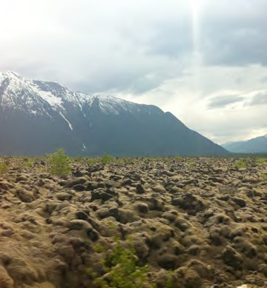
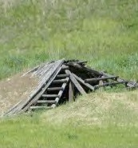
SECTION 10: SOCIAL DEVELOPMENT

Primary Numbers: 4600 – 5199

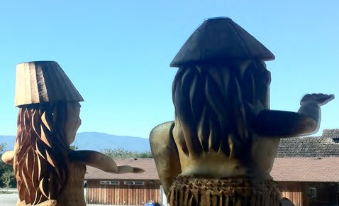

Section 10 includes subjects relating to the general community services provided, including social and disability assistance, family preservation, special needs groups and youth services.

PRIMARY NUMBERS AND PRIMARY SUBJECTS

4600 Social Development - General
4650 - Child Out of Parental Home Program
4660 - Family Preservation
4670 - Family Violence
4680 - In Home Care

4700 Community Care

4760 Family Preservation

4800 Social Assistance - General
4860 - Income Assistance
4880 - Disability Assistance

5000 Special Needs Groups

5100 Youth Centre

5160 Youth Services

A SA FD
4600 SOCIAL DEVELOPMENT – GENERAL

Includes records relating to the provision of social services to the community which are not found elsewhere in this section.

-01 General CY + 1 6y D

4640 CHILD AND FAMILY SERVICES – GENERAL

Includes records relating to the provision of family support services in the community.

-01 General CY + 1 6y D

4650 CHILD AND FAMILY SERVICES PROGRAMS – CHILD OUT OF PARENTAL HOME

Includes records relating to the provision of support services and benefits offered to non-custodial parents in the community.

-01 General CY + 1 6y D
-02 Custody benefits CY + 1 6y D
-20 Clients, by name SO* nil P
(*SO = until no longer in program)

4660 CHILD AND FAMILY SERVICES PROGRAMS – FAMILY PRESERVATION

Includes records relating to the Family Preservation Program.

-01 General CY + 1 6y D
-20 Clients, by name SO* nil P
(*SO = until no longer in program)

4670 CHILD AND FAMILY SERVICES PROGRAMS – FAMILY VIOLENCE

Includes records relating to the Family Violence Program.

-01 General CY + 1 6y D
-20 Clients, by name SO* nil P
(*SO = until no longer in program)

4680 CHILD AND FAMILY SERVICES PROGRAMS – IN HOME CARE

Includes records relating to the In Home Care Program.
-01 General CY + 1 6y D
-20 Clients, by name SO* nil P
(*SO = until no longer in program)

A SA FD

4700 COMMUNITY CARE

Includes records relating to the provision of community care facilities in the community.

-01 General CY + 1 6y D
-20 Facilities, by type, name, location SO* nil D
(*SO = life of facility)

4760 FAMILY PRESERVATION

Includes records relating to the provincially funded Family Preservation Program.

-01 General CY + 1 6y D
-20 Clients, by name SO* nil P
(*SO = until no longer in program)

4800 SOCIAL ASSISTANCE – GENERAL

Includes records relating to the provision of social assistance to members in the community. Includes program training materials.

-01 General CY + 1 6y D
-02 Training materials

4860 SOCIAL ASSISTANCE – INCOME ASSISTANCE

Includes records relating to the provision of income assistance to members in the community.

-01 General CY + 1 6y D
-20 Clients, by name CY + 1 6y D

4880 SOCIAL ASSISTANCE – DISABILITY ASSISTANCE

Includes relating to the provision of disability assistance to members in the community.

-01 General CY + 1 6y D
-20 Clients, by name CY + 1 6y D

5000 SPECIAL NEEDS GROUPS

Includes records relating to the provision of services and programs for physically disabled persons and persons with special needs.

-01 General CY + 1 6y D
-02 Clients, by name CY + 1 6y D
-20 Programs, by name SO* nil SR**
(*SO = completion of program)
(**SR = retain policy information)

A SA FD

5100 YOUTH CENTRE

Includes records relating to the operations and functions of the Youth Centre,

-01 General CY + 1 6y D
-20 Events, by name SO* nil SR**
(*SO = completion of program)
(**SR = retain policy information)

5160 YOUTH SERVICES

Includes records relating to the planning and provision of youth-oriented services and programs.

-01 General CY + 1 6y D
-20 Programs, by name CY + 1 6y SR*
(*SR = retain policy records)

