SECTION 1: ADMINISTRATION

Primary Numbers: 0100 – 0699
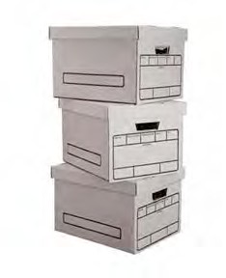
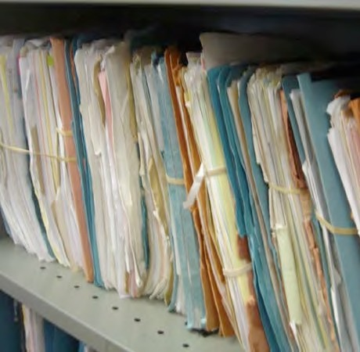

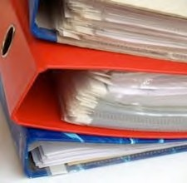

Section 1 covers a wide variety of general subjects relating to administrative and managerial services, associations, committees, conferences, meetings, etc. See Section 4, Information Systems and Services, for subjects relating to computer systems, public relations and other information services. See Section 6 for governance subjects such as elections, meetings of chief and council and the legislature.

PRIMARY NUMBERS AND PRIMARY SUBJECTS

0110 Administration - General
0125 Acts and Legislation - General
0150 Appreciation, Complaints, Inquiries
0170 Associations, Clubs, Societies
0200 Awards
0300 Cemetery Administration
0320 Ceremonies and Celebrations
0400 Circulars, Directives, Orders, Manuals, Policies
0440 Committees, Commissions and Meetings
0480 Conferences, Seminars, Symposia
0490 Cooperation and Liaison - General
0520 Corporations, Companies, Firms
0550 Delegation of Authority
0580 Inventions, Patents, Copyright, Logos and Trademarks
0600 Management Services/Reviews
0610 Office Services
0620 Plans and Programs
0630 Proclamations and Special Declarations
0640 Reports and Statistics - General
0680 Security - General
0685 Special Events
0695 Visits and Tours

A SA FD
0110 ADMINISTRATION – GENERAL

Includes records relating generally to administrative functions, which are not found elsewhere in this section. Includes incorporation and letters patent documents relating to the establishment of the First Nation organization. Also includes organization charts and materials relevant to organizational structure.
-01 General CY +1 6y D
-02 Incorporation SO nil P
-03 Organization Charts SO nil P
-20 Convenience Files CY + 1 nil D
Note: These are convenience copies of correspondence compiled for administrative convenience only. Classify the official file copy under the appropriate subject.
-30 Appointment Books, Calendars, Diaries SO nil SR
Note: Diaries relating to specific subjects should be classified under the appropriate subject.

0125 ACTS AND LEGISLATION

Includes records relating to general information on acts and legislation. Includes comparative studies of legislation from various levels of government. Where required, subdivide by jurisdiction.

-01 General SO* + 1 nil D
-02 Comparative Studies SO* + 1 nil SR
-20 Legislation, by jurisdiction SO* nil D
(*SO = until updated or replaced

0150 APPRECIATION, COMPLAINTS, INQUIRIES

Includes general letters of appreciation, complaint, condolence, congratulation, invitation, criticism, etc.

-01 General CY + 1 nil D
-20 Complaints, by Dept., issue CY + 1 6y D

A SA FD
0170 ASSOCIATIONS, CLUBS, SOCIETIES

Includes correspondence, proceedings, minutes, annual reports, financial statements, membership fees, etc. relating to associations, clubs, federations, foundations, leagues, orders, societies and similar organizations. For committees and commissions, see primary 0350 and 0440.

-01 General CY + 1 6y D
-20 Associations, Clubs, Societies, alpha by name CY + 1 6y D
- First Nations Education Steering Committee (FNESC)
- First Nations Schools Association (FNSA)

For a further breakdown within an individual organization, use the following categories:
-01 General
-02 Agenda
-03 Minutes
-04 Attendance lists
-05 Membership lists
-06 Reports
-07 Financial statements/budgets
-08 Newsletters/bulletins

0200 AWARDS

Includes records relating to the presentation of awards or the receipt of awards by the First Nation organization.

-01 General CY + 1 6y D
-20 Awards, individual, by name and date CY + 1 6y P

0300 CEMETERY ADMINISTRATION

Includes records relating to the administration and management of First Nation organization cemeteries, including the reservation of graves, issuance and maintenance of burial permits, interments, etc.
See Legal Citation Number 48, Appendix 2.

-01 General CY + 1 6y SR
-02 Cemetery Plans SO nil P
-20 Grave reservations, alpha by name SO nil P
-30 Burial permits, alpha by name SO nil P

0320 CEREMONIES AND CELEBRATIONS

Includes records relating to special ceremonies of the First Nation organization, including inaugurations, dedications, celebrations, etc.

-01 General CY+! 6y D
-20 Celebrations, by name and date CY + 1 6y SR

A SA FD

0400 CIRCULARS, DIRECTIVES, ORDERS, MANUALS, POLICIES

Includes administrative and operating manuals, bulletins, directives, instructions, etc. Also includes policies and procedures. For publications to external agencies, see Section 4, Information Systems and Services.

-01 General SO* nil P
-20 Administrative and operating manuals SO* nil P
-50 Policies and procedures SO* nil P
(*SO = retain until updated, then save permanently to provide context for decision making.)

0440 COMMITTEES, COMMISSIONS AND MEETINGS

Includes records relating to the establishment, organization and functions of boards, commissions, committees, councils, groups, panels, subcommittees, task forces and working groups not shown elsewhere. Includes agenda, notices, minutes, reports and other records. For associations, clubs, societies, etc. see primary 0170. For Council committees and meetings see primary 0350 and 0370.
Note: create individual primaries for organizations as required.

-01 General CY + 1 6y D
-20 Committees, alpha by name CY + 1 6y P

For a further breakdown within an individual committee, use the following categories:
-01 General
-02 Agendas
-03 Minutes
-04 Attendance lists
-05 Membership lists and appointments
-06 Reports
-07 Financial statements
-08 Terms of reference

0480 CONFERENCES, SEMINARS, SYMPOSIA

Includes records relating to participation in or the establishment, organization and functions of conferences, seminars and symposia. Includes agendas, notices, minutes, reports and other records. For associations, clubs, societies, see primary 0170. For committees and commissions, see primary 0440.

-01 General CY + 1 6y D
-20 Conferences, seminars, etc., alpha by title, date CY + 1 1y SR*
(* SR = retain records of sponsored seminars)

A SA FD

0490 COOPERATION AND LIAISON

Includes records of a general nature relating to liaison activities with organizations, which are not found elsewhere in the cooperation and liaison block. Liaison activities include the exchange of information, routine notifications and inquiries, offers of service, etc. Material on a specific subject should be placed in the appropriate subject file.

-01 General CY + 1 6y D
-20 British Columbia Government CY + 1 6y D
-30 Federal Government CY + 1 6y D
-40 International Agencies CY + 1 6y D
-50 Local and Regional Governments CY + 1 6y D
-60 Other First Nation Governments CY + 1 6y D
-70 Other First Nation Organizations CY+! 6y D
- Assembly of First Nations (AFN)
- Leadership Council (FNLC)
- First Nations Summit (FNS)
-80 Universities, Colleges and Schools CY + 1 6y D
-90 Health Authorities CY + 1 6y D

0520 CORPORATIONS, COMPANIES, FIRMS

Includes records of a general and routine nature relating to corporations, companies and firms. Such material includes solicitations, brochures, inquires, offers of service, etc. For material on a specific subject, e.g. contracts, accounts payable or receivable, file with the appropriate subject primary.

-01 General CY + 1 6 D
-20 Corporations, companies, firms, alpha by name CY + 1 6y D

0550 DELEGATION OF AUTHORITY

Includes records relating to the delegation of authority, including resolutions, signing authorities and relating matters.

-01 General CY + 1 nil D

A SA FD

0570 INVENTIONS, PATENTS, COPYRIGHT, LOGOS AND TRADEMARKS

Includes records relating to the applications for patents, copyrights, or trademarks (intellectual property) made on behalf of the First Nation organization. Also includes records relating to infringements, permission to use copyright material, etc. as well as records relating to the use of logos and trademarks, including the use of an approved visual identification program for municipal property, vehicles, celebrations, etc.

See Legal Citation Number 35, Appendix 2.

-01 General SO nil SR*
(*SR = keep all patents, copyrights and trademarks until expiry of claim or ownership)
(*SR = retain all graphic materials depicting logos and trademarks permanently)

0600 LEGISLATIVE AFFAIRS – GENERAL

Includes records of a general nature relating to the establishment and management of legislative and regulatory matters to the First Nation organization jurisdiction.

-01 General CY + 1 6y D

0610 MANAGEMENT SERVICES/REVIEWS

Includes records relating to management improvement studies, office surveys and other records relating to management information systems, operation performance surveys, etc.

-01 General CY + 1 6y D

0620 OFFICE SERVICES

Includes records relating to internal and external office services and procedures, including duplication and reproduction services, secretarial and typing services, translation services, mail and courier services, etc.

-01 General CY + 1 6y D

0630 PLANS AND PROGRAMS

Includes records relating to program planning coordination and direction, including the development and execution of plans in relation to program goals and objectives. Also includes the review and analysis of plans and programs.

-01 General CY + 2 3y SR*
(*SR = keep all strategic plans permanently)

A SA FD

0640 REPORTS AND STATISTICS

Includes reports and statistics on all administrative and operational subjects

Note: where volume requires, subdivide by frequency of issue.

-01 General CY + 1 6y D
-20 Annual reports and statistics, by name and date CY + 1 1y P
-30 Reports, by name and date CY + 1 1y SR*
(*SR = keep one time reports that are not accumulated in other reports.)

0680 SECURITY

Includes records relating to security issues including personnel security, information security, and physical security.
See Legal Citation Number 36, Appendix 2.

-01 General CY + 1 6y D
-20 Information security CY + 1 1y D
-30 Personnel security (PIB) CY + 1 1y D
-40 Physical security CY + 1 1y D
(* Personal Information Bank)

0685 SPECIAL EVENTS

Includes records relating to municipal sponsorship or participation in recreation and cultural events, festivities, etc. For ceremonies and celebrations, see primary 0320.

-01 General CY + 1 6y D
-20 Special event, by name CY + 1 6y SR*
(* SR = retain policy and program material for significant events)

0695 VISITS AND TOURS

Includes records relating to the arrangement, preparation, and conduct of visits and travel to and from other cities, provinces and countries, and visits of officials to the First Nation organization from other locations. Includes itineraries, reports and other relating records. For travel expenses and claims, see primary 1800.

-01 General CY + 1 6y D

