FNS
First Nations Summit

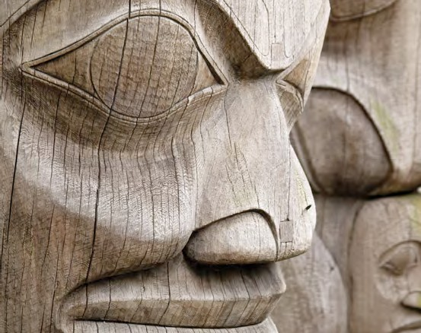
Information Management Toolkit

Information for First Nations Government in BC

Filing Toolkit | Appendix 1 – Records Classification and Retention Schedule | 2011
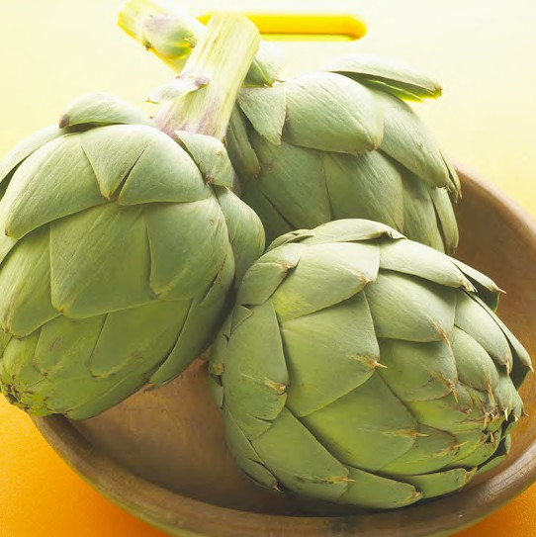
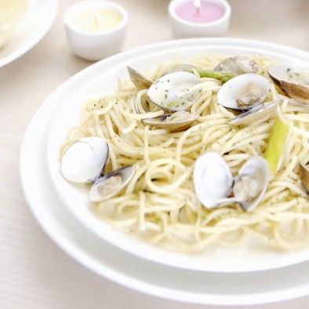

+

Introduction

to the Records & Information Management System and Retention Schedule

The Records & Information Management System for First Nations is a Block Numeric filing system. The organizing principle is function, arranged alphabetically by subject. The subject headings have been derived from a review of the records in First Nations government organizations in British Columbia and from consultations with First Nations government staff members and records management staff working in First Nations government offices.

The complete Records & Information Management System represents a menu from which staff can select the appropriate primary and secondary headings to classify all information generated or received by their organization.

Structure and Logic

Appendix
IM
Toolkit

of the Records & Information Management System and Retention Schedule

  - Sections
There are nineteen sections that represent the functions of a typical First Nations government. These are arranged as follows:

Administration:

Section 1 – Administration (Primary Numbers 0100 – 0699);
Section 2 – Buildings, Facilities and Properties (Primary Numbers 0700 – 0999);
Section 3 – Equipment and Supplies (Primary Numbers 1000 – 1299);
Section 4 – Information Systems and Services (Primary Numbers 1300 – 1599);
Section 5 – Finance (Primary Numbers 1600 – 2199);
Section 6 – Governance & Legal Matters (Primary Numbers 2200 – 2499);
Section 7 – Personnel (Primary Numbers 2500 – 2999);

Operations:

Section 8 – Lands (Primary Numbers 3000 – 3999);
Section 9 – Housing (Primary Numbers 4000 – 4599);
Section 10 – Social Development (Primary Numbers 4600 – 5199);
Section 11 – Child Care / Day Care Operations (Primary Numbers 5200 – 5499);
Section 12 – Education and Lifelong Learning (Primary Numbers 5500 – 5999)
Section 13 – Engineering, Public Works and Infrastructure (Primary Numbers 6000 – 6499);
Section 14 – Forestry and Resources Management (Primary Numbers 6500 – 6999);
Section 15 – Fisheries Resource Management (Primary Numbers 7000 – 7799);
Section 16 – Health (Primary Numbers 7800 – 8299);
Section 17 – Membership/Citizenship (Primary Numbers 8300 – 8499);
Section 18 – Protective Services (Primary Numbers 8500 – 8999);
Section 19 – Culture and History (Primary Numbers 9000 – 9399);
Section 20 – Economic Development Corporations & Activities (Primary Numbers 9400 - 9799), and Unassigned for future growth (Primary Numbers 9800 – 9999).

Appendix
IM
Toolkit

The style of coding is known as block numeric. The administration/operational split is characteristic of Canadian filing systems originally developed at the federal government ministries. It is also similar to the ARCS/ORCS model used by the Province of British Columbia. Administrative subjects are housekeeping subjects, and common to all organizations. Operational subjects are specifically relating to the mandate and business of the First Nation organization, and are unique to that business. Related agencies such as economic development corporations will require more operational functions than are shown in this arrangement. Topics in this system reflect the First Nation organization relationship to these other bodies.

The classification system is designed to expand as the business functions grow and change, so there is spacing between the code numbers assigned to primary subjects. Where the volume of records requires, First Nation records management staff are encouraged to add the required primary subjects, creating the appropriate classification code.

Appendix
IM
Toolkit

Primary and Secondary Subjects
Subjects are arranged in rough alphabetical order within each section. For each subject, the individual subjects or topics are displayed in a hierarchy, from general to more specific and relating sub topics, and represent the broad spectrum of typical functions.

In situations where there are relating primary subjects, these have been arranged to represent a primary “block”, e.g.:

2320 Chief and Council – General
2330 Chief and Council – Committees
2340 Chief and Council – Meetings

Within a block, the first primary is a general one, containing records relevant to the complete block, as well as general subjects that do not collect enough records to justify being assigned a unique primary heading. A differing retention period for relating subjects also warrants having a different subject heading.

For each primary subject heading there is a description or scope note to clearly describe the types of record materials that should be grouped under the primary heading. This description provides a reminder for staff, who will be filing or retrieving information infrequently.

Appendix
IM
Toolkit

A primary subject contains a variety of types of files or records, and is further subdivided into relating secondary subject files and/or case files. Secondary subject headings bring relating materials on a topic, and are usually assigned numbers -02 to -19. These secondary subjects may also include case files.

Case files usually consist of many different files or volumes, each of which contains diverse records relating to a specific entity, such as a person, meeting, event, project or transaction. Examples of common case records are individual meeting files, organized by the date of the meeting. Case files are usually numbered –20 or higher. Case files may also have their own unique numbering system,
e.g. employee numbers, policy numbers, and consequently can easily fit into the overall classification scheme.

Within each primary, the –01 is always reserved as a “general” file. The general file is usually the first secondary file opened, and is used for records where the content of the record falls within the primary, but there is no existing secondary, or where there is no existing classification for the document. The general number is used until sufficient volume is generated to warrant creating a new primary or secondary heading. An accepted volume is 5 to 10 pieces of information.

Occasionally, secondary subjects may be further subdivided into a third or tertiary subject heading, when a secondary subject requires further breakdown. For example, a further breakdown may be required for committees, where separate files are required for agendas, minutes from open meetings, and minutes from closed meetings. In these cases, the tertiary number is added to the secondary, and forms the complete file number.

A complete file number will typically have at least two components – the primary and secondary numbers, or three – the primary, secondary and tertiary numbers

Appendix
IM
Toolkit

Retention Periods

The recommended retention period is assigned to each secondary subject heading. There are three phases defined for each of these subjects:
- the active life (A), where the records are used for staff work and reference;
- the semi-active (SA) or inactive phase, where staff no longer use the records, but the records may be needed for regulatory, audit or other requirements. At this stage, records are removed to storage, and
- the final disposition (FD) phase, where the records are destroyed or retained permanently.

The basis for each retention is from the appraised value of the records, and also incorporates any legal requirements for retention.

Legal research was undertaken in 2011 to locate any regulations for retention of records. With the passage of time, organizations should undertake their own research to ensure current retention requirements.

- Records Classification

Appendix
IM
Toolkit

and retention Schedule

PART A ADMINISTRATION 0100 – 2999

Section 1 Administration 0100 – 0699
Section 2 Buildings, Facilities and Properties 0700 – 0999
Section 3 Equipment and Supplies 1000 – 1299
Section 4 Information Systems and Services 1300 – 1599
Section 5 Finance 1600 – 2199
Section 6 Governance and Legal Matters 2200 – 2499
Section 7 Personnel 2500 – 2999

PART B OPERATIONS 3000 – 9999

Section 8 Lands 3000 – 3999
Section 9 Housing 4000 – 4599
Section 10 Social Development 4600 – 5199
Section 11 Daycare/Child Care Operations 5200 – 5499
Section 12 Education and Life Long Learning 5500 – 5999
Section 13 Engineering, Public Works and Community Infrastructure 6000 – 6499
Section 14 Forestry Resources Management 6500 – 6999
Section 15 Fisheries Resource Management 7000 – 7799
Section 16 Health 7800 – 8299
Section 17 Membership/Citizenship 8300 – 8499
Section 18 Protective Services 8500 – 8999
Section 19 Culture and History 9000 – 9399
Section 20 Economic Development Corporations and Activities 9400 - 9799

Appendix
IM
Toolkit

RETENTION SCHEDULE TIME PERIOD CODES

The time periods for retention of record series are provided with every subject heading. Three columns are provided on the right side of the page:
"A" indicates the time period during which the record series is active, and required for daily business in the office.
"SA" indicates the time period during which the record series must be retained by the organization for regulatory or other reasons, but the records are semi-active and no longer needed for daily business. These may be removed from the active office space to a less costly storage location.
"FD" indicates final disposition, once the record series has been retained for all required purposes.

The various codes are defined as follows:
A = active
SA = semi active
FD = final disposition CY = calendar year FY = fiscal year
y = year
SR = selective retention
SO = until superceded or obsolete (each condition is noted)
P = permanent retention*
D = destroy
NA = not applicable
ARC = archives (where organizational archives exist)
- legal or business obligation to retain permanently
PIB = Personal Information Bank (collection of records filed by name, identification number or other personal identifier)

SECTION 1: ADMINISTRATION

Primary Numbers: 0100 – 0699
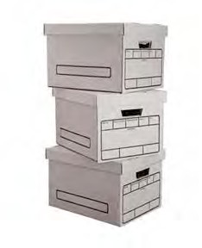
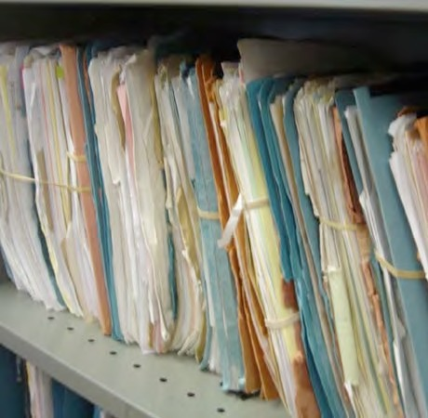

Section 1 covers a wide variety of general subjects relating to administrative and managerial services, associations, committees, conferences, meetings, etc. See Section 4, Information Systems and Services, for subjects relating to computer systems, public relations and other information services. See Section 6 for governance subjects such as elections, meetings of chief and council and the legislature.

PRIMARY NUMBERS AND PRIMARY SUBJECTS

0110 Administration - General
0125 Acts and Legislation - General
0150 Appreciation, Complaints, Inquiries
0170 Associations, Clubs, Societies
0200 Awards
0300 Cemetery Administration
0320 Ceremonies and Celebrations
0400 Circulars, Directives, Orders, Manuals, Policies
0440 Committees, Commissions and Meetings
0480 Conferences, Seminars, Symposia
0490 Cooperation and Liaison - General
0520 Corporations, Companies, Firms
0550 Delegation of Authority
0580 Inventions, Patents, Copyright, Logos and Trademarks
0600 Management Services/Reviews
0610 Office Services
0620 Plans and Programs
0630 Proclamations and Special Declarations
0640 Reports and Statistics - General
0680 Security - General
0685 Special Events
0695 Visits and Tours

A SA FD
0110 ADMINISTRATION – GENERAL

Includes records relating generally to administrative functions, which are not found elsewhere in this section. Includes incorporation and letters patent documents relating to the establishment of the First Nation organization. Also includes organization charts and materials relevant to organizational structure.
-01 General CY +1 6y D
-02 Incorporation SO nil P
-03 Organization Charts SO nil P
-20 Convenience Files CY + 1 nil D
Note: These are convenience copies of correspondence compiled for administrative convenience only. Classify the official file copy under the appropriate subject.
-30 Appointment Books, Calendars, Diaries SO nil SR
Note: Diaries relating to specific subjects should be classified under the appropriate subject.

0125 ACTS AND LEGISLATION

Includes records relating to general information on acts and legislation. Includes comparative studies of legislation from various levels of government. Where required, subdivide by jurisdiction.

-01 General SO* + 1 nil D
-02 Comparative Studies SO* + 1 nil SR
-20 Legislation, by jurisdiction SO* nil D
(*SO = until updated or replaced

0150 APPRECIATION, COMPLAINTS, INQUIRIES

Includes general letters of appreciation, complaint, condolence, congratulation, invitation, criticism, etc.

-01 General CY + 1 nil D
-20 Complaints, by Dept., issue CY + 1 6y D

A SA FD
0170 ASSOCIATIONS, CLUBS, SOCIETIES

Includes correspondence, proceedings, minutes, annual reports, financial statements, membership fees, etc. relating to associations, clubs, federations, foundations, leagues, orders, societies and similar organizations. For committees and commissions, see primary 0350 and 0440.

-01 General CY + 1 6y D
-20 Associations, Clubs, Societies, alpha by name CY + 1 6y D
- First Nations Education Steering Committee (FNESC)
- First Nations Schools Association (FNSA)

For a further breakdown within an individual organization, use the following categories:
-01 General
-02 Agenda
-03 Minutes
-04 Attendance lists
-05 Membership lists
-06 Reports
-07 Financial statements/budgets
-08 Newsletters/bulletins

0200 AWARDS

Includes records relating to the presentation of awards or the receipt of awards by the First Nation organization.

-01 General CY + 1 6y D
-20 Awards, individual, by name and date CY + 1 6y P

0300 CEMETERY ADMINISTRATION

Includes records relating to the administration and management of First Nation organization cemeteries, including the reservation of graves, issuance and maintenance of burial permits, interments, etc.
See Legal Citation Number 48, Appendix 2.

-01 General CY + 1 6y SR
-02 Cemetery Plans SO nil P
-20 Grave reservations, alpha by name SO nil P
-30 Burial permits, alpha by name SO nil P

0320 CEREMONIES AND CELEBRATIONS

Includes records relating to special ceremonies of the First Nation organization, including inaugurations, dedications, celebrations, etc.

-01 General CY+! 6y D
-20 Celebrations, by name and date CY + 1 6y SR

A SA FD

0400 CIRCULARS, DIRECTIVES, ORDERS, MANUALS, POLICIES

Includes administrative and operating manuals, bulletins, directives, instructions, etc. Also includes policies and procedures. For publications to external agencies, see Section 4, Information Systems and Services.

-01 General SO* nil P
-20 Administrative and operating manuals SO* nil P
-50 Policies and procedures SO* nil P
(*SO = retain until updated, then save permanently to provide context for decision making.)

0440 COMMITTEES, COMMISSIONS AND MEETINGS

Includes records relating to the establishment, organization and functions of boards, commissions, committees, councils, groups, panels, subcommittees, task forces and working groups not shown elsewhere. Includes agenda, notices, minutes, reports and other records. For associations, clubs, societies, etc. see primary 0170. For Council committees and meetings see primary 0350 and 0370.
Note: create individual primaries for organizations as required.

-01 General CY + 1 6y D
-20 Committees, alpha by name CY + 1 6y P

For a further breakdown within an individual committee, use the following categories:
-01 General
-02 Agendas
-03 Minutes
-04 Attendance lists
-05 Membership lists and appointments
-06 Reports
-07 Financial statements
-08 Terms of reference

0480 CONFERENCES, SEMINARS, SYMPOSIA

Includes records relating to participation in or the establishment, organization and functions of conferences, seminars and symposia. Includes agendas, notices, minutes, reports and other records. For associations, clubs, societies, see primary 0170. For committees and commissions, see primary 0440.

-01 General CY + 1 6y D
-20 Conferences, seminars, etc., alpha by title, date CY + 1 1y SR*
(* SR = retain records of sponsored seminars)

A SA FD

0490 COOPERATION AND LIAISON

Includes records of a general nature relating to liaison activities with organizations, which are not found elsewhere in the cooperation and liaison block. Liaison activities include the exchange of information, routine notifications and inquiries, offers of service, etc. Material on a specific subject should be placed in the appropriate subject file.

-01 General CY + 1 6y D
-20 British Columbia Government CY + 1 6y D
-30 Federal Government CY + 1 6y D
-40 International Agencies CY + 1 6y D
-50 Local and Regional Governments CY + 1 6y D
-60 Other First Nation Governments CY + 1 6y D
-70 Other First Nation Organizations CY+! 6y D
- Assembly of First Nations (AFN)
- Leadership Council (FNLC)
- First Nations Summit (FNS)
-80 Universities, Colleges and Schools CY + 1 6y D
-90 Health Authorities CY + 1 6y D

0520 CORPORATIONS, COMPANIES, FIRMS

Includes records of a general and routine nature relating to corporations, companies and firms. Such material includes solicitations, brochures, inquires, offers of service, etc. For material on a specific subject, e.g. contracts, accounts payable or receivable, file with the appropriate subject primary.

-01 General CY + 1 6 D
-20 Corporations, companies, firms, alpha by name CY + 1 6y D

0550 DELEGATION OF AUTHORITY

Includes records relating to the delegation of authority, including resolutions, signing authorities and relating matters.

-01 General CY + 1 nil D

A SA FD

0570 INVENTIONS, PATENTS, COPYRIGHT, LOGOS AND TRADEMARKS

Includes records relating to the applications for patents, copyrights, or trademarks (intellectual property) made on behalf of the First Nation organization. Also includes records relating to infringements, permission to use copyright material, etc. as well as records relating to the use of logos and trademarks, including the use of an approved visual identification program for municipal property, vehicles, celebrations, etc.

See Legal Citation Number 35, Appendix 2.

-01 General SO nil SR*
(*SR = keep all patents, copyrights and trademarks until expiry of claim or ownership)
(*SR = retain all graphic materials depicting logos and trademarks permanently)

0600 LEGISLATIVE AFFAIRS – GENERAL

Includes records of a general nature relating to the establishment and management of legislative and regulatory matters to the First Nation organization jurisdiction.

-01 General CY + 1 6y D

0610 MANAGEMENT SERVICES/REVIEWS

Includes records relating to management improvement studies, office surveys and other records relating to management information systems, operation performance surveys, etc.

-01 General CY + 1 6y D

0620 OFFICE SERVICES

Includes records relating to internal and external office services and procedures, including duplication and reproduction services, secretarial and typing services, translation services, mail and courier services, etc.

-01 General CY + 1 6y D

0630 PLANS AND PROGRAMS

Includes records relating to program planning coordination and direction, including the development and execution of plans in relation to program goals and objectives. Also includes the review and analysis of plans and programs.

-01 General CY + 2 3y SR*
(*SR = keep all strategic plans permanently)

A SA FD

0640 REPORTS AND STATISTICS

Includes reports and statistics on all administrative and operational subjects

Note: where volume requires, subdivide by frequency of issue.

-01 General CY + 1 6y D
-20 Annual reports and statistics, by name and date CY + 1 1y P
-30 Reports, by name and date CY + 1 1y SR*
(*SR = keep one time reports that are not accumulated in other reports.)

0680 SECURITY

Includes records relating to security issues including personnel security, information security, and physical security.
See Legal Citation Number 36, Appendix 2.

-01 General CY + 1 6y D
-20 Information security CY + 1 1y D
-30 Personnel security (PIB) CY + 1 1y D
-40 Physical security CY + 1 1y D
(* Personal Information Bank)

0685 SPECIAL EVENTS

Includes records relating to municipal sponsorship or participation in recreation and cultural events, festivities, etc. For ceremonies and celebrations, see primary 0320.

-01 General CY + 1 6y D
-20 Special event, by name CY + 1 6y SR*
(* SR = retain policy and program material for significant events)

0695 VISITS AND TOURS

Includes records relating to the arrangement, preparation, and conduct of visits and travel to and from other cities, provinces and countries, and visits of officials to the First Nation organization from other locations. Includes itineraries, reports and other relating records. For travel expenses and claims, see primary 1800.

-01 General CY + 1 6y D

SECTION 2: BUILDINGS, FACILITIES
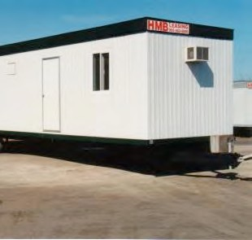
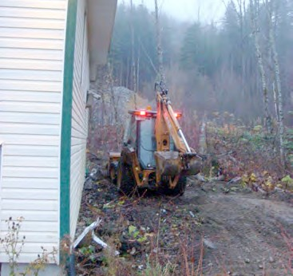
AND PROPERTIES

Primary Numbers: 0700 – 0999

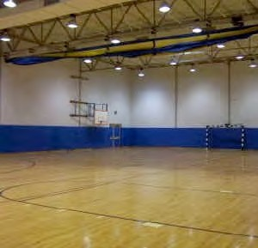

Section 2 is concerned with subjects involving the acquisition of accommodation for First Nation organization administration and operations through the purchase or rental of existing buildings and land, or through the construction of new buildings and facilities. These properties are altered, developed and maintained according to the particular needs of the First Nation organization administration.

For housing of First Nation organization members, see Section 9, Housing. For fire prevention, see Section 17, Protective Services.

PRIMARY NUMBERS AND PRIMARY SUBJECTS

0710 Buildings, Facilities and Properties – General

0730 Buildings – General
0810 – Individual

0890 Properties – General

0970 Utilities – General

A SA FD
0710 BUILDINGS, FACILITIES AND PROPERTIES – GENERAL

Includes records relating to buildings, facilities and properties for the First Nation administration and operations, which are not found elsewhere in this section.
For physical security of buildings, facilities and properties see primary 0680.

-01 General CY + 1 1y D

0730 BUILDINGS – GENERAL

Includes records relating to buildings and facilities, activities and programs, including acquisition, alterations and repairs, construction, damages, disposal and maintenance for the First Nation administration and operations.
Includes building directories, addresses, locations, etc. For individual buildings, see primary 0810.

-01 General CY + 1 3y D

0810 BUILDINGS – INDIVIDUAL

Includes records for individual buildings, facilities and structures owned by the First Nation administration and operations.

File records by standard building number, using the following secondary categories:
-01 General
-02 Land acquisition
-03 Planning, design and construction
-04 Modifications and alterations
-05 Maintenance
-06 Parking
-07 Disposal

-01 General CY + 1 5y SR*
-20 Individual buildings, by name SO 7y P
(*SR = retain precedents and statistics permanently)

0890 PROPERTIES – GENERAL

Includes records relating to the properties owned by the First Nation organization for administration or operating purposes. For individual properties occupied by First Nation organization members or tenants see primary 3700.

-01 General CY + 1 6y D
-20 Individual properties, by address SO nil P

For a further breakdown within an individual property by name, use the following categories:
-01 General
-02 Land acquisition
-03 Planning, design and construction
-04 Modifications and alterations
-05 Maintenance
-06 Parking
-07 Disposal

A SA FD

0970 UTILITIES – GENERAL

Includes records relating to the various building utilities: environmental controls such as air conditioning, ventilation and heating, garbage disposal, gas, lighting and electrical systems and facilities, and water and plumbing facilities.

-01 General CY + 1 6y D
-02 Heating systems CY + 1 6y D
-03 Air conditioning/ventilation CY + 1 6y D
-04 Garbage disposal CY + 1 6y D
-05 Gas CY + 1 6y D
-06 Lighting and electrical systems CY + 1 6y D
-07 Water and plumbing systems CY + 1 6y D
-08 Energy Management CY + 1 6y D

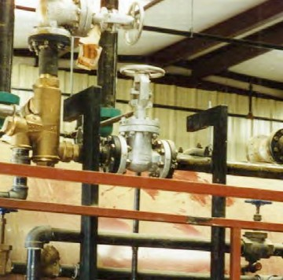
SECTION 3: EQUIPMENT AND SUPPLIES

Primary Numbers: 1000 – 1299

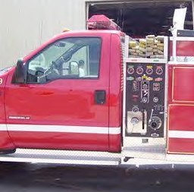

Section 3 covers the functions of procurement, storage and warehousing, issuing, maintaining and repairing, and other relating subjects, through to the ultimate disposal or write-off of obsolete or surplus materials.

PRIMARY NUMBERS AND PRIMARY SUBJECTS

1010 Equipment and Supplies - General
1015 - Vendors

1025 Asset Control and Inventories

1040 Audio-visual and Photographic Equipment

1045 Building Materials

1050 Catalogues, Manuals, Price Lists

1060 Clothing

1065 Computers - General
1070 - Hardware
1075 - Software

1085 Disposal and Surplus

1090 Fire Fighting Equipment

1095 Fisheries Equipment

1110 Forms

1120 Fuels - General
1125 - Heating
1130 - Motor Vehicle

1150 Furniture and Furnishings

1170 Office Machines and Equipment

1190 Parks Equipment and Supplies

1200 Procurement - General
1210 - Purchase Orders and Requisitions
1220 - Tenders and Quotations
1230 - Standing Offers (open orders)

1240 Public Works Equipment and Supplies - General
1245 - Material
1250 - Warehouse Stores

1260 Recreation Equipment and Supplies

1270 Stationery

1275 Telecommunication Equipment

1280 Vehicles

A SA FD
1010 EQUIPMENT AND SUPPLIES – GENERAL

Includes records relating to the general administration of equipment and supplies which are not found elsewhere in this section and to the procurement of equipment and supplies including user specifications, acquisition, maintenance and repairs not included elsewhere in this section.

-01 General CY + 1 2y D
-02 Equipment loans CY + 1 2y D
-03 Guarantees and warrantees SO* 6y D
(*SO=until expiry of guarantee or warranty)
-20 Equipment case files SO* 6y D
-30 Supplies case files SO* 6y D
(*SO = life of equipment or supplies purchase terms)

1015 EQUIPMENT AND SUPPLIES – VENDORS

Includes records relating to suppliers and vendors of equipment or supplies, such as technical data, equipment catalogues, price lists, routine correspondence unrelated to specific purchases. For purchase orders, see primary 1210. For record of payment and invoices, see primary 1630.

-01 General CY + 1 nil D
-20 Suppliers, alpha by name SO* nil D\
(*SO = until no longer a supplier)

1025 ASSET CONTROL AND INVENTORIES

Includes records relating to the control of fixed assets excluding buildings and lands, and stock inventory, including receipt, storage, inventorying and stocktaking. This section does not include records relating to financial assets.

-01 General FY+1 6y D
-02 Asset loss SO+1 6y D
-03 Warehouse inventory FY+1 6y D
-20 Fixed assets control case files SO* nil P
(*SO = until loss is written 0ff)

1040 AUDIO-VISUAL AND PHOTOGRAPHIC EQUIPMENT

Includes records relating to the purchasing of audio-visual and photographic equipment, including justification, user specifications, issue, maintenance and repairs.

-01 General CY + 1 6y D
-20 Equipment history files SO* nil D
(*SO = life of equipment)

A SA FD
1045 BUILDING MATERIALS

Includes records relating to the purchasing of building materials and supplies such as lumber, hardware, etc.

-01 General CY + 1 6y D

1050 CATALOGUES, MANUALS, PRICE LISTS

Includes technical data, equipment catalogues and manuals, price lists, etc.

-01 General CY nil D
-20 Suppliers SO nil D

1060 CLOTHING

Includes records relating to the purchase and issue of clothing, uniforms, smocks, etc. This primary also includes records on cleaning and laundering services.

-01 General CY 6y D
-02 Cleaning services CY 1y D
-03 Dress regulations SO* nil P
(*SO = until changed or updated)
-20 Itemized record of issue, alpha by name SO* nil D
(*SO = duration of employment)
-30 Special clothing maintenance reimbursement CY + 1 1y D

1065 COMPUTERS – GENERAL

Includes records relating to the purchase of computer equipment, including equipment evaluations, user specifications, maintenance and repairs. Includes purchasing procedures and correspondence relating to computer maintenance.

-01 General CY + 1 6y D

1070 COMPUTERS – HARDWARE

Includes records relating to the purchase of computer hardware, including equipment evaluations, user specifications, issue, maintenance and repairs. Includes history and maintenance files.

-01 General CY + 1 6y D
-02 Hardware research files CY + 1 6y D
-30 Hardware history files SO* nil D
-40 Hardware problems and maintenance SO* nil D
(*SO = life of equipment)

A SA FD

1075 COMPUTERS – SOFTWARE

Includes records relating to the purchase of commercially available computer software, including software evaluations, user requirements, issue, maintenance and repairs. Includes research, history and problem files.

-01 General CY + 1 6y D
-20 Software research files, by product and release no. CY + 1 1y D
-25 Software history files SO* nil D
-30 Software maintenance and problem files SO* nil D
(*SO = life of software)

1085 DISPOSAL AND SURPLUS

Includes records relating to the disposal of surplus equipment, the destruction of equipment. For information relating to the disposal of buildings, see primary number 0810.

-01 General CY + 1 6y D
-02 Disposals SO* + 1 1y D
-03 Write-offs SO* + 1 1y D
(*SO = upon completion of disposal or write-off transaction, and satisfaction of all audit requirements)

1095 FIRE FIGHTING EQUIPMENT

Includes records relating to the purchasing procedures for fire fighting equipment, including justification, specifications, issue, testing, maintenance and repairs.

-01 General CY + 1 6y D

1100 FISHERIES EQUIPMENT

Includes records relating to the purchasing procedures for fisheries equipment, including justification, specifications, issue, testing, maintenance and repairs.

-01 General CY + 1 6y D

1110 FORMS

Includes records relating to the purchasing and issue of forms. For information on forms management, see primary number 1490.

-01 General CY + 1 1y D

1120 FUELS – GENERAL

Includes records relating to the purchase of types of fuels which are not found elsewhere in the fuels block.

-01 General CY + 1 1y D

A SA FD

1125 FUELS – HEATING

Includes records relating to the purchase of heating fuels, including their performance, supply, etc.

-01 General CY + 1 6y D
-02 Natural Gas CY + 1 1y D
-03 Oil CY + 1 1y D

1130 FUELS - MOTOR VEHICLE

Includes records relating to the purchase of motor fuels, including their performance, supply, etc.

-01 General CY + 1 6y D
-02 Gasoline CY + 1 1y D
-03 Oils and lubricants CY + 1 1y D

1150 FURNITURE AND FURNISHINGS

Includes records relating to the purchasing of furniture and furnishings, including specifications, acquisition, maintenance and repairs.

-01 General CY + 1 6y D

1170 OFFICE MACHINES AND EQUIPMENT

Includes records relating to the purchasing of office machines and equipment (photocopiers etc.), including specifications, acquisition, maintenance and repairs. For computer equipment (hardware and software) purchase, see primary numbers 1065 to 1075.

-01 General CY + 1 6y D
-20 Office machine history files SO* nil D
(*SO = life of machine)

1190 PARKS EQUIPMENT AND SUPPLIES

Includes records relating to the purchasing of parks equipment and supplies, including specifications, acquisition, maintenance and repairs.

-01 General CY + 1 1y D
-20 Equipment history files SO* nil D
(*SO = life of equipment)

A SA FD
1200 PROCUREMENT – GENERAL

Includes records which are not found elsewhere in the purchasing section which generally relate to the purchase, requisition storage and issue of equipment and supplies. This primary also includes methods of purchasing not shown elsewhere.

-01 General CY + 1 6y D

1210 PROCUREMENT – PURCHASE ORDERS AND REQUISITIONS

Includes records relating to procurement and purchasing actions through requisitions and the commissioning of purchase orders. For invoices generated from purchase orders, see primary 1630.

-01 General CY + 1 6y D
-20 Purchase requisitions, alpha by vendor name CY + 1 6y D
-30 Purchase orders, if filed separately CY + 1 6y D

1220 PROCUREMENT – TENDERS AND QUOTATIONS

Includes records relating to purchasing through the securing of tenders, proposals and quotations. This primary may be used if the tender information is not filed with the purchase orders and requisitions.

-01 General CY + 1 6y D
-20 Tenders and quotations, in alpha or numeric order CY + 1 6y D

1230 PROCUREMENT – STANDING OFFERS (OPEN ORDERS)

Includes records relating to commodities or services available by standing order, including the names of contractors, their addresses, and offer expiry dates.

-01 General CY + 1 6y D
-20 Standing offers, by name of product or service and CY + 1 6y D
contractors' name

1240 PUBLIC WORKS EQUIPMENT AND SUPPLIES – GENERAL

Includes records relating to the purchasing of public works relating equipment and supplies which are not found elsewhere in this block. Includes justification, specifications, issue, maintenance and repair.

-01 General CY + 1 2y D
-20 Equipment history files SO* nil D
(*SO = life of equipment)

1245 PUBLIC WORKS EQUIPMENT AND SUPPLIES – MATERIAL

Includes records relating to the purchasing of public works material, including justification, specifications and issue.

-01 General CY + 1 6y D

A SA FD

1250 PUBLIC WORKS EQUIPMENT AND SUPPLIES – WAREHOUSE STORES

Includes records relating to the purchasing of and management of warehouse stores equipment and supplies.

-01 General CY + 1 6y D

1260 RECREATION EQUIPMENT AND SUPPLIES

Includes records relating to the purchasing of recreation program equipment and supplies, including justification, specifications, issue, maintenance and repair.

-01 General CY + 1 6y D
-20 Equipment history files SO* nil D
(*SO = life of equipment)

1270 STATIONERY

Includes records relating to the printing, purchasing and user specifications for stationery, including paper and small office items.

-01 General CY + 1 6y D

1275 TELECOMMUNICATION EQUIPMENT

Includes records relating to the purchasing, justification, specifications and issue of telecommunications equipment, including maintenance and repairs.

-01 General CY + 1 6y D
-02 Base stations SO* nil D
-03 Cellular phones/Blackberries SO* nil D
-04 Facsimiles SO* nil D
-05 Radios/dispatch SO* nil D
-06 Repeaters SO* nil D
-07 Telephones SO* nil D
(*SO = life of equipment)

1280 VEHICLES

Includes records relating to the purchasing, justification, specifications and issue of vehicles, including maintenance and repairs.
See Legal Citation number 4, Appendix 2

-01 General SO+1 nil D
-20 Vehicle history files, by department SO* + 1 nil D
- Education, school buses
- Health, van
(*SO = until vehicle is disposed of)

SECTION 4: INFORMATION SYSTEMS AND SERVICES

Primary Numbers: 1300 – 1599

Section 4 includes subjects relating to the information systems in use, including computer applications, system usage, date resource management, and information services, including publications and presentations, internal library services, mail, courier and postal services, record management, archives management and public relations.

PRIMARY NUMBERS AND PRIMARY SUBJECTS

1310 Information Systems and Services - General

1320 Archives - General

1330 Computer Systems - General
1335 - Applications
1340 - Documentation
1345 - Networks and Communications
1350 - Service Requests
1355 - Reports and Statistics

1390 Information Services - General
1400 - Audio-Visual Aids
1405 - Lectures and Speeches
1415 - Newsletters
1420 - Photographs
1425 - Public Programs

1440 Library Services

1460 Mail, Postal, Courier Services

1490 Records Management

A SA FD
1310 INFORMATION SYSTEMS AND SERVICES – GENERAL

Includes administrative information relating to the management of information systems and services, which is not included elsewhere in the section.

-01 General CY + 1 6y D

1320 ARCHIVES – GENERAL

Includes records which describe archival material, the designation of First Nation materials for archival preservation, the creation of facilities for internal archives and other relating records.

-01 General CY + 1 6y D
-20 Accessions, by number SO* nil P
-30 Arrangement and description projects, by number SO** nil P
-40 Appraisal projects, by number SO** nil P
-50 Conservation projects, by number SO** nil P
-60 Access projects, by number SO** nil P
(*SO = until receipt and processing of application)
(**SO = upon completion of project)

1330 COMPUTER SYSTEMS – GENERAL

Includes general records relating to computer systems which are not found elsewhere in this section.

-01 General CY + 1 6y D

1335 COMPUTER SYSTEMS – APPLICATIONS

Includes records relating to the administration of computer system applications. Includes design information (project proposals, system requirements, specifications, etc.) and development and implementation strategies (technical working notes and progress reports).

-01 General CY + 1 6y D
-20 Applications, by name description S)* 1y D
(*SO = until upgraded or replaced)

1340 COMPUTER SYSTEMS – DOCUMENTATION

Includes systems documentation: operating instructions, procedure manuals, guidelines, etc. for the various applications in the systems.

-01 General CY + 1 1y D
-20 Documentation SO* 1y D
(*SO = until replaced, NOTE: retain documentation for archived data)

A SA FD

1345 COMPUTER SYSTEMS – NETWORKS AND COMMUNICATION

Includes documentation relating to communication networks used to interconnect terminals and hosts of the computer system(s).

-01 General CY + 1 6y D

1350 COMPUTER SYSTEMS – SERVICE REQUESTS

Includes records relating to service requests for computer hardware and software, including emergency, corrective and development services.

-01 General CY + 1 6y D
-02 Log of service requests SO* 1y D
-20 Service reports SO* 1y D
(*SO = until replaced)

1355 COMPUTER SYSTEMS – REPORTS AND STATISTICS

Includes records relating to reports and statistics generated about computer system usage, etc.

-01 General CY + 1 6y D

1390 INFORMATION SERVICES – GENERAL

Includes records relating to the general administration of public relations and public affairs which are not found elsewhere in the information services and public relation sections. Includes news clippings, communication plans, etc.

-01 General CY + 1 6y D
-02 News clippings CY + 1 nil P

1400 INFORMATION SERVICES – AUDIO-VISUAL AIDS

Includes records relating to motion pictures, slide shows, videotapes, and other audio-visual aids. Includes audio- visual production project files.

-01 General CY + 1 6y D
-20 Audio visual production projects SO* nil P
(*SO = when completed)

1405 INFORMATION SERVICES – LECTURES AND SPEECHES

Includes records relating to speeches, lectures, addresses and the arrangements for speaking engagements.

-01 General CY + 1 6y D
-20 Individual speeches, by author, date CY + 1 1y P

A SA FD

1415 INFORMATION SERVICES – NEWSLETTER

Includes records relating to the administration, printing, production, and distribution of the newsletter. Publication files include manuscripts, source document information, etc., filed by date.

-01 General CY + 1 6y D
-02 Inventory fo newsletters SO* nil P
(*SO = when updated)
-20 Individual issues SO* nil P
(*SO – when completed)

1420 INFORMATION SERVICES – PHOTOGRAPHS

Includes records relating to the acquisition, use and retention of photographic prints and negatives.

-01 General CY + 1 6y D
-20 Photographs CY + 1 1y P

1425 INFORMATION SERVICES – PUBLIC PROGRAMS

Includes records relating to activities interacting with the public, including educational institutions and other organizations.

-01 General CY + 1 6y D
-20 Individual programs, by name SO* nil P
(*SO = when completed)

1440 LIBRARY SERVICES

Includes records relating to the provision of library services including the purchase, cataloguing and distribution of books, periodicals, newspapers, subscriptions and other types of information resources.

-01 General CY + 1 6y D
-02 Requests for materials CY 2y D
-03 Lists of library materials SO* nil P
(*SO = when updated)

1460 MAIL, POSTAL, COURIER SERVICES

Includes records relating to Canada Post, internal municipal mail and private courier services including rates, mail functions, regulations, inquiries and reports on lost or damaged mail, articles, etc.

-01 General CY + 1 6y D

A SA FD

1490 RECORDS MANAGEMENT – GENERAL

Includes records relating to the Records and Information Management Program. This includes general records and information management operational standards and procedures, development, adoption and implementation of file classification systems, procedures and techniques for management of records systems. Each of these functions may include projects.

-01 General CY + 1 6y D
-02 File classification system SO* nil P
-03 Records inventories SO* nil D
-04 Records retention and disposal schedule SO* nil P
-05 Records transfer lists SO* nil P
-06 Micrographics/image management SO* nil P
-07 Records destruction SO* nil P
-08 Records centres SO* nil P
-09 Forms management SO* nil D
-10 Correspondence management SO* nil D
(*SO = when updated)

SECTION 5: FINANCE

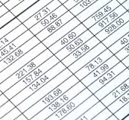
Primary Numbers: 1600 – 2199

Section 5 includes subjects relating to financial management, including the receipt, control and expenditure of First Nation funds. They include accounts and accounting, audits.

PRIMARY NUMBERS AND PRIMARY SUBJECTS

1610 Finance - General

1615 Accounting - General

1630 Accounts - Payable
1640 - Receivable

1650 Advances
1680 Audits

1690 Banks and Banking

1700 Budgets - General
1705 - Capital
1715 - Operating

1730 Cheques

1740 Claims (Financial)

1760 Debt

1770 Donations and Bequests

1780 Encumbrances

1790 Expenditure Control

1800 Expense Accounts

1830 Financial Statements

1850 Grants to Organizations

1855 Grants from Organizations

1860 Investments

1870 Letters of Credit

1880 Reports, Statistics, Statements

1890 Revenue Control

1900 Salaries and Wages - Benefits and Services
1920 - Payroll

1940 Signing Authorities

1950 Taxation - Assessments
1970 - Taxes Collected
2000 - Taxes Paid

A SA FD
1610 FINANCE – GENERAL

Includes records relating to financial administration and management functions which are not found elsewhere in this section.

-01 General CY + 1 6y D

1615 ACCOUNTING – GENERAL

Includes records relating to the general administration of accounting systems and procedures, classification of accounts, reconciliations and information which are not found elsewhere in the accounting block.

-01 General CY + 1 6y D
-02 Accounting codes (chart of accounts) SO* 6y D
-20 Reconciliations (coded by account number) CY + 1 6y D
(*SO = until modified or changed)

1630 ACCOUNTS – PAYABLE

Includes records relating to payable accounts. Includes correspondence, billings, packing slips, copies of financial transactions and other supporting documentation arranged by supplier name.

-01 General CY + 1 6y D
-02 Overdue accounts CY + 1 6y D
-20 Individual accounts, alpha by supplier name CY + 1 6y D

1640 ACCOUNTS – RECEIVABLE

Includes records relating to receivable accounts. This primary covers records relating to revenue generated through services and sources other than taxation. For records relating to taxation - taxes collected see primary 1970.

-01 General CY + 1 6y D
-20 Accounts receivable CY + 1 6y D
-30 Outstanding accounts SO* + 1 6y D
(*SO = when paid)
-40 Write-offs SO* + 1 6y D
(uncollected accounts)
(*SO = when written off)

1650 ADVANCES

Includes records relating to the control of petty cash, salary, travel and other accountable advances.

-01 General CY + 1 6y D
-02 Petty Cash CY + 1 6y D
-03 Travel advances CY + 1 6y D
-04 Salary advances CY + 1 6y D

A SA FD

1680 AUDITS

Includes records relating to the administration of audits and reviews of agreements, procedures and programs, including correspondence, reports, responses and follow-up.

-01 General CY + 1 6y D
-20 Audits, by year S) nil P

1690 BANKS AND BANKING

Includes records relating to the establishment, maintenance and termination of First Nation organization bank accounts.

-01 General CY + 1 6y D
-02 Bank and financial institution addresses SO* nil P
-20 Bank accounts CY + 1 10y D
(*SO = until updated or changed)

1700 BUDGETS – GENERAL

Includes records relating to budgetary practices and procedures, controls and programs.

-01 General CY + 1 6y D
-02 Budget planning CY + 1 6y D
-03 Approved budgets, by financial year CY + 1 nil P

1705 BUDGETS – CAPITAL

Includes records relating to the preparation of capital budgets.

-01 General CY + 1 6y D
-02 Budgets, by year CY + 1 nil P

1715 BUDGETS – OPERATING

Includes records relating to the preparation of operating budgets.

-01 General CY + 1 6y D
-02 Budgets, by year CY + 1 nil P

A SA FD

1730 CHEQUES

Includes records relating to the issuance and management of cheques, including cheque vouchers, journal vouchers, returned cheques, cheque lists, etc.

-01 General CY + 1 6y D
-02 Returned cheques CY + 1 6y D
-03 Cheque vouchers CY + 1 6y D
-04 Cheque register SO* nil P
(*SO = until updated)

1740 CLAIMS (FINANCIAL)

Includes records relating to claims for payment made by and against the First Nation organization.

See Legal Citation Number 40, Appendix 2.

-01 General CY + 1 6y D
-02 Claims, by name SO* 6y D
(*SO = until completion of limitation period)

1760 DEBT

Includes records relating to repayment on debt financing, loans, loan authorization, etc.

-01 General CY + 1 6y D

1770 DONATIONS AND BEQUESTS

Includes records relating to donations and bequests to the First Nation organization, and donations and bequests made by the First Nation organization. Includes correspondence and particulars.

-01 General CY + 1 6y D
-20 Donations and bequests, by year and name of donor CY + 1 6y P

1780 ENCUMBRANCES

Includes records relating to the claim or lien against real property.

-01 General CY + 1 6y D

1790 EXPENDITURE CONTROL

Includes records relating to the administration and control of expenditures, including credit card management and expenditure guidelines. For signing authorities, see primary 1940.

-01 General CY + 1 6y D
-02 Credit cards CY + 1 6y D

A SA FD

1800 EXPENSE ACCOUNTS

Includes records relating to employee expense accounts. See primary 1650 for travel advances.

-01 General CY + 1 6y D
-20 Expense accounts, by name CY + 1 6y D

1830 FINANCIAL STATEMENTS

Includes records relating to financial statements for the First Nation organization.

-01 General CY + 1 6y D
-02 Annual financial statements CY + 1 6y P

1850 GRANTS TO ORGANIZATIONS

Includes records relating to the awarding of grants to outside organizations, agencies or individuals to carry out specific projects and assignments, etc.

-01 General CY + 1 6y D
-20 Grant files, alpha by name of organization or individual CY + 1 6y D

1855 GRANTS FROM ORGANIZATIONS

Includes records relating to grants of money from outside organizations, agencies or individuals to the First Nation organization.

-01 General CY + 1 6y D
-02 Grants in lieu of taxes – Federal CY + 1 6y D
-03 Grants – Provincial CY + 1 6y D

1860 INVESTMENTS

Includes records relating to procedures, guidelines and the management of investments.

-01 General CY + 1 6y D
-20 Investments, by name, date SO* 8y D
(*SO = until concluded)

A SA FD

1870 LETTERS OF CREDIT

Includes records relating to the issuance and receipt of letters of credit.

-01 General CY + 1 6y D
-20 Letters of credit (individual) SO* 8y D
(*SO = until expires)

1880 REPORTS, STATISTICS, STATEMENTS

Includes records relating to the financial reporting systems, financial management reports, statistics and statements. Includes working papers, correspondence and individual reports. For administrative reports and statistics, see primary 0640.

-01 General CY + 1 6y D
-20 Reports, by title and date CY + 1 6y P

1890 REVENUE CONTROL

Includes records relating to the control of recoverable amounts and potential revenues. Includes records on revenue and expense accounts, recoverable amounts, etc. For fixed amounts due and payable, see primary 1630. For funds recoverable due to agreements and arrangements, see primary 1660.

-01 General CY + 1 6y D
-02 Revenue accounts CY + 1 6y D
-03 Recoverable amounts CY + 1 6y D

1900 SALARIES AND WAGES – BENEFITS AND SERVICES

Includes records relating to payment of employee benefits and services.

-01 General CY + 1 6y D
-02 Superannuation register SO* nil P
(*SO = until updated)
-20 Benefits, by name CY + 1 6y D
- Medical Services Plan of BC
- Extended Health

1920 SALARIES AND WAGES – PAYROLL

Includes records relating to the payment of employees, including the calculation of pay, deductions from that pay, and adjustments to pay. This includes regular, overtime and the employee pay records. Note: the hours worked by an employee on each day, regardless of whether the employee is paid on an hourly or other basis, constitute a part of the employee payroll record, and will be retained as part of the individual payroll record.
See Legal Citation number 7, 41, Appendix 2.

-01 General CY + 1 6y D
-20 Current payroll files (PIB) S)* 2y D
(*SO = when employment terminates)
(PIB = Personal Information Bank)
A SA FD

1940 SIGNING AUTHORITIES

Includes records relating to payment and spending signing authorities.

-01 General CY + 1 6y D

1950 TAXATION – ASSESSMENTS

Includes records relating to the assessments of properties for the purposes of taxation. These include the assessment role, court of revision, etc.

-01 General CY + 1 2y D
-02 Court of revision SO* 2y P
-20 Assessment roll, by year SO* 2y P
(*SO = updated annually, obtain in microfiche from BC Assessment Authority)

1970 TAXATION – TAXES COLLECTED

Includes records relating to the receipt of property taxes by the First Nation organization Taxation Department.

-01 General CY + 1 6y D
-02 Rates CY + 1 6y SR
-03 Deferrals SO* + 1 6y D
(*SO = until paid)
-04 Exemptions CY + 1 6y D
-05 Penalties CY + 1 6y D
-06 Prepayments CY + 1 6y D
-07 Tax sale CY + 1 6y P
-20 Individual tax records, by name and address CY=1 6y P

2000 TAXATION – TAXES PAID

Includes records relating to customs and excise tax, provincial sales tax, tax incentives and tax exemptions paid by the First Nation organization.

-01 General CY + 1 6y D
-02 Federal taxes CY + 1 6y D
-03 Provincial taxes CY + 1 6y D
-04 Exemptions CY + 1 6y D

SECTION 6: GOVERNANCE AND
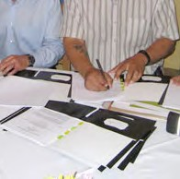
LEGAL MATTERS
Primary Numbers: 2200 – 2499

Section 6 covers subjects of a legal nature, such as accidents, agreements and contracts, claims and litigation. Also includes risk management and insurance. This section also includes governance functions, such as elections, meetings of chief and council, the legislature, laws and bylaws.

PRIMARY NUMBERS AND PRIMARY SUBJECTS

2210 Governance and Legal Matters - General

2220 Accidents

2240 Agreements and Contracts - General
2250 - Land Sale/Option Agreements
2260 - Government Protocols and Cost Sharing Agreements
2270 - Contracts

2300 Band Council Resolutions and Bylaws

2320 Chief and Council - General
2330 - Committees
2340 - Meetings
2350 - Meetings -In Camera (Closed)

2370 Elections

2400 Incorporations and Annual Filings

2420 Information and Privacy

2430 Insurance Claims

2440 Leases

2450 Legal Opinions

2460 Litigation

2470 Risk Management and Insurance

A SA FD
2210 GOVERNANCE AND LEGAL MATTERS – GENERAL

Includes records relating to matters of general legal and membership concerns to the First Nation organization, which are not found elsewhere in this section.

-01 General CY + 1 6y D

2220 ACCIDENTS

Includes records relating to accidents involving property or personnel, and includes policies, procedures, reports, investigations and settlements. For claims made against or by the First Nation organization, see primary 2360.

-01 General CY + 1 6y D
-20 Incident files, by name and date SO* 6y D
(*SO = settlements of claim and expiry of limitation period)

2240 AGREEMENTS AND CONTRACTS – GENERAL

Includes records of a general nature relating to financial and other arrangements entered into by the First Nation organization with other parties, public and private. For land sale/option agreements, see primary 2260. For contracts, see primary 2300. For easements and rights of way, see primary 3440. For leases, see primary 2380. For restrictive covenants, see primary 3850.

-01 General CY + 1 6y D
-02 Agreements register SO* nil P
(*SO = until updated)
-20 Agreements, by date and topic SO* nil P
(*SO = until expired)

2250 AGREEMENTS AND CONTRACTS – LAND SALE/OPTION AGREEMENTS

Includes records relating to the sale and purchase of land by the First Nation organization.

-01 General CY + 1 6y D
-20 Agreements, by address, name of signatories SO* 7y P
(*SO = expiry, life of agreement)

2260 AGREEMENTS AND CONTRACTS – GOVERNMENT PROTOCOLS AND COST-SHARING AGREEMENTS

Includes records relating to agreements and arrangements made between the First Nation organization and other levels of government. Includes all original documentation and relating correspondence. Copies of the agreements and working documentation may be placed with the appropriate subject file.

-01 General CY+1 6y D
-20 Agreements, by name of agency and date SO* nil D
(*SO = until completion of term of agreement)

A SA FD

2280 AGREEMENTS AND CONTRACTS – CONTRACTS

Includes records relating to contract administration by the First Nation organization, including actual contracts of various types relating to personal service, equipment, developments, etc.

-01 General CY + 1 6y D
-20 Contracts, by type and name SO* 7y D
(*SO = completion, life of equipment)

2300 BAND COUNCIL RESOLUTIONS AND BYLAWS

Includes records relating to the creation and enactment of specific First Nation organization council resolutions and bylaws.

-01 General CY + 1 6y D
-02 Proposed Bylaws CY + 1 6y P
-20 Individual Band Council Resolutions (BCRs), listed numerically SO* nil P
-30 Individual Bylaws, listed numerically SO* nil P
(*SO = until repealed)
-50 Repealed or dormant BCRs/Bylaws P

2320 CHIEF AND COUNCIL – GENERAL

Includes records of a general nature relating to the First Nation organization governing body (the Chief and Council) which do not appear in other relating subject areas. For committees of Chief and Council, see primary 0350. For meetings of Chief and Council, see primary 0370.

-01 General CY + 2 5y P

2330 CHIEF AND COUNCIL – COMMITTEES

Includes records relating to the establishment, organization and functions of the committees of the Chief and Council. Agendas, minutes, lists of appointments, reports and general information will be included.

-01 General CY + 2 5y P
-20 Committees CY + 2 5y P
- Social Development

2340 CHIEF AND COUNCIL – MEETINGS

Includes the records of the meetings of the Chief and Council, including agenda packages, minutes, reports and other information from the meetings of Chief and Council. Keep meeting records together by date, and subdivide into folders as necessary.

-01 General CY + 2 5y P
-20 Meetings, by date
-01 Agenda CY + 2 5y D
-02 Minutes CY + 2 5y P
-03 Reports CY + 2 5y P
-04 Resolutions CY + 2 5y P

A SA FD

2350 CHIEF AND COUNCIL – MEETINGS – IN CAMERA (CLOSED)

Includes the records of the in camera (closed) meetings of Chief and Council, including agenda packages, minutes, reports and other information from the meetings of Chief and Council. Keep meeting records together by date, and subdivide into folders as necessary.

-01 General CY + 2 5y P
-20 Meetings, by date
-01 Agenda CY + 2 5y D
-02 Minutes CY + 2 5y P
-03 Reports CY + 2 5y P
-04 Resolutions CY + 2 5y P

2370 ELECTIONS

Includes records relating to the conduct of elections including voter registration, polls, results, etc.

-01 General CY + 2 5y P
-02 Voters list SO* nil P
(*SO = after election is complete)
-03 Statistics/results, by year CY + 2 5y P
-04 Information from other jurisdictions CY + 2 5y D
-20 Elections, by date CY + 2 5y P

For a further breakdown within an individual election, use:
-01 General
-02 Candidates
-03 Referenda
-04 Advertising
-05 Voting divisions/places
-06 Staff
-07 Equipment and supplies
-08 Training
-09 Advance voter registration
-10 Special voting opportunities (advance, mail in, mobile)
-11 Campaign financing disclosure statements

2400 INCORPORATIONS AND ANNUAL FILINGS

Includes records relating to the establishment, incorporation, letters patent and other documentation associated with the establishment and annual filings of corporations established by the First Nation organization. For the operational functions and projects of the corporations, see the specific subject heading in Section 20 – Economic Development Corporations and Activities.

-01 General CY + 1 6y D
-20 Individual corporations, by name SO* 6y P
(*SO = until corporation is dissolved

A SA FD

2420 INFORMATION AND PRIVACY

Includes records relating to the administration and management of access to information and privacy issues, including the operation of the Information Room

-01 General CY + 1 6y D
-20 Access requests CY + 1 6y D
-30 Privacy protection requests (PIB) CY + 1 6y D
-50 Appeals SO* nil P
(*SO = until appeal is complete)
(PIB = Personal Information Bank)

2430 INSURANCE CLAIMS

Includes records relating to claims by and against the First Nation organization, including motor vehicle damage claims and property and personal damage claims.

-01 General CY + 1 6y D
-20 Claims case files SO* + 1 6y D
(*SO = expiry of limitation period)

2440 LEASES

Includes records relating to leases to which the First Nation organization is a party.

-01 General CY + 1 6y nil
-20 Leases, by name and address SO* nil P
(*SO = expiry of lease)

2450 LEGAL OPINIONS

Includes the collection of legal memoranda that are prepared and/or received by First Nation organization staff on a variety of legal issues and legislation.

-01 General CY + 1 6y P
-02 Index of legal opinions SO* nil P
(*SO = until updated)
-20 Opinions/memos by subject, author SO* nil P
(*SO = upon completion)

2460 LITIGATION

Includes records of litigation instigated by or against the First Nation organization.

-01 General CY + 1 6y P
-02 Index of litigation SO* nil P
(*SO = until updated)
-20 Cases, by daye and name of appellant SO* nil P
(*SO = upon completion)
A SA FD

2470 RISK MANAGEMENT AND INSURANCE

Includes records relating to risk management and insurance, including insurance coverage, agents and management of the insurance function. For claims, see primary 2300.

-01 General CY + 1 6y D
-20 Policies, by type and name of carrier SO* 6y D
(*SO = upon expiry and settlement of outstanding claims)

SECTION 7: PERSONNEL
Primary Numbers: 2500 – 2999

Self-Governance

Section 7 covers subjects relating to the employees and personnel functions of the organization. These subjects include attendance, establishment, leave, holidays, promotions, training, labour relations and negotiations, etc. For subjects relating to administration of salaries, wages and benefits see Section 5 - Finance.

PRIMARY NUMBERS AND PRIMARY SUBJECTS

2510 Personnel – General

2520 Accidents and Injuries

2530 Attendance Records

2550 Benefits – General

2560 Classifications - General

2590 Employees - General
2600 - Current
2620 - Terminated

2630 Employment Programs

2640 Health and Safety

2650 Hours of Work and Overtime

2660 Labour Relations

2720 Leave Management

2730 Performance Planning and Review

2735 Personnel Planning

2750 Retirements and Pre-retirements

2760 Separations and Layoffs

2770 Staffing - General
2780 - Applications
2790 - Compensations

2800 Training Development - General
2810 - Courses

2810 Volunteers

A SA FD
2510 PERSONNEL – GENERAL

Includes records relating to the general administration of personnel management activities which are not found elsewhere in this section.

-01 General CY + 1 6y D

2520 ACCIDENTS AND INJURIES?

Includes records relating to employee accidents and personal injuries as a direct result of work duties and to claims with the Workers' Compensation Board (WCB). Includes records relating to first aid, investigations confirming hazardous substance symptoms, asbestos-containing materials, corrective actions to control fibre release, cytotoxic drugs (where used), hearing tests and radiations surveys (where required to be conducted).

-01 General CY + 1 8y D
-02 WCB claim cost statements CY + 1 8y D
-03 WCB inspection reports – outside CY + 1 8y D
-04 WCB inspection reports – inside CY + 1 8y D
-05 WCB hearing tests SO* 1y D
(*SO = when employment terminates)
-06 WCB re-employment CY + 1 8y D
-07 WCB experience rates CY + 1 8y D
-08 WCB audits CY + 1 8y D
-20 Non-compensable accidents and injuries – first aid records CY + 1 2y D
-30 All other WCb claims CY + 1 8y D

2530 ATTENDANCE RECORDS

Includes records relating to the administration of attendance: time and attendance reports, various types of leave, etc. Note: the hours worked by an employee on each day, regardless of whether the employee is paid on an hourly or other basis, constitute a part of the employee payroll record, and will be retained as part of the individual payroll record in primary 1920.

-01 General CY + 1 6y D
-20 Attendance records, by work group, date CY + 1 6y SO*
(*SO = upon completion of all requirements)

2550 BENEFITS – GENERAL

Includes records relating to the administration of employee benefits, including Canada Pension Plan, group life insurance, extended health and dental, medical, pension, etc. For records relating to the issuance of pay, see primary 1920. See Legal Citation number 20, Appendix 2.

-01 General CY + 1 6y D
-20 Benefits, by type SO* nil D
(*SO = until benefit ceases and all claims are settled)

A SA FD

2560 CLASSIFICATION – GENERAL

Includes records relating to specifications to provide guidance in evaluating positions and responsibilities, classification of positions and employees, job descriptions, class specifications, etc. Some positions and salaries based on Aboriginal Financial Officers Association of Canada (AFOA).

-01 General CY + 1 6y D
-02 Job descriptions SO* nil P
(*SO = until replaced)

2590 EMPLOYEES – GENERAL

Includes records of a general nature relating to employees, including the requirements and procedures for criminal records checks. (Note: individual employee criminal records checks are filed within employee records.)

-01 General CY + 1 6y D
-02 Criminal record checks SO* nil D
(*SO = until updated)

2600 EMPLOYEES – CURRENT

Includes the master record on individual employees: personal data, resume, appraisals and evaluations, training, commendations, discipline, health examinations, etc. For terminated employees, see primary 2620. For pay records, see primary 1920.

-01 General CY + 1 6y D
-20 Employee files, alpha by name (PIB) SO* nil P
(*SO = until termination; once terminated, file should be moved to primary 2620)
(*Personal Information Bank)

2620 EMPLOYEES – TERMINATED

Includes records of individual terminated employees. Terminated includes resignation, retirement, dismissal, layoff, etc.

-01 General CY + 1 6y D
-20 Terminated employee files, alpha by name SO* nil P

2630 EMPLOYMENT PROGRAMS

Includes records relating to employment programs including the summer student program.

-01 General CY + 1 6y D
-20 Summer programs, by name SO* nil P
(*SO = until program is completed)

A SA FD

2640 HEALTH AND SAFETY

Includes records relating to the administration of health and safety programs: first aid, occupational health, smoking in the workplace, accident prevention, and asbestos investigation. Includes Workplace Hazardous Material Information System (WHMIS). For accidents and records of injury, see primary 2520. For protective clothing, see primary 1060. For building safety programs (fire and earthquake), see primary 0710.

-01 General CY + 1 6y D
-02 Safety committee meetings CY + 1 1y D
-20 Program, by name CY + 1 2y SR*
(*SR = WHMIS records are permanent, for other records retain policy information and destroy routine information. Retain testing records according to Occupational Health and Safety requirements for various types of tests.)

2650 HOURS OF WORK AND OVERTIME

Includes records relating to hours of work, flexible hours, time off for special occasions, early closings, overtime etc. For individual attendance records, see primary 2530.

-01 General CY + 1 6y D
-02 Overtime SO* nil D
-03 Non-standard hours SO* nil D
(*SO = until replaced)

2660 LABOUR RELATIONS

Includes records relating to employee/management relations and services.

-01 General CY + 1 6y D

2720 LEAVE MANAGEMENT

Includes records relating to the administration of leave management, including vacation, sick leave, paid holidays, unpaid leave, compassionate leave, bereavement leave, banked time, annual leave etc. For individual attendance records, see primary 2530.

-01 General CY + 1 6y D

2730 PERFORMANCE PLANNING AND REVIEW

Includes records relating to the administration of performance planning and review programs, work plans, performance appraisals, etc.

-01 General CY + 1 6y D

A SA FD

2735 PERSONNEL PLANNING

Includes records relating to current and projected staffing requirements, personnel resource requirements, forecasts and estimates, etc.

-01 General CY + 1 6y D

2750 RETIREMENTS AND PRE-RETIREMENTS

Includes records relating to the retirement of employees, and the calculation and recording of pre-retirement benefits. For specific employee files, see primaries 2600 and 2620.

-01 General CY + 1 6y D

2760 SEPARATIONS AND LAYOFFS

Includes records relating to the layoff or separation of employees other than through retirement. For individual employee files, see primary 2600. For retirements, see primary 2750.

-01 General CY + 1 6y D

2770 STAFFING – GENERAL

Includes records which are not found elsewhere in the staffing block which relate to the staffing of positions.

-01 General CY + 1 6y D

2780 STAFFING – APPLICATIONS

Includes records relating to the receipt of applications for employment, unsolicited offers of service, resumes, etc. (Records of successful applicants are transferred to primary 2600.)

-01 General CY + 1 6y D
-20 Application, by name CY*
(*Note: Retain one year from date of receipt to comply with Privacy Act (ATIP).

2790 STAFFING – COMPETITIONS

Includes records relating to competitions, short lists of candidates, interview format and questions, results, offer and rejection letters.

-01 General CY + 1 6y D
-20 Competitions, by position name and date CY + 1 1y D

A SA FD

2800 TRAINING AND DEVELOPMENT – GENERAL

Includes records relating to the general administration of training and development activities and functions. For specific training programs, see primary 2810.

-01 General CY + 1 1y D
-02 Employee orientation SO* nil P
(*SO = when updated)
-03 Educational leave CY 1y D

2810 TRAINING AND DEVELOPMENT – COURSES

Includes records relating to courses, types of courses, course content and brochures, attendance records and evaluation reports for all forms of staff training. For conferences, seminars and symposia, see primary 0390.

-01 General CY + 1 2y D
-20 Courses (individual files) CY + 1 2y D
-25 Courses (evaluation files) SO* nil P
-30 Courses (attendance) SO* nil P
(*SO = until termination)

2830 VOLUNTEERS

Includes records relating to persons providing volunteer services to the First Nation organization, the services so provided and to the requirements and conditions of the voluntary service. Elected officials (Councilors) and Fire Department volunteers are included in this subject area.

-01 General CY + 1 6y D
-02 Accidents, liability insurance SO* nil P
-03 Training and orientation CY + 1 2y D
-04 Schedules CY + 1 1y D
-20 Current volunteer records, by name) SO* nil P
(*SO = until termination, as with employee files)

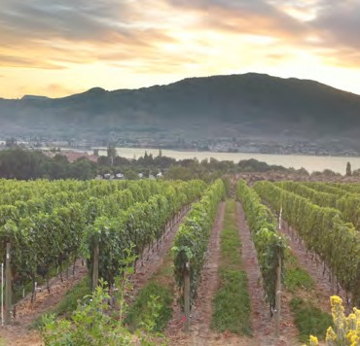
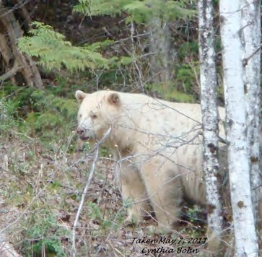
SECTION 8: LANDS

Primary Numbers: 3000 - 3999

Section 8 includes records relating to the processes of land management and land development within the First Nation organization area. Includes design and mapping, specific types of development, environmental management, land claims and referrals.
For records relating to forestry and natural resources, see Section 13 – Forestry Management.

PRIMARY NUMBERS AND PRIMARY SUBJECTS

3010 Land Administration - General

3120 Crown Land

3180 Demographic Data

3200 Design and Mapping

3240 Development - General
3280 - Commercial/Industrial
3300 - Residential
3320 - Waterfront

3400 Development Permits

3440 Easements and Rights of Way

3500 Environmental Management - General

3600 Land - Preliminary Review

3620 Land Claims

3700 Land Records

3800 Referrals

3850 Restrictive Covenants

3900 Zoning and Rezoning

A SA FD
3010 LAND ADMINISTRATION – GENERAL

Includes records relating to the administration of land relating matters which are not found elsewhere in this section. Land administration covers the management of all land-relating matters within the First Nation organization jurisdiction.

-01 General CY + 1 6y D

3120 CROWN LAND

Includes records relating to crown land in or adjacent to the First Nation organization jurisdiction.

-01 General CY + 1 6y D
-20 Individual crown parcels, by number SO* nil P
(*SO = until no longer crown land)

3180 DEMOGRAPHIC DATA

Includes records relating to demographic data and statistics about the First Nation organization jurisdiction.

-01 General CY + 1 6y D
-02 Census data (Statistics Canada) SO nil P

3200 DESIGN AND MAPPING

Includes records relating to design and survey services and procedures, in house design, design standards and specifications. Also includes GIS mapping, aerial photographs and topographical maps.

-01 General CY + 1 6y D
-02 Design Standards and specifications SO* 6y P
(*SO = until updated or replaced)
-20 Mapping projects SO* nil P
- Fire Protection Mapping

3240 DEVELOPMENT – GENERAL

Includes records relating to the general development activities, functions and proposals for the community.

-01 General CY + 1 6y D

3280 DEVELOPMENT – COMMERCIAL/INDUSTRIAL

Includes general records relating to commercial and/or industrial development of properties.

-01 General CY + 1 6y D
-20 Projects, by name SO* nil P
(*SO = until completed)

A SA FD

3300 DEVELOPMENT – RESIDENTIAL

Includes general records relating to residential development of properties.

-01 General CY + 1 6y D
-20 Projects, by name SO* nil P
(*SO = until completed)

3320 DEVELOPMENT – WATERFRONT

Includes general records relating to planning and development of waterfront properties.

-01 General CY + 1 6y D
-20 Projects, by name SO* nil P
(*SO = until completed)

3400 DEVELOPMENT PERMITS

Includes records relating to the application, issuance and management of development permits and variance permits within the First Nation organization area jurisdiction.

-01 General CY + 1 6y D
-20 Permits (individual) arranged by year and permit number SO* + 1 6y P
(*SO = until completion of permit)
-30 Development variance permits arranged by year and permit SO + 1 6y P
number

3440 EASEMENTS AND RIGHTS OF WAY

Includes records relating to the granting of easements and rights of way.

-01 General CY + 1 6y D
-20 Easements, by address SO* nil P
-30 Rights of way, by address SO* nil P
(*SO = filing of quit claim, otherwise permanent)

3500 ENVIRONMENTAL MANAGEMENT – GENERAL

Includes records relating to environmental control issues, assessments, functions and activities. Also includes environmental management issues, by type (e.g. air quality control, pesticides and herbicides, oil spills, gas spills, etc.

-01 General CY + 1 6y D
-02 Environmental Sustainability Plan SO nil P
-03 Ecosystems CY + 1 6y P
-20 Incidents, by date, location CY + 1 6y P
-30 Environmental issues, by type CY + 1 6y P
- Species at Risk
- Archeological sites

A SA FD

3600 LAND – PRELIMINARY REVIEW

Includes records relating to application and analysis of proposed changes for any community development, such as building, rezoning, sub-division, etc.

-01 General CY + 1 6y D
-20 Projects, by title, applicant, date SO* nil P
(*SO = until completion of review; approved reviews move to project file)

3620 LAND CLAIMS

Includes records relating to land claims, including specific claims.

-01 General CY + 1 6y D
-20 Specific claims, by name, location SO* 6y P
(*SO = upon expiry and settlement of outstanding claims)

3700 LAND RECORDS

Includes records relating to individual lots within the First Nation organization jurisdiction. Also includes information from the INAC Land Registry.

-01 General CY + 1 6y D
-02 Land records, by lot number

3800 REFERRALS

Includes records relating to referrals from the Provincial Government of British Columbia, Regional District and other parties. This primary subject includes all referrals to the First Nation organization and is retained after the completed referral). For the forestry component of referrals, see primary 6250.

-01 General CY + 1 6y D
-20 Referrals, by number SO* nil P
(*SO = until processed)

3850 RESTRICTIVE COVENANTS

Includes records relating to the granting of restrictive covenants.

-01 General CY + 1 6y D
-20 Restrictive covenants SO* nil P
(*SO = upon completion)

3900 ZONING AND REZONING -?

Includes records relating to the application and process for zoning and rezoning properties within the First Nation organization jurisdiction.

-01 General CY + 1 6y D
-20 Applications by year, application SO*+ 1 6y P
(*SO = when completed)

SECTION 9: HOUSING

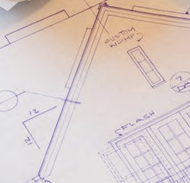
Primary Numbers: 4000 – 4599

Section 9 includes subjects relating to housing in the First Nation organization community. This includes the housing management functions, including housing allocation, housing maintenance and repair, and rent management, new house construction, social and rental housing, mortgages and funding of housing, tenants, including applications and lease agreements.

PRIMARY NUMBERS AND PRIMARY SUBJECTS

4000 Housing - General

4020 Building Regulations - General
4030 - Building Permits and Inspections

4050 Contractors

4100 Housing - Applications and Allocations
4120 - Maintenance and Repairs

4150 Housing Projects

4200 Mortgages

4210 Mortgage Funders

4300 Properties/Houses - General
4310 - Individual

4400 Rental Housing

4300 Social Housing

4500 Subdivisions and Subdivision Control

A SA FD
4000 HOUSING – GENERAL

Includes records of a general nature relating to housing matters within the First Nation organization jurisdiction not found elsewhere in this section.

-01 General CY + 1 6y D

4020 BUILDING REGULATIONS – GENERAL

Includes records of a general nature relating to the regulation of buildings in the First Nation organization jurisdiction.

-01 General CY + 1 6y D

4030 BUILDING REGULATIONS – BUILDING PERMITS AND INSPECTIONS

Includes records relating to the applications for construction of buildings, all inspections and approvals of building within the jurisdiction of the First Nation organization, for issuance of permits. This includes commercial as well as residential developments.

NOTE: There may be separate primaries for each type of permit, if the volume and method of work requires the splitting of information.

-01 General CY + 1 6y D
-20 Individual building arranged by street address SO* nil P
(*SO = life of the buildings)

4050 CONTRACTORS

Includes records relating to the contractors supplying services to the First Nation organization housing functions, including new construction and repairs.

-01 General CY + 1 6y D
-20 Contractors, by name of company SO* nil P
(*SO = until contract is completed and all warranties are finished)

4100 HOUSING APPLICATIONS AND ALLOCATIONS

Includes records relating to the housing applications, including the housing applications process, including administration and allocation of housing to qualified applicants.

-01 General CY + 1 6y D
-20 Applications, by name SO* + 1 6y P
(*SO = until housing is provided)

A SA FD

4120 HOUSING MAINTENANCE, REPAIRS AND RENOVATIONS

Includes records relating to the maintenance, repairs and renovations of housing. Includes mold remediation projects.

-01 General CY + 1 6y D
-20 Maintenance projects, by name SO* + 1 6y P
(*SO = until housing is provided)

4150 HOUSING PROJECTS

Includes records relating to housing projects, including capital works and new construction.

-01 General CY + 1 6y D
-20 Projects, by name SO* + 1 6y P
(*SO = until project is complete)

4200 MORTGAGES

Includes records relating to the mortgages for single family dwellings that are secured by First Nation organization members.

-01 General CY + 1 6y D
-20 Mortgages, by name of mortgage holder SO* + 1 6y P
(*SO = until paid and all warranties expire)

4210 MORTGAGE FUNDERS

Includes records relating to the organizations providing mortgage funding for First Nation organization members.

-01 General CY + 1 6y D
-20 Mortgage funders, by name SO* + 1 6y P
(*SO = until paid and all warranties expire)

4300 PROPERTIES/HOUSES – GENERAL

Includes records of a general nature relating to the properties within the First Nation organization jurisdiction.

-01 General CY + 1 6y D

4310 PROPERTIES/HOUSES – INDIVIDUAL

Includes individual records relating to the development, zoning, dwelling and other pertinent information on all lands within the First Nation organization. (These records may constitute the master property records for all properties within the First Nation organization jurisdiction.)

-01 General CY + 1 6y D
-20 Individual properties, by lot number SO* nil P
(*SO= until records are updated or modified)

A SA FD

4400 RENTAL HOUSING

Includes records relating to the development and operation of rental housing within the First Nation organization jurisdiction. For each rental housing unit, records include applications for accommodation and lease agreements.

-01 General CY + 1 6y D
-20 Individual properties, by lot number SO* nil D
(*SO = until records are updated or modified)

4430 SOCIAL HOUSING

Includes records relating to the development and operation of social housing within the First Nation organization jurisdiction. For each social housing unit, records include applications for accommodation and lease agreements.

-01 General CY + 1 6y D
-20 Individual properties, by lot number SO* nil D
(*SO = until records are updated or modified)

4500 SUBDIVISIONS AND SUBDIVISION CONTROL

Includes individual records relating to the application, inspection and approval of subdivisions within the First Nation organization jurisdiction.

-01 General CY + 1 6y D
-20 Individual properties, by year of application SO* 6y P
(*SO = when completed)

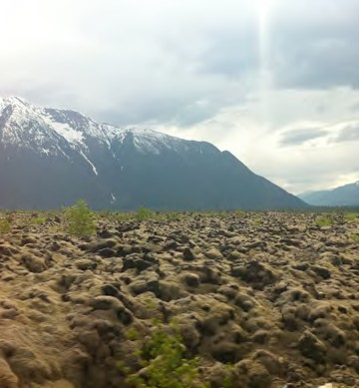
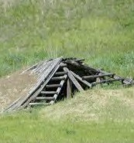
SECTION 10: SOCIAL DEVELOPMENT

Primary Numbers: 4600 – 5199

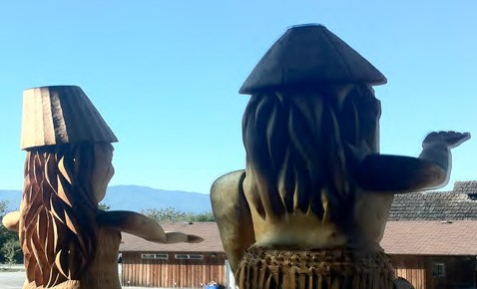

Section 10 includes subjects relating to the general community services provided, including social and disability assistance, family preservation, special needs groups and youth services.

PRIMARY NUMBERS AND PRIMARY SUBJECTS

4600 Social Development - General
4650 - Child Out of Parental Home Program
4660 - Family Preservation
4670 - Family Violence
4680 - In Home Care

4700 Community Care

4760 Family Preservation

4800 Social Assistance - General
4860 - Income Assistance
4880 - Disability Assistance

5000 Special Needs Groups

5100 Youth Centre

5160 Youth Services

A SA FD
4600 SOCIAL DEVELOPMENT – GENERAL

Includes records relating to the provision of social services to the community which are not found elsewhere in this section.

-01 General CY + 1 6y D

4640 CHILD AND FAMILY SERVICES – GENERAL

Includes records relating to the provision of family support services in the community.

-01 General CY + 1 6y D

4650 CHILD AND FAMILY SERVICES PROGRAMS – CHILD OUT OF PARENTAL HOME

Includes records relating to the provision of support services and benefits offered to non-custodial parents in the community.

-01 General CY + 1 6y D
-02 Custody benefits CY + 1 6y D
-20 Clients, by name SO* nil P
(*SO = until no longer in program)

4660 CHILD AND FAMILY SERVICES PROGRAMS – FAMILY PRESERVATION

Includes records relating to the Family Preservation Program.

-01 General CY + 1 6y D
-20 Clients, by name SO* nil P
(*SO = until no longer in program)

4670 CHILD AND FAMILY SERVICES PROGRAMS – FAMILY VIOLENCE

Includes records relating to the Family Violence Program.

-01 General CY + 1 6y D
-20 Clients, by name SO* nil P
(*SO = until no longer in program)

4680 CHILD AND FAMILY SERVICES PROGRAMS – IN HOME CARE

Includes records relating to the In Home Care Program.
-01 General CY + 1 6y D
-20 Clients, by name SO* nil P
(*SO = until no longer in program)

A SA FD

4700 COMMUNITY CARE

Includes records relating to the provision of community care facilities in the community.

-01 General CY + 1 6y D
-20 Facilities, by type, name, location SO* nil D
(*SO = life of facility)

4760 FAMILY PRESERVATION

Includes records relating to the provincially funded Family Preservation Program.

-01 General CY + 1 6y D
-20 Clients, by name SO* nil P
(*SO = until no longer in program)

4800 SOCIAL ASSISTANCE – GENERAL

Includes records relating to the provision of social assistance to members in the community. Includes program training materials.

-01 General CY + 1 6y D
-02 Training materials

4860 SOCIAL ASSISTANCE – INCOME ASSISTANCE

Includes records relating to the provision of income assistance to members in the community.

-01 General CY + 1 6y D
-20 Clients, by name CY + 1 6y D

4880 SOCIAL ASSISTANCE – DISABILITY ASSISTANCE

Includes relating to the provision of disability assistance to members in the community.

-01 General CY + 1 6y D
-20 Clients, by name CY + 1 6y D

5000 SPECIAL NEEDS GROUPS

Includes records relating to the provision of services and programs for physically disabled persons and persons with special needs.

-01 General CY + 1 6y D
-02 Clients, by name CY + 1 6y D
-20 Programs, by name SO* nil SR**
(*SO = completion of program)
(**SR = retain policy information)

A SA FD

5100 YOUTH CENTRE

Includes records relating to the operations and functions of the Youth Centre,

-01 General CY + 1 6y D
-20 Events, by name SO* nil SR**
(*SO = completion of program)
(**SR = retain policy information)

5160 YOUTH SERVICES

Includes records relating to the planning and provision of youth-oriented services and programs.

-01 General CY + 1 6y D
-20 Programs, by name CY + 1 6y SR*
(*SR = retain policy records)

SECTION 11: DAYCARE/CHILDCARE
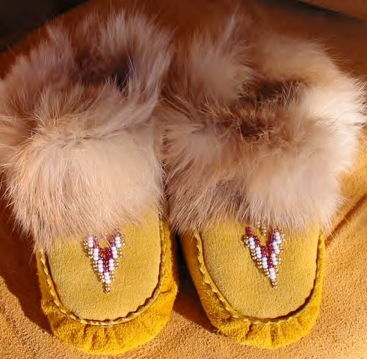
OPERATIONS

Primary Numbers: 5200 - 5499

Section 11 includes subjects relating to the daycare and/or childcare services provided by the First Nation organization. These include the programs, children’s records, and the reports and funding information.

PRIMARY NUMBERS AND PRIMARY SUBJECTS

5210 Daycare Services - General

5220 Daycare Funding

5240 Daycare Licensing

5300 Daycare Services - Programs

A SA FD
5200 DAYCARE SERVICES – GENERAL

Includes records of a general nature relating to the administration, development, operation and maintenance of daycare services within the First Nation organization not found elsewhere in this section. For construction records of daycare/childcare buildings, see Section 2 – Buildings, Facilities and Properties.

-01 General CY + 1 6y D

5220 DAYCARE FUNDING

Includes records relating to organizations providing funding for daycare or childcare of the First Nation organization. Includes subsidies from provincial sources.

-01 General CY + 1 6y D
-02 Subsidies CY + 1 6y D

5240 DAYCARE/CHILD CARE SERVICES – PROGRAMS

Includes records relating to the licensing of daycares.

-01 General CY + 1 6y D
-02 Inspections CY + 6y D
-20 License, by year CY + 1 6y D

5300 DAYCARE/CHILD CARE SERVICES – PROGRAMS

Includes records relating to programs for daycare and child care.

-01 General CY + 1 6y D
-20 Programs, by name SO* 6y D
-30 Preschool children enrolled, by name SO* 6y D
-40 Children, aged 3-5, enrolled, by name SO* 6y D
-50 Infants and toddlers, enrolled, by name SO* 6y D
(*SO = until program is completed)

SECTION 12: EDUCATION AND
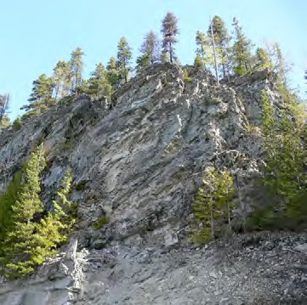
LIFELONG LEARNING

Primary Numbers: 5500 – 5999

Section 12 includes subjects relating to education and lifelong learning in the First Nation organization community, including funding, governance and partners as well as post secondary and continuing adult education programs.

PRIMARY NUMBERS AND PRIMARY SUBJECTS

5510 Education and Life-long Learning -General

5520 Education Funding

5530 Education Governance

5600 Education Partners

5700 Education Programs - Post Secondary
5750 - Post Secondary - Students
5800 - Continuing Education - Adult

A SA FD
5510 EDUCATION AND LIFE LONG LEARNING – GENERAL

Includes records relating to the provision of education and lifelong learning opportunities and services to the community which are not found elsewhere in this section.

-01 General CY + 1 6y D

5520 EDUCATION FUNDING

Includes records relating to the funding of education in the community, including sources of funding, and proposals, agreements and final reports to the various funding agencies.

-01 General CY + 1 6y D
-20 Funding organizations, by name CY + 1 6y P
-INAC
-FNSA

For each organization, create the following folders by year
-01 Proposals
-02 Contribution agreements
-03 Final reports

5530 EDUCATION GOVERNANCE

Includes records relating to the governance of education in the community, including jurisdiction and coordination of educational programs and services, agreements and band council resolutions. Original signed agreements will be found in primary 2280.

-01 General CY + 1 6y D
-02 Jurisdiction CY + 1 6y P
-03 Agreements CY + 1 ^Y P
-04 BCRs CY + 1 6y P
-20 Governing bodies, by name CY + 1 6y P

5600 EDUCATION PARTNERS

Includes records relating to the educational organizations who partner with the First Nation organization to provide educational services and programs.

-01 General CY + 1 6y D
-20 Partners, by name CY + 1 6y D

5700 EDUCATION PROGRAMS – POST SECONDARY

Includes records relating to post secondary education programs offered in the community. Also includes allocations for students from the community attending post-secondary education.

-01 General CY + 1 6y D
-20 Programs, by name, location SO* 6y D
(*SO = until updated or changed)
-50 Education allocations, by name, date SO* 6y D
(*SO = until completion of educational program)

A SA FD

5750 EDUCATION PROGRAMS – POST SECONDARY – STUDENTS

Includes records relating to individual post secondary students including transcripts and educational progress reports.

-01 General CY + 1 6y P
-20 Students, by name, by location SO* nil P
(*SO = until updated or changed)

5800 EDUCATION PROGRAMS – CONTINUING EDCATION – ADULT

Includes records relating to community adult education training programs and courses.

-01 General CY + 1 6y D
-20 Programs and course, by name SO* nil D
(*SO = until updated or changed)

SECTION 13: PUBLIC WORKS AND
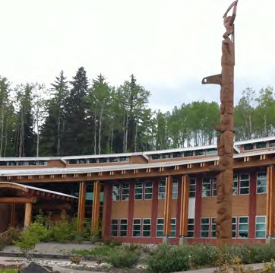
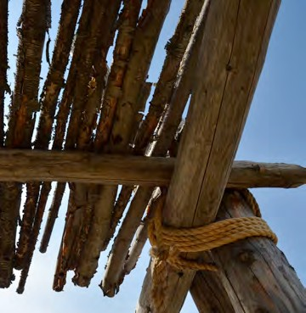
COMMUNITY INFRASTRUCTURE

Primary Numbers: 6000 – 6499

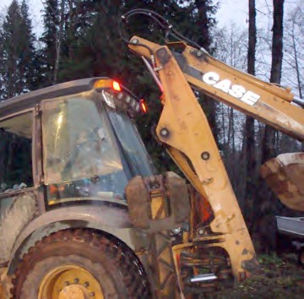

Section 13 includes subjects relating to the engineering, construction and maintenance of First Nation community infrastructure, including streets and roads, water service, septic systems, solid waste removal, etc.

PRIMARY NUMBERS AND PRIMARY SUBJECTS

6010 Public Works and Community Infrastructure - General

6025 Drainage and Flood Control

6100 Inspection and Testing

6130 Public Works Projects

6200 Septic Systems

6250 Solid Waste Disposal

6300 Streets and Roads

6350 Utilities - General

6400 Water Supply and Distribution

A SA FD

6010 PUBLIC WORKS AND COMMUNITY INFRASTRUCTURE – GENERAL

Includes general records relating to public works and community infrastructure services which are not found elsewhere in this section. Complaints about public works services are filed here.

-01 General CY + 1 6y D
-02 Complaints

6025 DRAINAGE AND FLOOD CONTROL

Includes records relating to the control of storm water, drainage, creek and river control, culverts, flood plains and flood damage, etc.

-01 General CY + 1 6y D
-02 Culverts CY + 1 6y P
-03 Creek control, by name SO* nil P
-04 Flood damage, by event CY + 1 6y P
-05 Ditches CY + 1 6y P
-06 Flood control/flood plains CY + 1 6y P
-07 Drainage jobs CY + 1 6y P
(*SO = until modified or updated)

6100 INSPECTION AND TESTING

Includes records relating to the procedures and guidelines for inspecting and testing services for capital works projects, etc.

-01 General CY + 1 6y D

6130 PUBLIC WORKS PROJECTS

Includes records relating to the planning, design and construction of public/capital works projects. Specific project files will include cost estimates, design, project authorization, land acquisition, meetings, reports, design engineering studies, consultants, contract award, purchase orders, etc.

-01 General CY + 1 6y D
-20 Projects, by name SO* nil P
(*SO = upon completion of project)

6200 SEPTIC SYSTEMS

Includes records relating to the administration, management and operation of septic systems.

-01 General CY + 1 6y D
-02 Septic Tanks and fields SO* nil P
(*SO = until modified or updated)

A SA FD

6250 SOLID WASTE DISPOSAL

Includes records relating to solid waste (garbage) collection and disposal, hazardous waste and waste paint. Also includes records relating to recycling of waste materials.

-01 General CY + 1 6y D
-02 Collection CY + 1 6y P
-03 Landfill sites SO* nil P
-04 Illegal dumping of rubbish CY + 1 6y SR*
-05 Hazardous waste CY + 1 6y P
-06 Recycling CY + 1 6y D
-07 Composting CY + 1 6y D
(*SR = retain all policy and program materials)
(*SO = until modified or updated)

6300 STREETS AND ROADS

Includes records relating to the planning, design, construction, operation and maintenance of roads, streets, highways and other public thoroughfares. Includes sidewalks and street lighting.

-01 General CY + 1 6y D
-02 Bridges SO* 6y P
-03 Street lighting SO* 6y P
-04 Closures SO* 6y P
-05 Road allowances SO* 6y P
-06 Highways SO* 6y P
-07 Sidewalks, walkways, and overpasses SO* 6y P
-08 Paving programs SO* 6y P
-09 Snow and ice removal CY + 1 6y D
-10 Roadway maintenance SO* 6y D
-20 Individual roads, alpha by name SO* 6y P
(*SO = until modified or updated)

6350 UTILITIES

Includes records relating to the planning, design, installation, operation, maintenance and repair of utility systems and facilities. For utility fees, see primary 1820.

-01 General CY + 1 6y D
-02 Electrical SO* nil P
-01 General
-02 Pole relocation
-03 Major transmission lines
-03 Telephone SO* nil P
-04 Cablevision SO* nil P
(*SO = until modified or updated)

A SA FD

6400 WATER SUPPLY AND MANAGEMENT

Includes records relating to the planning, design, construction, installation, operation and maintenance of water supply, including surface and ground water supply and distribution systems. For drinking water testing, see primary 6640.

-01 General CY + 1 6y D
-02 Fire hydrants, by location SO* nil P
-03 Water mains SO* nil P
-04 Water connections, by location SO* nil P
-05 Pumping stations SO* nil P
-06 Water consumption CY + 1 6y P
-07 Water pressure SO* nil P
-08 Wells SO* nil P
(*SO = until modified or updated)
(P for all records relating to infrastructure and facilities)

SECTION 14: FORESTRY
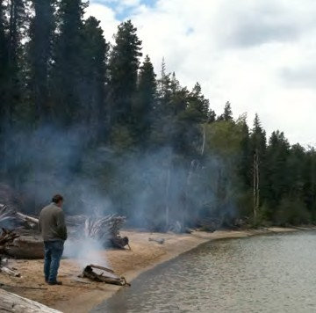
MANAGEMENT

Primary Numbers: 6500 – 6999

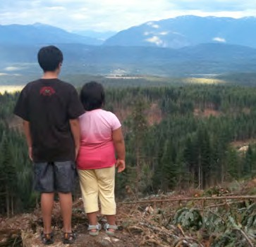

Section 14 includes the subjects relating to the administration and management of forestry.

PRIMARY NUMBERS AND PRIMARY SUBJECTS

6510 Forestry Management - General
6550 - Certification
6600 - Contracts
6700 - Permits
6800 - Plans and Projects
6900 - Mill
6960 - Sales

A SA FD
6510 FORESTRY MANAGEMENT – GENERAL

Includes records relating to the administration, development and management of forestry resources within the First Nation organization jurisdiction.

-01 General CY + 1 6y D
-02 Forestry management issues CY + 1 6y P
-20 Forestry areas, by location CY + 1 6y P

6550 FORESTRY MANAGEMENT – CERTIFICATION

Includes records relating to WorkSafe and Green Certification of forestry operations and employees of the First Nation organization.

-01 General CY + 1 6y D
-02 Green Certification CY + 1 6y P
-03 WorkSafe Certification CY + 1 6y P

6600 FORESTRY MANAGEMENT – CONTRACTS

Includes records relating to contracts for forestry resources of the First Nation organization jurisdiction.

-01 General CY + 1 6y D

6700 FORESTRY MANAGEMENT – PERMITS

Includes records relating to various forestry permits within the First Nation organization jurisdiction. Includes cutting and road permits as well as timber permits issued through INAC.

-01 General CY + 1 6y D
-02 Cutting Permits CY + 1 6y P
-03 Road Permits CY + 1 6y P
-04 Timber Permits – INAC CY + 1 6y _

6800 FORESTRY MANAGEMENT – PLANS AND PROJECTS

Includes records relating to the administration, development and management of forestry plans and projects, including site plans, logging plans, silviculture, forest management plans and salvage – fall and burn projects.

-01 General CY + 1 6y D
-02 Site plans CY + 1 6y D
-03 Logging plans CY + 1 6y D
-04 Silviculture CY + 1 6y D
-05 Forest management plans CY + 1 6y D
-06 Salvage – Fall and Burn projects CY + 1 6y D

A SA FD

6900 FORESTRY MANAGEMENT – MILLS

Includes records relating to the operations and functions of mills operated by the First Nation organization.

-01 General CY + 1 6y D

6960 FORESTRY MANAGEMENT – SALES

Includes records relating to the administration, development and management of forestry resource sales within the First Nation organization jurisdiction.

-01 General CY + 1 6y D

SECTION 15: FISHERIES
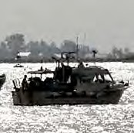
MANAGEMENT

Primary Numbers: 7000 – 7799

This section includes records relating to the management of fisheries, shellfish and watershed resources within First Nations jurisdiction. Subjects include the administration of licenses and permits, the management of the food fish program, the various watershed management programs, the maintenance of the docks and floats, the maintenance of the boats, and the various rivers and creeks.

PRIMARY NUMBERS AND PRIMARY SUBJECTS

7010 Fisheries Management – General

7100 Boats – General
7120 – Individual

7200 Docks and Floats

7300 Food Fish – General
7320 – Coho/Chinook/Chum
7340 – Halibut
7360 – Herring Roe
7380 – Sockeye

7400 Kelp Program

7500 Licensing, Permits

7600 Shellfish Nursery System

7700 Watershed Management
7720 – Individual

A SA FD
7010 FISHERIES MANAGEMENT – GENERAL

Includes records relating to the general administration of fisheries, including shellfish and watershed management activities, which are not found elsewhere in this section.

-01 General CY + 1 6y D

7100 BOATS - GENERAL

Includes records relating to the general administration and operation of boats which are not found elsewhere in this section.

-01 General CY + 1 6y D

7120 BOATS – INDIVIDUAL

Includes records relating to the operation and maintenance of the individual boats in the First Nations fleet.

-01 General SO* nil P
-20 Individual boats, by name SO* nil P
(*SO = when no longer owned)

7200 DOCKS AND FLOATS

Includes records relating to the docks and floats, including operation, maintenance and repairs.

-01 General CY + 1 6y D
-20 Docks, by location SO* + 1 6y D
-30 Floats, by location SO* + 1 6y D
(*SO = until updated or replaced)

7300 FOOD FISH – GENERAL

Includes records of a general nature relating to the food fish programs, including food fish processing.

-01 General CY + 1 6y D
-20 Processing, by year CY + 1 6y D

7320 FOOD FISH – COHO, CHINOOK, CHUM SALMON

Includes records relating to the food fishery, including coho, chinook and chum salmon.

-01 General SO* nil P
-02 Reports SO* nil P
-20 Chinook food fish, by year SO* nil P
-30 Coho food fish, by year SO* nil P

A SA FD

7340 FOOD FISH – HALIBUT

Includes records relating to the halibut food fishery.

-01 General SO* nil P
-02 Reports SO* nil P
-20 Halibut food fish, by year SO* nil P

7360 FOOD FISH – HERRING ROE

Includes records relating to the herring roe food fishery.

-01 General SO* nil P
-02 Reports SO* nil P
-20 Herring roe food fish, by year SO* nil P

7380 FOOD FISH – SOCKEYE

Includes records relating to the herring roe food fishery.

-01 General SO* nil P
-02 Reports SO* nil P
-20 Sockeye food fish, by year SO* nil P

7400 KELP PROGRAM

Includes records relating to the kelp program.

-01 General SO* nil P
-02 Reports SO* nil P
-20 Program, by year

7500 LICENSES AND PERMITS

Includes records relating to fishing licenses and permits.

-01 General CY + 1 6y D
-02 Reports SO* nil D
-20 Permits, by year SO* + 1 10y D
-30 Licenses, by year SO* + 1 6y D

7600 SHELLFISH NURSERY SYSTEM

Includes records relating to the shellfish nursery system.

-01 General SO* nil P
-20 Individual nurseries, by location SO* nil P
(*SO = until company is closed or sold)

A SA FD

7700 WATERSHED MANAGEMENT

Includes records of a general nature relating to the watershed management system, including watershed restoration.

-01 General CY + 1 6y D

7720 WATERSHED MANAGEMENT – INDIVIDUAL

Includes records relating to the individual watershed management systems, including watershed restoration.

-01 General SO* nil P

SECTION 16: HEALTH
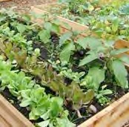
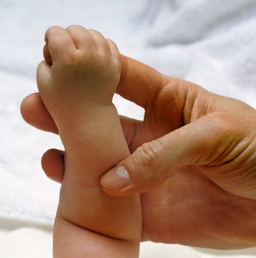
Primary Numbers: 7800 – 8299

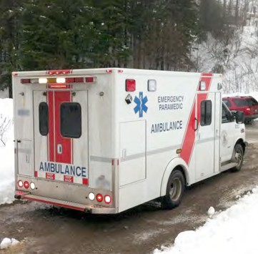

Section 16 includes the subjects relating to the administration and management of health care services with the First Nation organization.

PRIMARY NUMBERS AND PRIMARY SUBJECTS

7810 Health Care - General

7820 Child and Family Health Programs - General
7830 - pre-natal and Post-natal Program
7840 - Infant Development Program
7850 - Outreach

7900 Chronic Disease Program - General
7920 - Individual

7950 Emergency Services - General

7980 Environmental Health - General

8000 Health Care Administration - General
8020 - Non-Insured Health Benefits
8040 - Member Information and Benefits

8100 Home and Community Care Programs - General
8120 - Community Health Care Nurse - General
8130 - Community Health Care Nurse - Immunization Program

8150 Mental Health and Addictions Program - General

8200 Training and Workshops

8220 Youth Programs

A SA FD
7810 HEALTH CARE – GENERAL

Includes records of a general nature relating to the administration, development, operation and maintenance of health care services within the First Nation organization jurisdiction, which are found elsewhere in this section.

-01 General CY + 1 6y D

7820 CHILD AND FAMILY HEALTH PROGRAMS – GENERAL

Includes records relating to the child and family health programs offered through the Health Department of the First Nation organization.

-01 General CY + 1 6y D
-02 Work plan CY + 1 6y D
-03 Budgets and reports CY + 1 6y D

7830 CHILD AND FAMILY HEALTH PROGRAMS – PRE-NATAL & POST-NATAL PROGRAM

Includes records relating to the pre-natal and post-natal programs offered through the Health Department of the First Nation organization.

-01 General CY + 1 6y D
-02 Work plan CY + 1 6y D
-03 Budgets and reports CY + 1 6y D
-20 Participants, by name

7840 CHILD AND FAMILY HEALTH PROGRAMS – INFANT DEVELOPMENT PROGRAM

Includes records relating to the Infant Development Program offered through the Health Department of the First Nation organization.

-01 General CY + 1 6y D
-02 Work plan CY + 1 6y D
-03 Budgets and reports CY + 1 6y D

7850 CHILD AND FAMILY HEALTH PROGRAMS – OUTREACH

Includes records relating to the Outreach Program offered through the Health Department of the First Nation organization.

-01 General CY + 1 6y D

7900 CHRONIC DISEASE PROGRAMS – GENERAL

Includes records relating to the administration and operation of chronic disease programs including program proposals and funding.

-01 General CY + 1 6y D

A SA FD

7920 CHRONIC DISEASE PROGRAMS – INDIVIDUAL

Includes records relating to chronic disease programs such as diabetes education, nutrition management, healthy heart and obesity management.

-01 General CY + 1 6y D
-20 Chronic disease programs, by name SO* 6y D
- Diabetes
- Nutrition
- Healthy Heart
- Obesity
(*SO = when program ceases)

7950 EMERGENCY SERVICES – GENERAL

Includes records relating to emergency service plans coordinated by the Health Department of the First Nation organization.

-01 General CY + 1 6y D
-20 Pandemic Plan SO* 6y D
(*SO = when updated)

7980 ENVIRONMENTAL HEALTH – GENERAL

Includes records relating to the administration, development, operation and maintenance of environmental health issues such as drinking water testing and Healthy Home Assessments for mould.

-01 General CY + 1 6y D
-20 Programs, by name SO* 6y D
(*SO = until completed)

8000 HEALTH CARE ADMINISTRATION – GENERAL

Includes records relating to the administration, development, operation and maintenance of health care programs, including local clinics, operated by the Health Department of the First Nation organization, or delivered as services by contract agencies to the First Nation organization.

-01 General CY + 1 6y D

8020 HEALTH CARE ADMINISTRATION – NON-INSURED HEALTH BENEFITS (NIHB)

Includes records relating to the non-insured health benefits program, including patient travel and data entry into electronic system. Also includes quarterly reports to Health Canada.

-01 General CY + 1 6y D
-20 Reports, by month

A SA FD

8040 HEALTH CARE ADMINISTRATION – MEMBER INFORMATION AND BENEFITS

Includes records relating to First Nation organization members’ personal health information including benefits, Care cards, prescriptions and relating health information. Filed alphabetically by member name.

-01 General CY + 1 6y D
-20 First Nation organization members, by name SO* nil P
(*SO = until updated)

8100 HOME AND COMMUNITY CARE PROGRAMS – GENERAL

Includes records relating to the home and community care programs offered by the Health Department of the First Nation organization.

-01 General CY + 1 6y D

8120 HOME AND COMMUNITY CARE PROGRAMS – COMMUNITY HEALTH NURSE - GENERAL

Includes records relating to the functions of the community health nurse, including assessments for Extended Care, TB Testing, and Homemakers Program.

-01 General CY + 1 6y SR
-02 Work plan CY + 1 6y D
-03 Budgets and reports CY + 1 6y D
-20 Home and Community Care Program, by name CY + 1 6y D
- Assessments for Extended Care
- TB Testing
- Homemakers

8130 HOME AND COMMUNITY CARE PROGRAMS – COMMUNITY HEALTH NURSE – IMMUNIZATION PROGRAM

Includes records relating to the immunization programs operated by the community health nurse through the Home and Community Care Program.

-01 General CY + 1 6y D
-02 Work plan CY + 1 6y D
-03 Budgets and reports CY + 1 6y D
-20 Immunization programs, by name and date

8150 MENTAL HEALTH AND ADDICTIONS PROGRAM – GENERAL

Includes records relating to the Mental Health and Addictions Program offered by the Health Department of the First Nation organization.

-01 General CY + 1 6y D
-20 Programs, by name CY + 1 6y D
-30 Clients, by name CY + 1 6y D
-40 Treatment centres, by name CY +1 6y D

A SA FD

8200 TRAINING AND WORKSHOPS

Includes records relating to training and workshops offered to the staff of the Health Department as well as members of the band.

-01 General CY + 1 6y D

8250 YOUTH PROGRAMS

Includes records relating to administration and operation of youth programs offered through the Health Department of the First Nation organization. Also includes individual program records, such as Pulling Together and Senior Leadership.

-01 General CY + 1 6y D
-20 Programs, by name

SECTION 17: MEMBERSHIP/
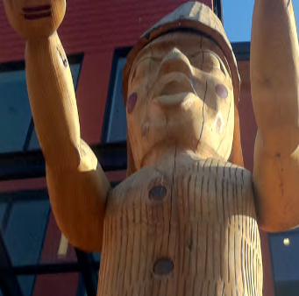
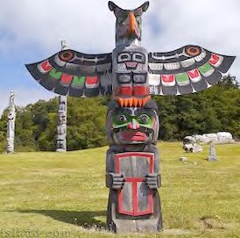
CITIZENSHIP

Primary Numbers: 8300 - 8699

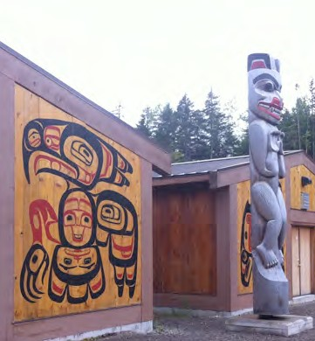

Section 17 includes subjects relating to Membership/Citizenship of the First Nation organization.

PRIMARY NUMBERS AND PRIMARY SUBJECTS

8320 Membership – General
8400 – Applications
8440 – Members

A SA FD
8320 MEMBERSHIP – GENERAL

Includes records relating to the general membership matters which are not found elsewhere in this section.

-01 General CY + 1 6y D

8400 MEMBERSHIP – APPLICATIONS

Includes records relating to the applications for membership in the First Nation organization. Includes application forms and individual applications.

-01 General CY + 1 6y D
-02 Application forms SO* nil D
-20 Applications, by last name of applicant SO** nil P
(*SO = until revised)
(**SO = until accepted or rejected)

8440 MEMBERSHIP – MEMBERS

Includes records relating to the current members of the First Nation organization. Includes the member registry as well as records of individual members. For individual members, each record includes application, birth certificate other identification and supporting documents. Upon death and receipt of the death certificate, active member records become deceased member records.

-01 General CY + 1 6y D
-02 Member registry SO* nil P
-03 Status cards SO* nil P
-20 Individual members, A-Z by last name SO** nil P
-30 Deceased members, A-Z by last name SO*** nil P
(*SO = until updated)
(**SO = until death)
(***SO = when death certificate is received)

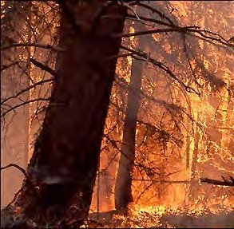
SECTION 18: PROTECTIVE SERVICES

Primary Numbers: 8500 – 8999

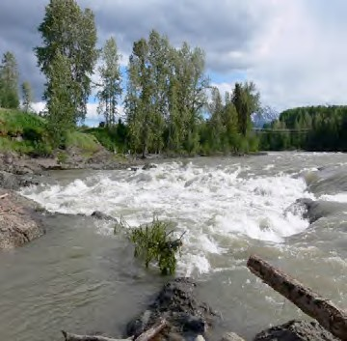

Section 18 includes subjects relating to the protective services provided by the First Nation organization. Emergency programs, fire protection and police protection are included in this section.

PRIMARY NUMBERS AND PRIMARY SUBJECTS

8510 Protective Services – General

8600 Ambulance Services

8630 Emergency Measures - General

8700 Fire Protection - General
8780 - Volunteer Fire Department

8900 Police Services - General
8920 - Issues
8940 - Community Relations

A SA FD

8510 PROTECTIVE SERVICES – GENERAL

Includes records of a general nature relating to the protection of persons in the First Nation organization jurisdiction, which are not found elsewhere in this section.

-01 General CY + 1 6y D

8600 AMBULANCE SERVICES

Includes records relating to the monitoring and liaison of ambulance services/Lifeboat Services with the First Nation organization.

-01 General CY + 1 6y D

8630 EMERGENCY MEASURES – GENERAL

Includes records relating to policies and plans for provision of assistance in emergency situations, for plans for the continuation of operations of the First Nation organization in case of emergency, civil defense planning actions and precautions, etc.

-01 General CY + 1 6y D
-02 Provincial SO P
-01 General
-02 Provincial Emergency Plan
-03 Regional
-03 First Nation organization SO P
-01 General
-02 Emergency Operational Plan
-04 Evacuation Routes
-05 Mutual Aid
-06 Floods
-07 Emergency relief
-08 Contact personnel

8700 FIRE PROTECTION – GENERAL

Includes records relating to provision of fire protection services offered within the First Nation organization jurisdiction, which are not found elsewhere in this section.

-01 General CY + 1 6y D

8750 FIRE PROTECTION – VOLUNTEER FIRE DEPARTMENT

Includes records relating to the provision of the volunteer fire department to the First Nation organization jurisdiction.

-01 General CY + 1 6y D

A SA FD

8800 POLICE SERVICES – GENERAL

Includes records of a general nature relating to the provision of police services to the First Nation organization jurisdiction, which are not found elsewhere in this section.

-01 General CY + 1 6y D
-02 RCMP CY + 1 6y D

8820 POLICE SERVICES – ISSUES

Includes records relating to crime relating issues such as vandalism, etc.

-01 General CY + 1 6y D

8840 POLICE SERVICES – COMMUNITY RELATIONS

Includes records relating to the relationships between the police department and the community. Includes information on individual community programs.

-01 General CY + 1 6y D
-20 Programs, by name CY + 1 6y SR*
(*SR = retain policy and program information)

SECTION 19: CULTURE AND
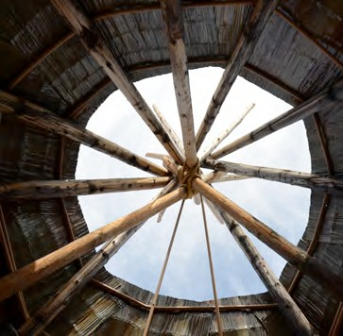
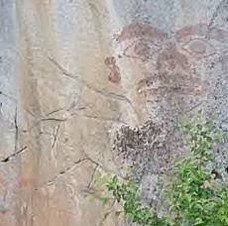
HISTORY

Primary Numbers: 9000 – 9399

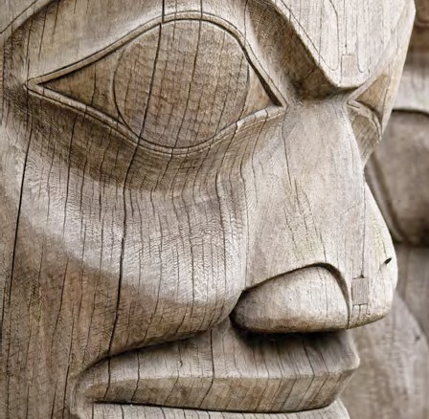

Section 19 includes subjects relating to the preservation of traditional knowledge and culture of the First Nation organization. Includes relationships with committees and activities to collect and map traditional territories, and liaison with other First Nations and tribal councils for the preservation of language, culture and traditions.

PRIMARY NUMBERS AND PRIMARY SUBJECTS

9010 Culture and History - General

9020 Archives

9050 Cultural Activities

9100 Heritage Conservation

9120 Historic and Heritage Sites

9200 Language Use and Studies

9300 Traditional Use and Studies

A SA FD
9010 CULTURE AND HISTORY – GENERAL

Includes records of a general nature relating to the culture and history of the First Nation organization community, which are not found elsewhere in this section.

-01 General CY + 1 6y D

9020 ARCHIVES

Includes records relating to the administration, operations and functions of community archives. For records relating to the internal Band office archives, see primary 1320.

-01 General CY + 1 6y D

9050 CULTURAL ACTIVITIES

Includes records of a general nature relating to arts and cultural activities.

-01 General CY + 1 6y D

9100 HERITAGE CONSERVATION

Includes records relating to the identification, regulation and preservation of heritage properties within the First Nation organization jurisdiction. Community heritage properties are located in primary 0810.

-01 General CY + 1 6y D

9120 HISTORIC AND HERITAGE SITES

Includes records relating to the identification, regulation and preservation of archaeological sites.

-01 General CY + 1 6y D
-20 Projects, by name SO* nil P
(*SO + until completed)

9200 LANGUAGE USE AND STUDIES

Includes records relating to the study and use of the First Nation organization language.

-01 General CY + 1 6y D
-20 Programs, by name SO* nil P
(*SO = until program is completed)

A SA FD

9300 TRADITIONAL USE STUDIES

Includes records relating to the development and completion of traditional use studies within the First Nation organization jurisdiction.

-01 General CY + 1 6y D
-20 Programs, by name SO* nil P
(*SO = until program is completed)

SECTION 20: ECONOMIC
DEVELOPMENT CORPORATIONS AND ACTIVITIES

Primary Numbers: 9000 – 9399

Section 20 includes subjects relating to the economic development activities of the First Nation organization, including the establishment of corporations for economic development purposes and establishing business relationships.

PRIMARY NUMBERS AND PRIMARY SUBJECTS

9410 Economic Development Corporations and Activities - General

9440 Economic Development Corporations - Individual.

9500 Economic Development - General

9540 Economic Development Projects

A SA FD

9410 ECONOMIC DEVELOPMENT CORPORATIONS AND ACTIVITIES – GENERAL

Includes records of a general nature relating to economic development activities of the First Nation organization, including the establishment of corporations and relationships for economic development, which are not found elsewhere in this section.

-01 General CY + 1 6y D

9440 ECONOMIC DEVELOPMENT CORPORATIONS – INDIVIDUAL

Includes records relating to the establishment, terms of reference and operational mandate of the First Nation economic development corporations, including relationships with external organizations.

For the letters patent and incorporation information for the corporation, see Section 6 – Legal and Specific Claims/Governance.

-01 General CY + 1 6y P
-20 Corporations, individual, by name CY + 1 6y P

9500 ECONOMIC DEVELOPMENT – GENERAL

Includes records relating to the encouragement of growth of existing businesses and industries and the attraction of new investment and economic activity to the First Nation organization.

-01 General CY + 1 6y D

9540 ECONOMIC DEVELOPMENT PROJECTS

Includes records relating to economic development projects, including terms of reference and project reports.

-01 General CY + 1 6y D
-20 Projects, by name SO* nil P

