Managing Electronic Folders and Electronic Documents

Once the records classification system has been adopted by a First Nations organization, it is logical to organize all information according to the same classification. The next step is establishing the folders and subfolders within the information network environment with the same subjects/titles as the paper records in filing cabinets. However, in addition to setting up the folders, subfolders and documents, the network drives are generally established with specific functions and subjects.

- Network Drive Structure and Folders

Filing electronic documents follows the same logic as filing paper documents. You need work places to create documents, and filing spaces to keep, access and share documents. These work spaces can be created on a network so that staff can file and save documents in a logical manner. Computer technology staff can then manage the security and back up requirements to protect the network.

The following is an example of a network environment map and organization structure:

DRIVE | FUNCTION
C | The local hard drive on each computer  Individual staff stores files locally in the computer;  Files are not accessible to the network, and are not backed up by network procedures  NOT RECOMMENDED except when travelling with a lap top
H | The work area for individual staff  Staff members store files of work in progress;  Files are on the network, and are backed up by network procedures;  Files are organized by functions/subjects according to the Records Classification
P | Confidential files, for the specific use of designated staff  Files are on the network, and backed up by network processes  Files are organized by functions/subject folders according to the Records Classification  Files are READ ONLY, and not removed except by network administrator
S | The central filing area for electronic documents  ALL final copies & shared documents prepared by ALL staff  Files are on the network, and backed up by network processes  Files are organized by functions/subject folders according to the Records Classification  Documents are named according to a standard naming convention (see notes on Document Naming)  Files are READ ONLY, and not removed except by network administrator
X | The archived and historic directories  Files are on the network, and backed up by network processes  Files are organized by functions/subject folders according to the Records Classification  Files are accessible through the network administrator  Files are READ ONLY, and not removed except by network administrator
Z | The data files for applications  Files are organized by application name, and are backed up by network processes
Insert Print Screen

All files must be saved on the server, in the appropriate shared directory (network drive). This serves several purposes, namely to avoid multiple copies of files, to aid in backups, and to help quickly locate files. Documents in local hard drives can’t be shared; they are not secure; they will not be saved in the nightly backups, and desktop computers and their hard disks can generally be overwritten or replaced on very short notice.

For working documents that do not need to be shared with others in the office, or for a work space, staff use the H: drive, which points to a personal folder on the server

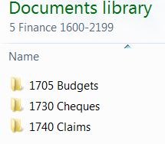
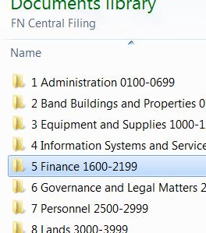
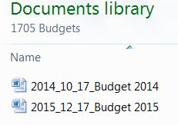
- Document Naming Conventions

The following recommended procedures for naming electronic documents are to be applied when electronic documents are created or received. These naming conventions will assist all staff to locate and retrieve electronic documents, and to make distinctions about different versions.

There are seven elements to be included in each name:

  - Title –word(s) that clearly describes the content of the document, and will be logical to the user for searching and retrieving;

  - Version – a two-digit version number to facilitate sorting and display of documents;

  - Date – YYYY_MM_DD – significant date relevant to the document, e.g. Version date or publication date;

  - Author – first initial and last name;

  - Business unit/program – name of business unit or program area;

  - Type – document type, e.g. AGD (agenda) AGR (agreement) PRC (procedures). should standardize lists of document types. The use of document types shortens the title of document; and

  - Extension – derived from the application in which the document has been created, e.g. .doc; .xls.

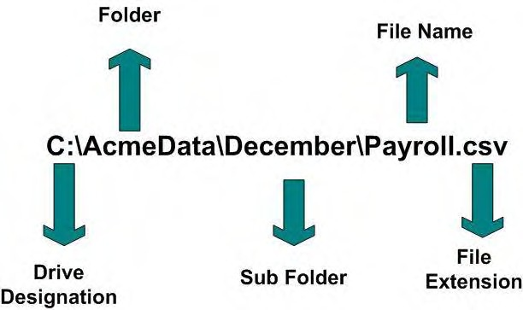

Examples of the naming convention include:

Using the full naming convention, the name of this document would be:

- Document Naming Conventions_V09_2011-0701_sb_fnps _PRC.doc;

- Elements are Title_Version_Date_Author_Organization_Type_extention;

Using the folder structure to include some of the document name, for example, for Chief and Council Meetings. Within the folder there is another folder for minutes by date. The folder structure is thus Chief and Council\Meetings\Minutes. The naming convention may consist of:

- Meeting Date_Version_Author.doc;

- 2010-07-01_V01_sbradley.doc;

- 2010-07-01_V02_sbradley.doc;

The title of the document is the meeting date, but because part of the name is dependent upon the folder structure, the context of the folders is also important, and if the document is moved to another folder, the name must be expanded to include the Chief and Council Meeting portion of the name.

Where there is the capability to search on metadata elements, the name of the document can be simplified to:

- Document Naming Conventions_V09_2010-07-01.doc; and

- Other elements, such as author, will be captured in the document metadata.

Version number and date are still required to distinguish between versions for those persons who may not know or remember the date when searching for the document.

The Alberta government provides much guidance in all aspects of electronic information management at their Information Management website. Information in this manual was derived from their document naming specification:

Alberta. Information Management Branch. “Naming Conventions for Electronic Documents.” Electronic Information Management. August 2005. https://www.alberta.ca/assets/documents/IM-Naming-Conventions.pdf

