Filing Closing, Storage & Destruction Procedures

Records Activity Changes

When records are no longer referenced for daily work, they are deemed to be “inactive” or “semi-active”. This inactive time is provided in the Records Classification and Retention schedule for each subject heading. – see R5 – When do I remove Records?

Check the abbreviations and table at the beginning of the Records Classification and Retention Schedule to determine whether this change is based on a specific date, or based on a specific condition, such as the completion of a contract.

When this retention condition occurs, the files are closed and records are boxed up and removed to storage. The rationale for removing them is to free up filing space, and ensure the ongoing accessibility for those records still actively referenced for staff work.

Usually, there are still requirements to retain the records, and so the inactive records must continue to be accessible through indexes and available if needed. Consequently, controls are still exercised over these records, even when they are not close at hand.

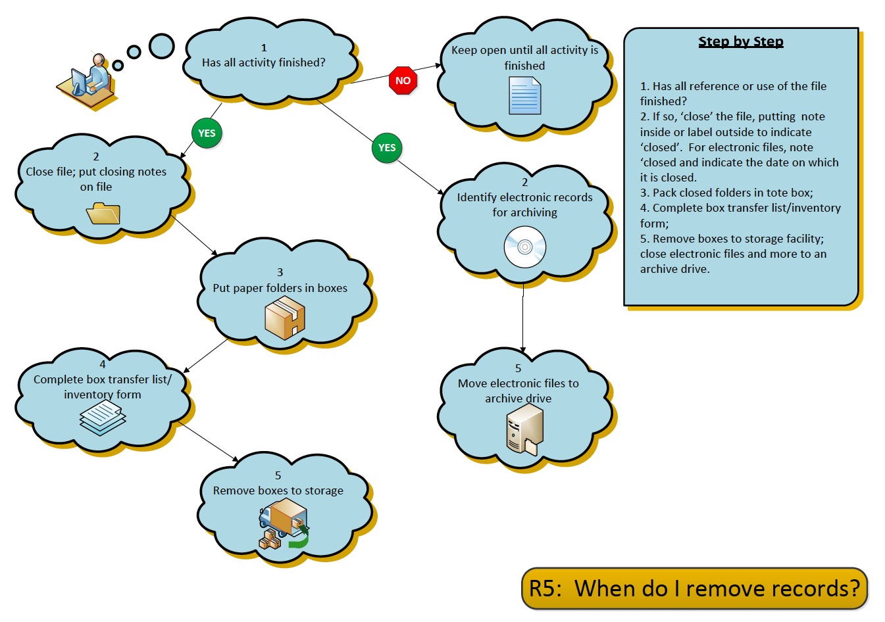

Closing files

Records are closed at a logical time, likely at year end. For some records, a conditional retention is required, such as “retain until employment ceases”. In this case, the inactive state begins when the condition of employment is completed. When records are closed, a formal file closure notice or label is placed in the folder, and the folder is removed from the active file area.

Boxing and storing paper records

Tote boxes are used for records storage. These boxes hold 1.5 cubic feet of paper records. These boxes are strong, contain no glue, have handles and may be stacked in the storage space.

The following instructions for boxing records must be followed, to enable rapid retrieval of stored records, and also enable the approved disposal of records. Copies of the box storage form (also know as the “records transfer” form, and box label form are included at the end of this section.

- Pack file folders into the box in their original filing order, and with other records of the same retention period.

- When the box is filled, complete an inventory listing (“records transfer list”) describing the contents of the box.

- The records management staff member issues records storage/transfer forms, and also issues box numbers, so that the boxes may be identified, placed on shelving, and be retrieved if necessary.

- Three copies of the inventory/transfer list are made. One copy goes into the box, to become an inventory of contents. The second copy stays with the department owning the box. The third copy goes into the master storage binder that is maintained by the records management staff.

- When a stored folder is required, staff may reference their departmental inventory list or consult with the records custodian to determine what box holds the information.

If no records management software application is available, it is recommended that staff create a spreadsheet with the information available in summary form. The spreadsheet is a searchable electronic tool that will help staff to later find files, and locate the boxes in which the files are stored.

See Forms – Records Transfer List; Box Label

Records Transfer List
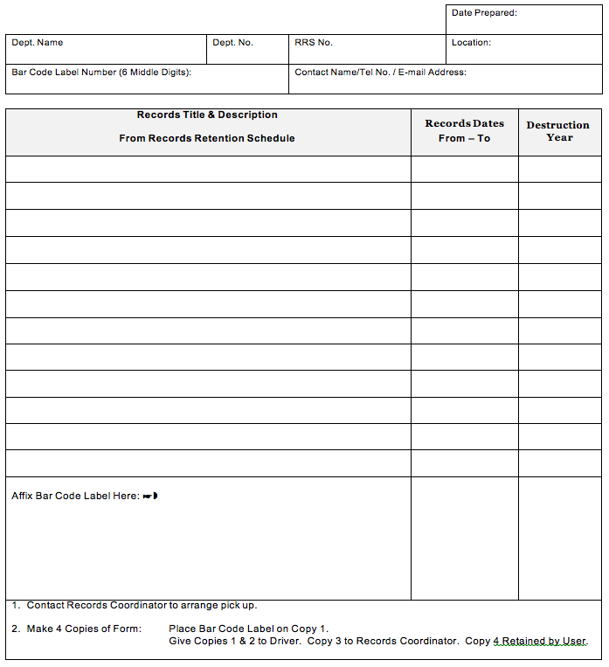

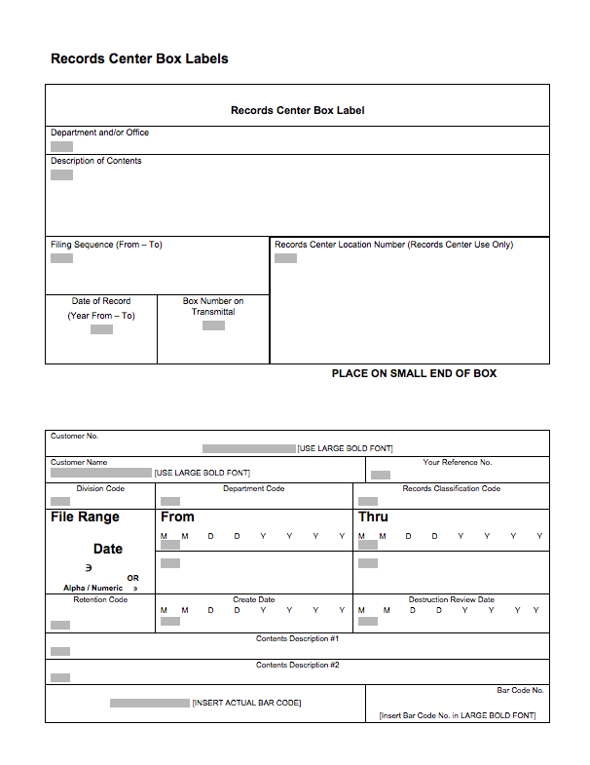

Records Storage Space

If appropriate storage space is available, staff can equip the space with industrial strength shelving to store records. Ensure that this space is safe from hazards such as flooding, mice, insects or other hazards that may damage the records. It is recommended that boxes never be stored directly on a floor, and that bottom shelves of storage racking be set at least two inches from the floor, to prevent moisture from the floor or any water leaks soaking into the storage boxes.

Two examples of records storage areas are shown: a basement facility, secure and dry, and a records storage centre, similar to a commercial records warehouse, purpose built for records storage.

Organizing the space bays (sections of shelving) and individual shelves of the shelving units are tagged with a number or letter, and the locations of the shelves and bays are coded according to the number or letter, so that boxes can be place in identified box storage locations, e.g. Bay 2, Shelf 2. The storage location of the box is then marked on the records transfer/inventory sheet.
Consequently, every box has a unique storage address and can quickly be located on the specific section and shelf where it has been placed.

The storage area is locked, and access is strictly controlled, to ensure that the order of storage of boxes is not disturbed.

Records Destruction

The planned disposal of records

The final stage in the life cycle of information is the disposal or permanent preservation of records.
Records disposal occurs when there are no longer requirements for the information. For organizations with an approved recorded information management policy and within the policy, an approved retention schedule, the planned disposal of records is part of the “usual and ordinary course of business” of how organizations make and keep records.

The approval of the draft Records Retention Schedule included with the Records Classification System will provide First Nations governments with an approved and controlled method.

The Retention Schedule was created through the following steps:

Records were appraised for their value, including operational, legal, financial, historic and reference; and

Research was undertaken to assure that all requirements for the records are known.

It is the responsibility of each First Nations government to ensure that their policy environment encompasses retention and disposition as part of their working environment.

The Disposal Process – see R5 – When do I destroy records?

Once the Retention Schedule is approved

Records are flagged for disposal or preservation;

A final review is undertaken, and approvals provided by relevant managers;

Records are destroyed on a regular basis, using appropriate methods to preserve confidentiality of content;

A Destruction Register is maintained, indicating what records were destroyed and when; and

The processes are regularly reviewed, und updated when laws and regulations change.

Arbitrary and unplanned records destruction is considered to be a suspicious activity. Arbitrary and unplanned records destruction may be found by courts to be illegal destruction of evidence. Illegal destruction of evidence may bring serious legal sanctions against the organization, including court judgments, fines or imprisonment.

For further information
Further information and forms samples for records transfer, storage and disposal operation are found in:

ARMA International Standards Task Force. Retention Management for Records and Information. Lenexa, KS: ARMA International, 2005.

