Daily Operations with Active Records

Introduction

When you know what records you have, the next step is organizing them. The following procedures and routines will ensure that records are received and entered into an organized records management system. The descriptions will cover records in all formats.

This daily routine is necessary so that all staff members have rapid access to information to perform their work, and that the information resources of the organization are collected and protected for future reference.

For materials received from external organizations, these processes ensure that incoming mail is saved and filed promptly. For materials exchanged between staff and offices, these processes ensure that the new records created by staff are also saved and filed promptly for later retrieval.

Filing procedures

Incoming hard copy records are received by postal mail, courier and fax. Incoming mail is opened, sorted, and placed in designated locations for staff to pick up and transmit to designated staff in their work groups, or for the records management staff member to collect for filing into the office records collection.

Centralized Files and Working Copies of Records

Records are filed where they are convenient to the users. In most cases, records are filed within workgroups, with designated staff to be responsible for the filing on behalf of the various workgroups. However, some organizations prefer one central file for all records, with working copies of current project information (“working files”) kept in offices. Whatever approach is taken, as quickly as possible, records must be filed, to ensure that they can be found. Always make sure that no original materials are interfiled with working papers.

All records must be put away daily, with no loose papers left unfiled.

If information is being held for action, use a “bring forward” system, and file the information by date of action. Bring the item back for review on the action date. Keep this information filed by date in action files.

Daily routine – see R3 – Incoming Mail and Filing Process

On a daily basis, work as follows:

  - Have a specific "in-basket" or holding place, where staff members place paper records for filing. Also, establish a formal mail pick-up, to obtain all information prepared by staff for filing.

  - Work with current information to be filed, and try to file away information on a daily basis. (Keeping up with daily work will keep the backlog to only a few items, and ensure that all staff can find information when required).

  - For each item of correspondence or document to be filed, read carefully and determine the subject of the correspondence. (Note that there may be several subjects, so the main subject of the correspondence must be determined. Also, the "RE" or "SUBJECT" line may not always accurately describe the contents nor be the main subject of the item.) No two persons see information the same way, so the best approach is to think about where or by what subject this information will be looked for in the future.

  - Pick the best match from the classification categories. Write the numeric code in pencil on the upper right corner of the first page. If there are any other subjects included in the document that must be noted, create a cross reference (other file folder to look into) in pencil under the main number with an "x" beside this additional number. (See the notes in Section 1, subsection e below about cross-references.);

  - If you are uncertain about what subject to pick, ask the creator or recipient of the correspondence to give suggestions about where the record should be filed. If the appropriate subject category for filing cannot be determined, put the record aside to review with staff. Continue coding until all documents in the basket are completed; and

  - If you are uncertain about what subject to pick, ask the creator or recipient of the correspondence to give suggestions about where the record should be filed. If the appropriate subject category for filing cannot be determined, put the record aside to review with staff. Continue coding until all documents in the basket are completed; and

  - Sort the records into filing order by the subject codes, and put away paper records into the file folders with the matching subject codes.

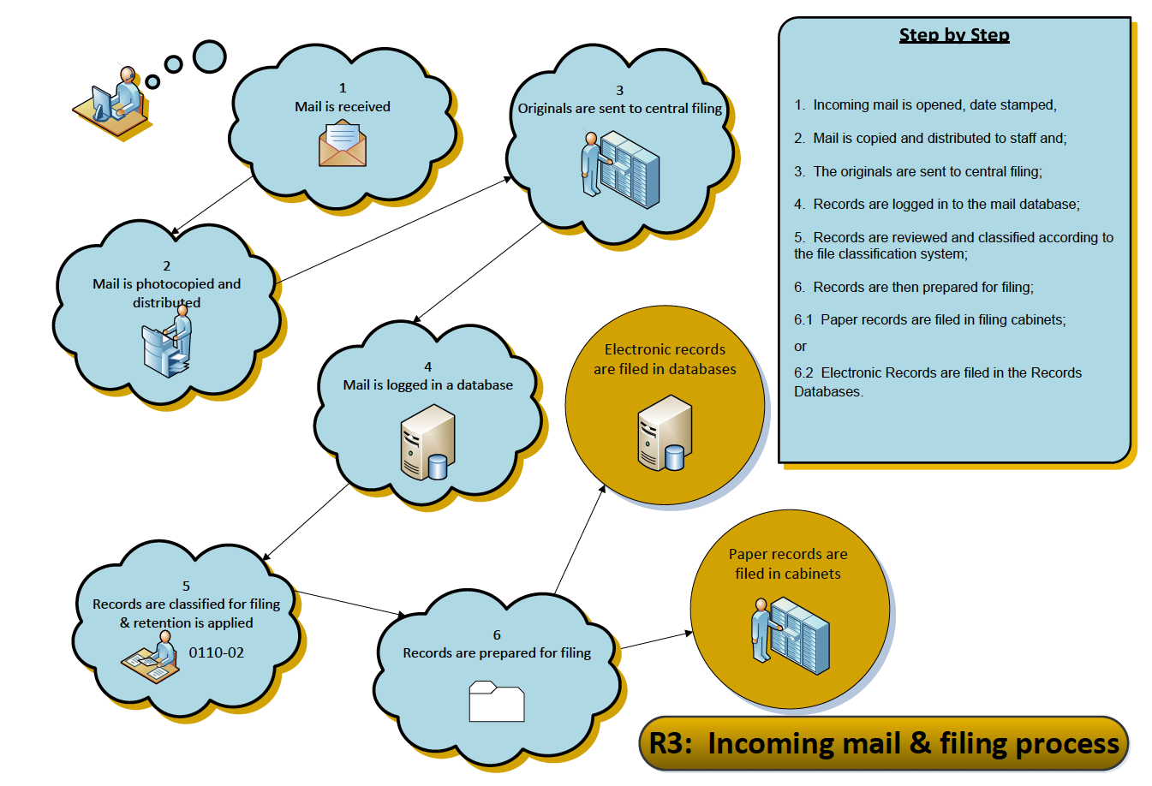

- Creating cross-references

“Cross-references” are additional file codes that may be necessary or helpful to link the documents in the main folder or subject area to other folders with relevant to related materials.

Use this marking when a document can be related to several separate subjects, projects or files open on a particular matter, and it will help in the future to locate all relevant materials.

A cross-reference is marked on a document, upper right corner, below the assigned filecode where the document if files, and is written in pencil as follows: X4430-20. The “X” in front of the file code marks this as a cross-reference, and will indicate the other file folders where related items are located.

To avoid confusion, do not assign more than three cross-references to a document.

- Creating new file volumes/folders

Maintain folders at a manageable size, otherwise folders will tear and documents will spill out of the folders and be damaged.

When a folder exceeds one inch in thickness, close the folder and open a new volume/folder. Some high-activity subjects may require three or four volumes. Choose a convenient time to close the file (preferably at year end, half-year, or if necessary, at month end). Change the label on the closed volume folder to indicate the volume number and date range of information in the file, and add the words “File Closed”.

Open the new folder indicating the volume number on the label and an open ended date as well: (e.g. Vol. 2, JAN 5/2011 – ). Repeat this process when and if the folder again becomes too full, opening Vol. 3, and so on.

File House-keeping tips

As you are filing, watch for the following situations:

  - Inspect the filing for completeness. This means ensuring that all attachments and enclosures have been included. If reference is made to previous correspondence, ensure that it is also in the file.

  - Sort and remove items that are non-records or transitory records that should not be set aside for filing. Remove any unrelated paper before filing. This includes envelopes, directional slips, "to file" notes and post-it notes.

  - Remove paper clips, pins, rubber bands and clamps as these deteriorate rapidly and mark documents. Extra staples should also be removed and documents should be checked to ensure that they are meant to be stapled together.

  - Repair any torn or damaged papers.

  - Newspaper clippings will deteriorate rapidly as the paper is highly acidic. Clippings should be photocopied for the file and the original clipping discarded. Ensure the date and name of the source newspaper are legibly marked on the copy, and that these items are filed by month and year.

  - Fold papers, maps and oversized documents so that they can be viewed without removing them from the filing order. Be sure that oversized documents do not hide the file label, extend out of the file and interfere with filing.

  - Organize loose documents (e.g. photographs) by placing in envelopes behind pertinent correspondence, with a descriptive note on the envelope.

  - Punch holes carefully in the file document. If any information is eliminated by the punch holes, pencil in the information where it can be seen. Sort papers into desired filing order. It is recommended that documents be filed in chronological order, with oldest documents on the bottom and then in date order from oldest to newest on top.

  - If no date is given on the record, write the date of filing on it (e.g. FILED ON JANUARY 23/10). Use a plastic sorter for sorting large volumes of filing. Use prongs to fasten documents to the folder.

Opening new files

If there is no file already opened for a particular subject, review the complete Records Classification and Retention Schedule to identify the correct file code for the subject matter, and place on the document as described above.

Create a new folder label. Use a label template such as the ones included in these instructions to create a neat and consist appearance, and also to ensure that all relevant information is recorded on the label, including the file number, the folder title, the date the folder is opened, and the subject heading and retention period for the file category.

Keep track of all of the files that are opened, and record the use of the new file number in the listing of open files. (See the notes about this listing in Section 5 – Maintaining Records),

Cross-reference the document to other relevant subjects, as necessary, and as described above.

Creating new subject headings

If a record relates a completely new subject or function not shown on the Records Classification and Retention Schedule, review the new topic with staff, determine where to insert the new file code, and create the new subject heading, description and recommended retention of the subject. Use the existing file headings, descriptions and retention periods to provide a model for the new subject you create.

j. Outgoing Information – see R4 – Outgoing Mail Process

Collect a copy of all outgoing correspondence for filing

Be sure to include a space for "Our File Number" on all outgoing correspondence, reports, memoranda and press releases.

Ensure that outgoing records include the complete file number (primary and secondary number) from the records classification system.

If this outgoing information has signatures committing the organization, or other official notations, file a photocopy of the original.

Collect copies in the "in basket" and follow the procedures for filing as described above.

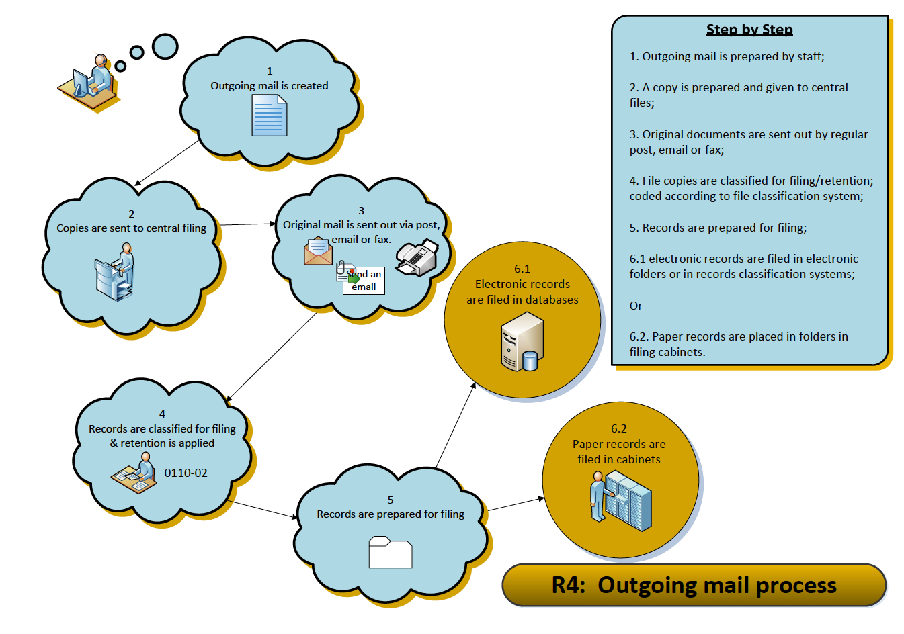

Maintaining File Lists

The complete Records Classification system is a menu of functions and subjects, from which staff select the appropriate codes to describe the records they use. As new files are opened, the office staff should keep an up to date list of all opened files.

Where staff have been using an older filing system, as a new file number is selected for files, the new file number should be recorded on the old file list, to create a cross-reference from the new to the older filing system. Using a spreadsheet or MS Access database will be appropriate for this reference tool. When all new files have been opened, the cross-reference list should be filed away for safekeeping, and maintained as a key to the “old” files that may be in storage. The records management staff will maintain and update the list as necessary.

Duplication of Records and Offices of Primary Responsibility (OPR)

Staff activities and work may result in several individuals creating records on the same topic. When this happens, one department or staff member must be nominated the official record holder, and assume the responsibility of the "Office of Primary Responsibility".

- The OPR designation is given to each section or subject heading within the Records Classification and Retention Schedule.

- This label assists us to determine where records on specific subjects are located within various offices. It also signals that, while there may be duplicates for working purposes, ONLY the OPR will retain the record for the required retention period. Others will retain their copies only until they are no longer referenced, and then these copies will be forwarded to the OPR for filing or disposal.

- This label also assists all staff members to eliminate duplicate materials, and reduces the amount of unnecessary material that would otherwise be sent offsite for storage. At the same time, this process will also ensure that the complete record of any project or activity is retained for the duration of the retention period designated.

Circulating Files

An effective records management system includes procedures for controlling records once they have been filed. Staff must know where the records can be found, when they are looking for information.

In a centralized records system, no records are circulated. Staff will use the office file on site, or make photocopies of documents when leaving the office.

As another option, staff can borrow records, using a sign out procedure must be used if records are removed from the file collections. Staff will use “in-out” guides, and must record the file name, as well as their name and the date removed, placing the out guide in the cabinet where the file is usually kept.

Under no circumstances should staff remove documents from folders. Staff use the complete file folder, copy the required documents, and return the complete folder.

Records Security

The safekeeping of records is an essential component of records management. Vital records (critical or irreplaceable for operations) must be retained in secure storage.

Fireproof filing cabinets are recommended for such documents. Records borrowed from the fireproof cabinets must be returned to storage at the end of each workday.

Regular backup and offsite storage of electronic data provides safekeeping of electronic records.

All records must be retained in secure and confidential storage. Records such as personnel records, payroll records or records must be retained in appropriate secure storage with procedures to safeguard their content. Lock cabinets when staff are not accessing the records.

All records must be retained in secure and confidential storage. Records such as personnel records, payroll records or records must be retained in appropriate secure storage with procedures to safeguard their content. Lock cabinets when staff are not accessing the records.

Procedures for records disposal follow in Section 5 “File Closing, Transfer and Destruction Procedures.”

Further information and samples for active records operation are found in:

ARMA International Standards Task Force. Establishing Alphabetic, Numeric and Subject Filing Systems. Lenexa, KS: ARMA International, 2005.

Bennick, Ann, Ed.D., CRM Judy Vasek Sitton, CRM Managing Active Business Records Overland Park, KS: ARMA International, 2014.

