FNS
First Nations Summit

INFORMATION MANAGEMENT TOOLKIT | VOLUME 2 – PROCEDURES MANUAL | 2011
INFORMATION MANAGEMENT TOOLKIT
INFORMATION FOR FIRST NATIONS GOVERNMENT IN BC

IM
Toolkit
2011

Cataloguing In Publication Data
Will be updated for FNS – new ISBN and copyright

ISBN 0-9781701-0-5

© 2011 First Nations Summit. All rights reserved. No part of this publication may be stored, reproduced, transcribed, translated or transmitted into any other form without the prior written permission of the First Nations Summit

Without restricting the generality of the foregoing, no one may make commercial use of any content of this publication whatsoever, including selling any information, software, products of services or displaying or otherwise using any content of this publication on any website.

Disclaimer

The contents of this publication are for general information purposes only and are not intended to provide legal advice or opinion of any kind. The contents of this publication should not be relied upon. The contents of this publication should not be seen as a substitute for obtaining competent legal counsel or advice or other professional advice. If legal advice or counsel or other professional advice is required, the services of a competent professional person should be sought. While the First Nations Summit has made reasonable efforts to ensure that the contents of this publication are accurate, the First Nations Summit does not warrant or guarantee the accuracy, currency or completeness of the contents of this publication. The First Nations Summit expressly disclaims all representations, warranties, conditions and endorsements. In no event shall the First Nations Summit, its directors, agents, consultants or employees be liable for any loss, damages or costs whatsoever, including (without limiting the generality of the foregoing) any direct, indirect, punitive, special, exemplary or consequential damages arising from, or in connection to, any use of any of the contents of this publication.
IM
TOOLKIT
2011
TABLE OF CONTENTS

Disclaimer Page 3
- Introduction Page 6
  - What are records? Page 8
  - Information Survey or Inventory Page 11
- Daily Operations with Active Records Page 14
  - Introduction Page 14
  - Filing Procedure Page 14
  - Key Records to be Managed Page 14
  - Daily Routine Page 15
  - Creating Cross-References Page 17
  - Creating New Volumes/Folders Page 17
  - File House-keeping tips Page 18
  - Opening new files Page 19
  - Creating new Subject Headings Page 19
  - Outgoing Information Page 20
  - Maintaining File Lists Page 22
  - Duplication of Records and Offices of Primary Responsibility (OPR) Page 22
  - Circulating Files Page 23
  - Records Security Page 24
- Key Records to be Managed Page 25
  - The components of a clear business document Page 25
  - The key records series Page 25
    - Agreements and Contracts Page 27
    - Band Council Resolutions Page 27
    - Letters to Chief and Council Page 32
    - Reports to Chief and Council Page 34
    - Minutes of Chief and Council Meetings Page 34

- Filing cabinets, folders and labels Page 37

  - Cabinets Page 37

  - Folders Page 39

  - Label Template Page 41

- File Closing, Storage and Destruction Procedures Page 42

  - Records activities cease Page 42

  - Closing files Page 44

  - Boxing and storing paper files Page 44

  - Records storage space Page 48

  - Records destruction Page 49

  - The Disposal Process Page 50

- Transitory Records Page 52

- Managing Electronic Folders and Electronic Documents Page 54

  - Network Drive Structure and Folders Page 54

  - Document Naming Conventions Page 57

Appendix 1 – Records Classification and Retention Schedule
- Introduction to the Records Classification System and Retention Schedule

- Structure and Logic of the Classification System and Retention Schedule

  - Sections

  - Primary and Secondary Subjects

  - Retention Periods

- Records Classification and Retention Schedule

Appendix 2 – Legal Citations

Introduction

The information in this volume of the Information Management Toolkit is provided for the designated records management staff member, who will have daily responsibility for the records of the First Nations government.

The contents of this volume were originally created by the First Nations Public Service (FNPS) of BC in 2011. The FNPS ceased operations in 2012, and the First Nations Summit has since assumed responsibility for the content and updating of this volume.

This section includes information on:

  - Conducting an information survey, to determine what information exits in the office and related organizations.

  - What is a record

  - How to file records using the model records classification and records retention system (included as Appendix 1)

  - How to manage records for daily work

  - The type of filing equipment and supplies to select

  - Closing files when they are no longer referenced

  - Storing records until their useful life is over, and

  - Destroying or saving records for future reference, including obtaining the appropriate approvals

A model records retention schedule is included with the classification system. First Nations should confirm that the recommendations for retention are suitable for their requirements.

In addition, research was undertaken in 2011 to locate any regulations for retention of records. With the passage of time, organizations should undertake their own research to ensure current retention requirements.

There is also a section about electronic records that includes information on:

- Organizing electronic records in directories

- A model electronic document naming convention.

Finally, this tool kit as a whole is intended to be the “Records Management Manual” that is referenced in the Information Management Resolution and Policies, and also in the Canadian standards for maintaining records as evidence. As such, the procedures manual serves as the eyewitness to the credibility of the First Nations records keeping processes, and will support the use of records as evidence.

- What are records?

Records= emails, BCRs, mail, letters, maps, documents, reports, etc.

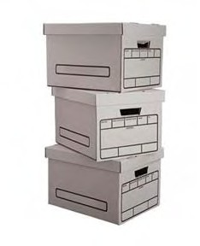
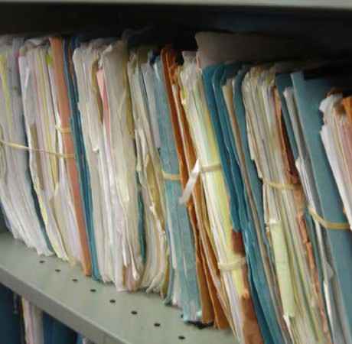

Records are defined as “information created, received or maintained as evidence and information by an organization or person, in pursuance of legal obligations or in the transaction of business”.

Depending upon regulations or legal definitions, any document in any format within a First Nations government can be considered a “record”, e.g. paper document, e-mail, map.
Each staff member and elected official must understand this definition, and support the processes that are explained in this volume for collecting, filing and maintaining the records of the organization.

The diagram, “R1 – Is it a record?” shows the step-by-step questions that help to define what a record is. See also diagram “R1a – When is email a Record”.

Once you have defined what records are, your next step is to see what records you have in your organization

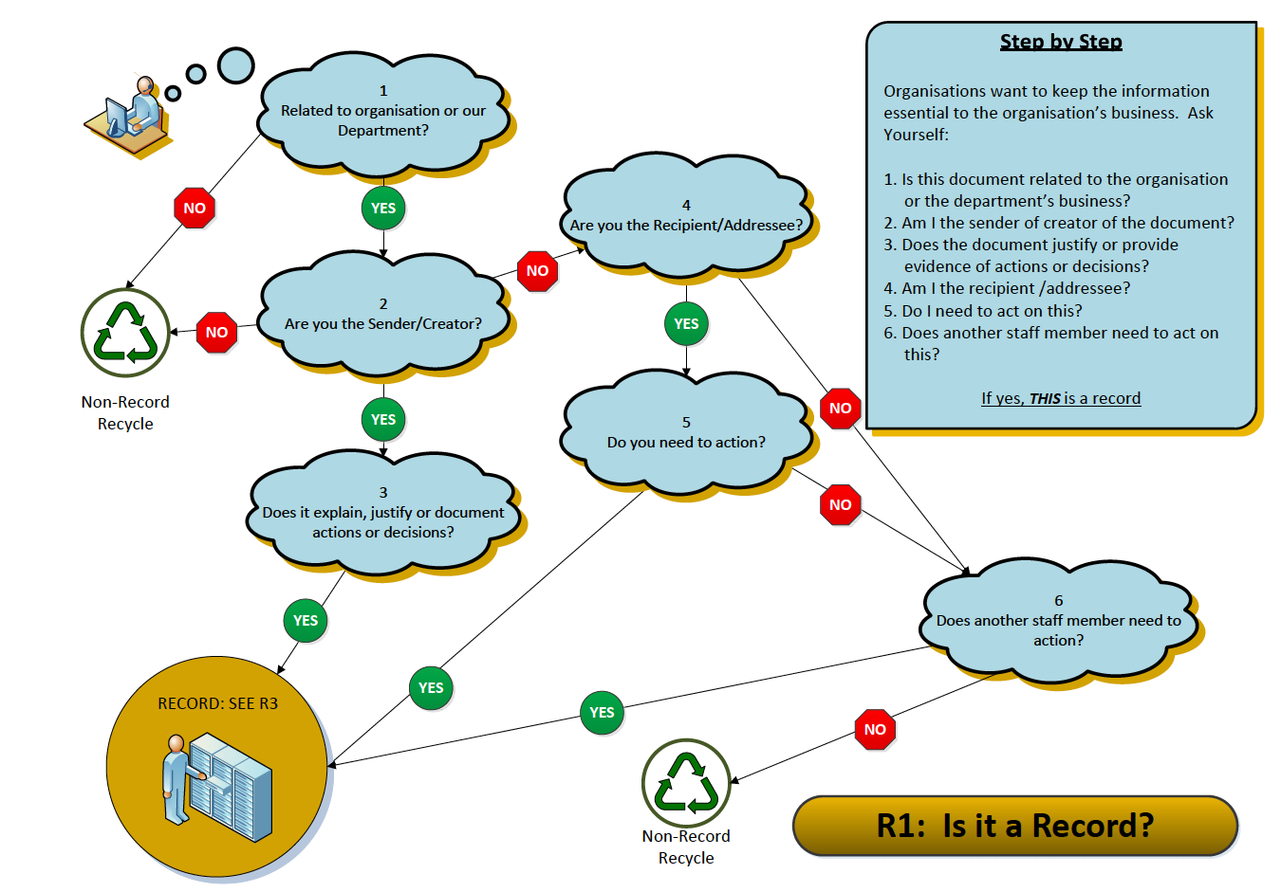
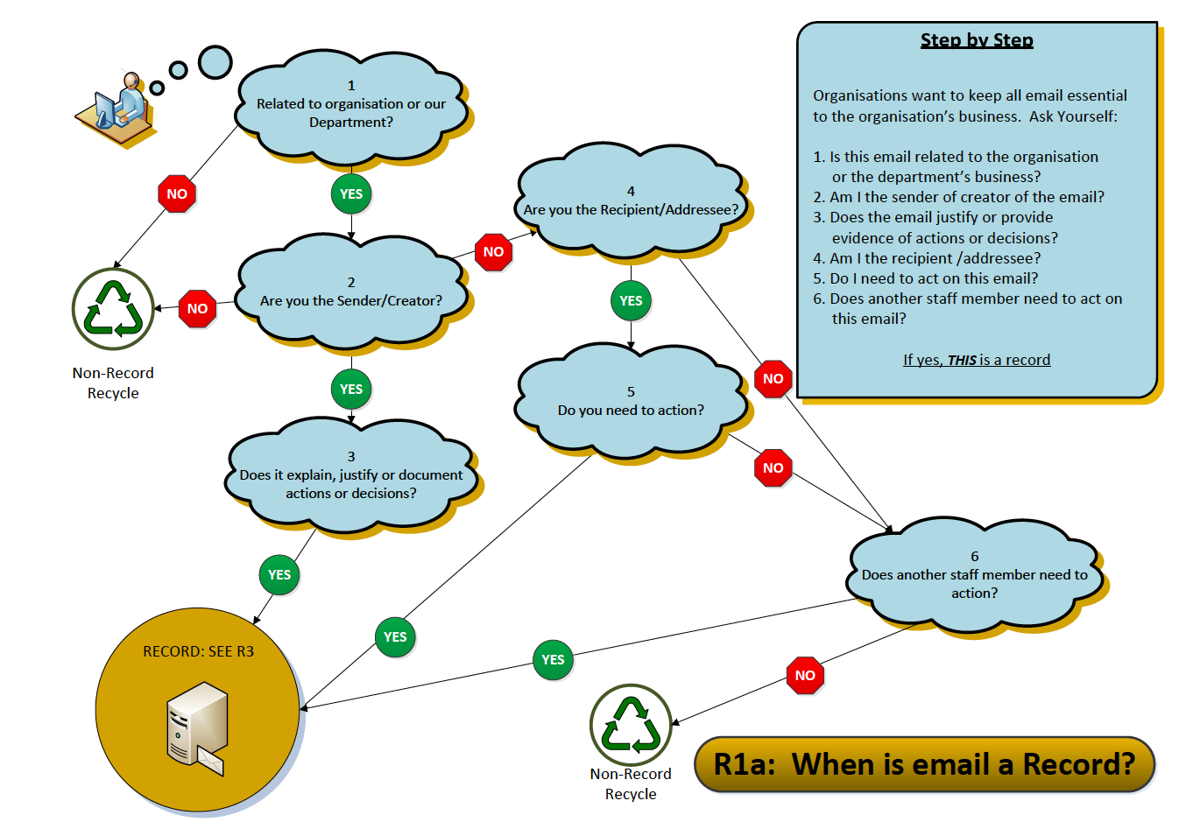
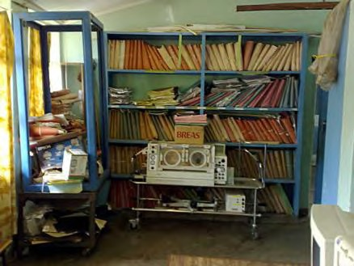
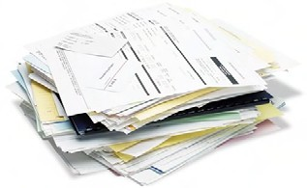
- Information Survey or Inventory

Do you know what information you have in your office? If not, a records and information survey, or inventory, is required, for you to get a clear picture of what records and information belong to the organization.

Generally, if you understand what records have been collected in various locations over time, and that there may be mixed collections (e.g. they include a variety of different subjects), then a records survey is a good idea, to get a clearer picture of the amount and subject matter that you will be organizing.

The keys to completing a survey are:

- Be organized about what you want to find out. Use a form to collect the same information for every collection that you identify, and make sure to create a listing of all the locations. See Form 1 – Information Survey that is included in this section, to show the kinds of details you want to know about your records.

- Set a timetable, and try to complete the survey quickly. This will ensure that you have up to date information, and that you can finish this activity as quickly as possible. If you can, get other staff to help with this survey. Review your form with them and explain that they need to be accurate and clear in describing what they find.

- When you have finished, create a spreadsheet with columns to match the various categories of information you collect from the form. Fill in a line of data for each survey form. When you have all the forms compiled into the spreadsheet, you will have a snapshot of how much information you have, where it is located, and what subject matters are included.

Now, set your priorities for action!

ORGANIZATION X
RECORDS AND INFORMATION SURVEY

DEPT. NAME: DATE:

COMPLETED BY:

RECORDS SERIES TITLE:

DEPARTMENT OR WORK GROUP (If applicable):

DESCRIPTION: Types of documents, how arranged. Note any personal information.
DATE RANGE: (from yr/mo to yr/mo)
VOLUME: (how many inches of files)
FORMAT: (non-paper)
RETENTION PERIOD: (if known)
Note: Attach a file list if one is available.

TYPE OF STORAGE EQUIPMENT: (type of cabinet, or storage method, e.g. tote box)

USE OF SECURITY DEVICES: (locks, passwords, restricted access)

LOCATION: (office, storage room, offsite)

The following information will be obtained from the records custodian, or designated caretaker of the records:

USES OF INFORMATION

Who uses these records? How often are records referenced?

Is information confidential?

Who has access to confidential information?

Is this a vital records series, e.g. what would happen if this information is lost?

Does this information have long term or permanent value to the organization?

Other facts or features of these records?

Information Management Toolkit / Form 1 - Information Survey.doc

Daily Operations with Active Records

Introduction

When you know what records you have, the next step is organizing them. The following procedures and routines will ensure that records are received and entered into an organized records management system. The descriptions will cover records in all formats.

This daily routine is necessary so that all staff members have rapid access to information to perform their work, and that the information resources of the organization are collected and protected for future reference.

For materials received from external organizations, these processes ensure that incoming mail is saved and filed promptly. For materials exchanged between staff and offices, these processes ensure that the new records created by staff are also saved and filed promptly for later retrieval.

Filing procedures

Incoming hard copy records are received by postal mail, courier and fax. Incoming mail is opened, sorted, and placed in designated locations for staff to pick up and transmit to designated staff in their work groups, or for the records management staff member to collect for filing into the office records collection.

Centralized Files and Working Copies of Records

Records are filed where they are convenient to the users. In most cases, records are filed within workgroups, with designated staff to be responsible for the filing on behalf of the various workgroups. However, some organizations prefer one central file for all records, with working copies of current project information (“working files”) kept in offices. Whatever approach is taken, as quickly as possible, records must be filed, to ensure that they can be found. Always make sure that no original materials are interfiled with working papers.

All records must be put away daily, with no loose papers left unfiled.

If information is being held for action, use a “bring forward” system, and file the information by date of action. Bring the item back for review on the action date. Keep this information filed by date in action files.

Daily routine – see R3 – Incoming Mail and Filing Process

On a daily basis, work as follows:

  - Have a specific "in-basket" or holding place, where staff members place paper records for filing. Also, establish a formal mail pick-up, to obtain all information prepared by staff for filing.

  - Work with current information to be filed, and try to file away information on a daily basis. (Keeping up with daily work will keep the backlog to only a few items, and ensure that all staff can find information when required).

  - For each item of correspondence or document to be filed, read carefully and determine the subject of the correspondence. (Note that there may be several subjects, so the main subject of the correspondence must be determined. Also, the "RE" or "SUBJECT" line may not always accurately describe the contents nor be the main subject of the item.) No two persons see information the same way, so the best approach is to think about where or by what subject this information will be looked for in the future.

  - Pick the best match from the classification categories. Write the numeric code in pencil on the upper right corner of the first page. If there are any other subjects included in the document that must be noted, create a cross reference (other file folder to look into) in pencil under the main number with an "x" beside this additional number. (See the notes in Section 1, subsection e below about cross-references.);

  - If you are uncertain about what subject to pick, ask the creator or recipient of the correspondence to give suggestions about where the record should be filed. If the appropriate subject category for filing cannot be determined, put the record aside to review with staff. Continue coding until all documents in the basket are completed; and

  - If you are uncertain about what subject to pick, ask the creator or recipient of the correspondence to give suggestions about where the record should be filed. If the appropriate subject category for filing cannot be determined, put the record aside to review with staff. Continue coding until all documents in the basket are completed; and

  - Sort the records into filing order by the subject codes, and put away paper records into the file folders with the matching subject codes.

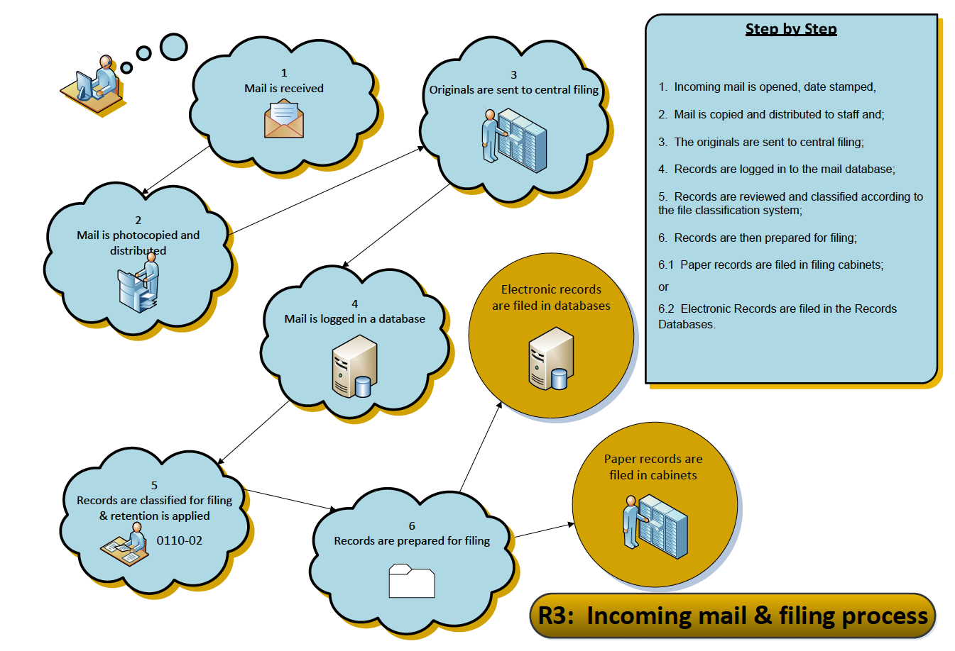

- Creating cross-references

“Cross-references” are additional file codes that may be necessary or helpful to link the documents in the main folder or subject area to other folders with relevant to related materials.

Use this marking when a document can be related to several separate subjects, projects or files open on a particular matter, and it will help in the future to locate all relevant materials.

A cross-reference is marked on a document, upper right corner, below the assigned filecode where the document if files, and is written in pencil as follows: X4430-20. The “X” in front of the file code marks this as a cross-reference, and will indicate the other file folders where related items are located.

To avoid confusion, do not assign more than three cross-references to a document.

- Creating new file volumes/folders

Maintain folders at a manageable size, otherwise folders will tear and documents will spill out of the folders and be damaged.

When a folder exceeds one inch in thickness, close the folder and open a new volume/folder. Some high-activity subjects may require three or four volumes. Choose a convenient time to close the file (preferably at year end, half-year, or if necessary, at month end). Change the label on the closed volume folder to indicate the volume number and date range of information in the file, and add the words “File Closed”.

Open the new folder indicating the volume number on the label and an open ended date as well: (e.g. Vol. 2, JAN 5/2011 – ). Repeat this process when and if the folder again becomes too full, opening Vol. 3, and so on.

File House-keeping tips

As you are filing, watch for the following situations:

  - Inspect the filing for completeness. This means ensuring that all attachments and enclosures have been included. If reference is made to previous correspondence, ensure that it is also in the file.

  - Sort and remove items that are non-records or transitory records that should not be set aside for filing. Remove any unrelated paper before filing. This includes envelopes, directional slips, "to file" notes and post-it notes.

  - Remove paper clips, pins, rubber bands and clamps as these deteriorate rapidly and mark documents. Extra staples should also be removed and documents should be checked to ensure that they are meant to be stapled together.

  - Repair any torn or damaged papers.

  - Newspaper clippings will deteriorate rapidly as the paper is highly acidic. Clippings should be photocopied for the file and the original clipping discarded. Ensure the date and name of the source newspaper are legibly marked on the copy, and that these items are filed by month and year.

  - Fold papers, maps and oversized documents so that they can be viewed without removing them from the filing order. Be sure that oversized documents do not hide the file label, extend out of the file and interfere with filing.

  - Organize loose documents (e.g. photographs) by placing in envelopes behind pertinent correspondence, with a descriptive note on the envelope.

  - Punch holes carefully in the file document. If any information is eliminated by the punch holes, pencil in the information where it can be seen. Sort papers into desired filing order. It is recommended that documents be filed in chronological order, with oldest documents on the bottom and then in date order from oldest to newest on top.

If no date is given on the record, write the date of filing on it (e.g. FILED ON JANUARY 23/10). Use a plastic sorter for sorting large volumes of filing. Use prongs to fasten documents to the folder.

Opening new files

If there is no file already opened for a particular subject, review the complete Records Classification and Retention Schedule to identify the correct file code for the subject matter, and place on the document as described above.
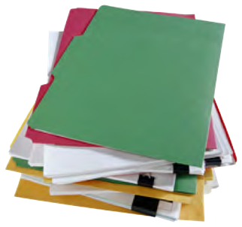
Create a new folder label. Use a label template such as the ones included in these instructions to create a neat and consist appearance, and also to ensure that all relevant information is recorded on the label, including the file number, the folder title, the date the folder is opened, and the subject heading and retention period for the file category.

Keep track of all of the files that are opened, and record the use of the new file number in the listing of open files. (See the notes about this listing in Section 5 – Maintaining Records),

Cross-reference the document to other relevant subjects, as necessary, and as described above.

Self Governance

Creating new subject headings

If a record relates a completely new subject or function not shown on the Records Classification and Retention Schedule, review the new topic with staff, determine where to insert the new file code, and create the new subject heading, description and recommended retention of the subject. Use the existing file headings, descriptions and retention periods to provide a model for the new subject you create.

j. Outgoing Information – see R4 – Outgoing Mail Process

Collect a copy of all outgoing correspondence for filing

Be sure to include a space for "Our File Number" on all outgoing correspondence, reports, memoranda and press releases.

Ensure that outgoing records include the complete file number (primary and secondary number) from the records classification system.

If this outgoing information has signatures committing the organization, or other official notations, file a photocopy of the original.

Collect copies in the "in basket" and follow the procedures for filing as described above.

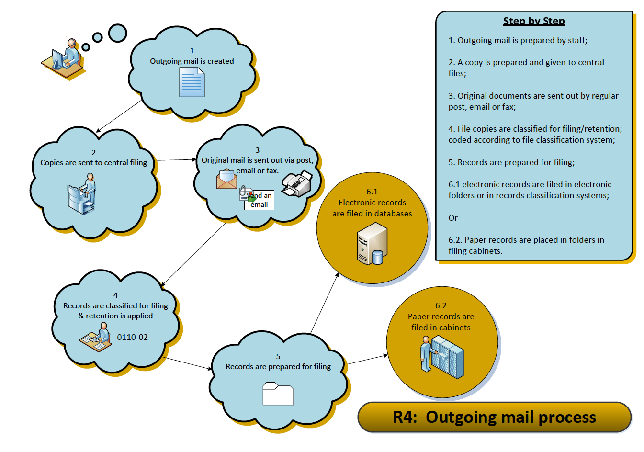

Maintaining File Lists

The complete Records Classification system is a menu of functions and subjects, from which staff select the appropriate codes to describe the records they use. As new files are opened, the office staff should keep an up to date list of all opened files.

Where staff have been using an older filing system, as a new file number is selected for files, the new file number should be recorded on the old file list, to create a cross-reference from the new to the older filing system. Using a spreadsheet or MS Access database will be appropriate for this reference tool. When all new files have been opened, the cross-reference list should be filed away for safekeeping, and maintained as a key to the “old” files that may be in storage. The records management staff will maintain and update the list as necessary.

Duplication of Records and Offices of Primary Responsibility (OPR)

Staff activities and work may result in several individuals creating records on the same topic. When this happens, one department or staff member must be nominated the official record holder, and assume the responsibility of the "Office of Primary Responsibility".

- The OPR designation is given to each section or subject heading within the Records Classification and Retention Schedule.

- This label assists us to determine where records on specific subjects are located within various offices. It also signals that, while there may be duplicates for working purposes, ONLY the OPR will retain the record for the required retention period. Others will retain their copies only until they are no longer referenced, and then these copies will be forwarded to the OPR for filing or disposal.

- This label also assists all staff members to eliminate duplicate materials, and reduces the amount of unnecessary material that would otherwise be sent offsite for storage. At the same time, this process will also ensure that the complete record of any project or activity is retained for the duration of the retention period designated.

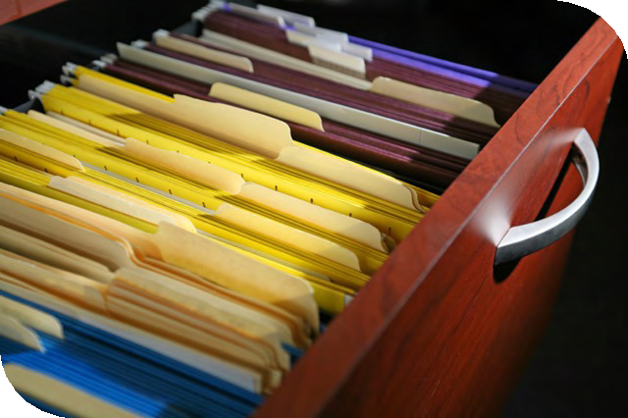

Circulating Files

An effective records management system includes procedures for controlling records once they have been filed. Staff must know where the records can be found, when they are looking for information.

In a centralized records system, no records are circulated. Staff will use the office file on site, or make photocopies of documents when leaving the office.

As another option, staff can borrow records, using a sign out procedure must be used if records are removed from the file collections. Staff will use “in-out” guides, and must record the file name, as well as their name and the date removed, placing the out guide in the cabinet where the file is usually kept.

Under no circumstances should staff remove documents from folders. Staff use the complete file folder, copy the required documents, and return the complete folder.

Records Security

The safekeeping of records is an essential component of records management. Vital records (critical or irreplaceable for operations) must be retained in secure storage.

Fireproof filing cabinets are recommended for such documents. Records borrowed from the fireproof cabinets must be returned to storage at the end of each workday.

Regular backup and offsite storage of electronic data provides safekeeping of electronic records.

All records must be retained in secure and confidential storage. Records such as personnel records, payroll records or records must be retained in appropriate secure storage with procedures to safeguard their content. Lock cabinets when staff are not accessing the records.

All records must be retained in secure and confidential storage. Records such as personnel records, payroll records or records must be retained in appropriate secure storage with procedures to safeguard their content. Lock cabinets when staff are not accessing the records.

Procedures for records disposal follow in Section 5 “File Closing, Transfer and Destruction Procedures.”

Further information and samples for active records operation are found in:

ARMA International Standards Task Force. Establishing Alphabetic, Numeric and Subject Filing Systems. Lenexa, KS: ARMA International, 2005.

Bennick, Ann, Ed.D., CRM Judy Vasek Sitton, CRM Managing Active Business Records Overland Park, KS: ARMA International, 2014.

Key Records To Be Managed

The components of a clear business document

In order for business correspondence to be considered reliable and authentic, it should be created in a consistent manner, with the date, author and other elements of the letter clearly expressed. Use the following template as a model to ensure that the required components are present so that the letter will be considered authentic, and useful as evidence in the future.

The “essential” or mandatory items are circled in red, and the optional items are enclosed in blue boxes.

See - B1 – Basic Document Creation Procedure

The key records series

Within the First Nations government, there are several sets of record types that are duplicated, and then sometimes lost. These records include:

  - Agreements and contracts
  - Band Council Resolutions,
  - the meetings of Chief and Council,
  - correspondence with Chief and Council, and
  - reports to Chief and Council

The following section provides a series of recommended steps to ensure that all staff receive the necessary information to do their work, and the original or signed documents, as evidence of decisions made, are sent for filing.

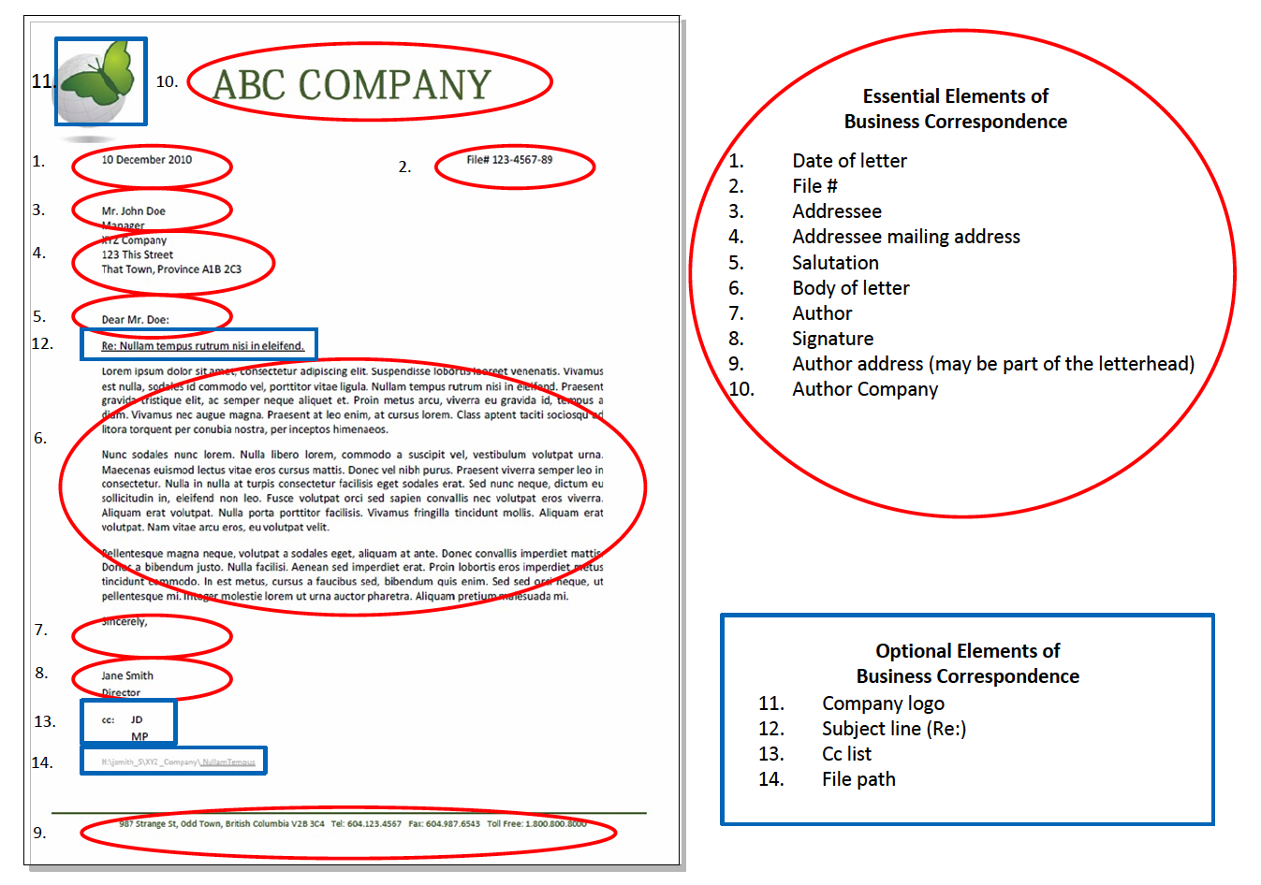

Agreements and Contracts – see B6 – Agreements & Contracts

There can be disagreement about where to file signed agreements, contracts and similar documents. Management staff are responsible for overseeing programs, where the supervision of services provided under terms in contracts and agreements are a key component. However, it is easy to misfile an original agreement with working papers, and then have the working papers be removed, stored or lost. Auditors will always request a review of signed contracts and agreements as part of their annual review of First Nations government operations.

Consequently, it is recommended that all original signed agreements be filed centrally, or with the Director of Finance, for safekeeping, and that copies of agreements are filed within the relevant subject file along with the working papers and reports associated with the agreement. If necessary, staff may also keep reference copies of these documents to track their daily work. As with minutes of Chief and Council, it is recommended that all agreements and contracts be filed in fireproof filing cabinets for safekeeping.

Band council resolutions – see B2 – Band Council Resolutions

Band council resolutions (BCRs) are essential documents that provide evidence of decision making, particularly about financial matters. Frequently, original BCRs are required for outside organizations, and it is easy to lose track of the sequence and location of these documents. The following diagram provides recommendations for the creation, distribution and filing of these documents.

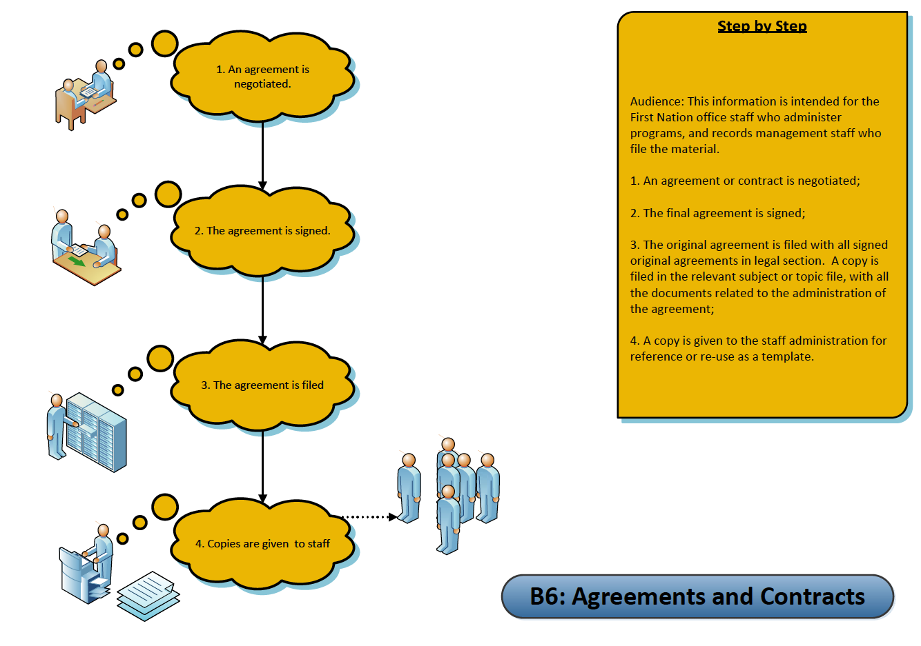

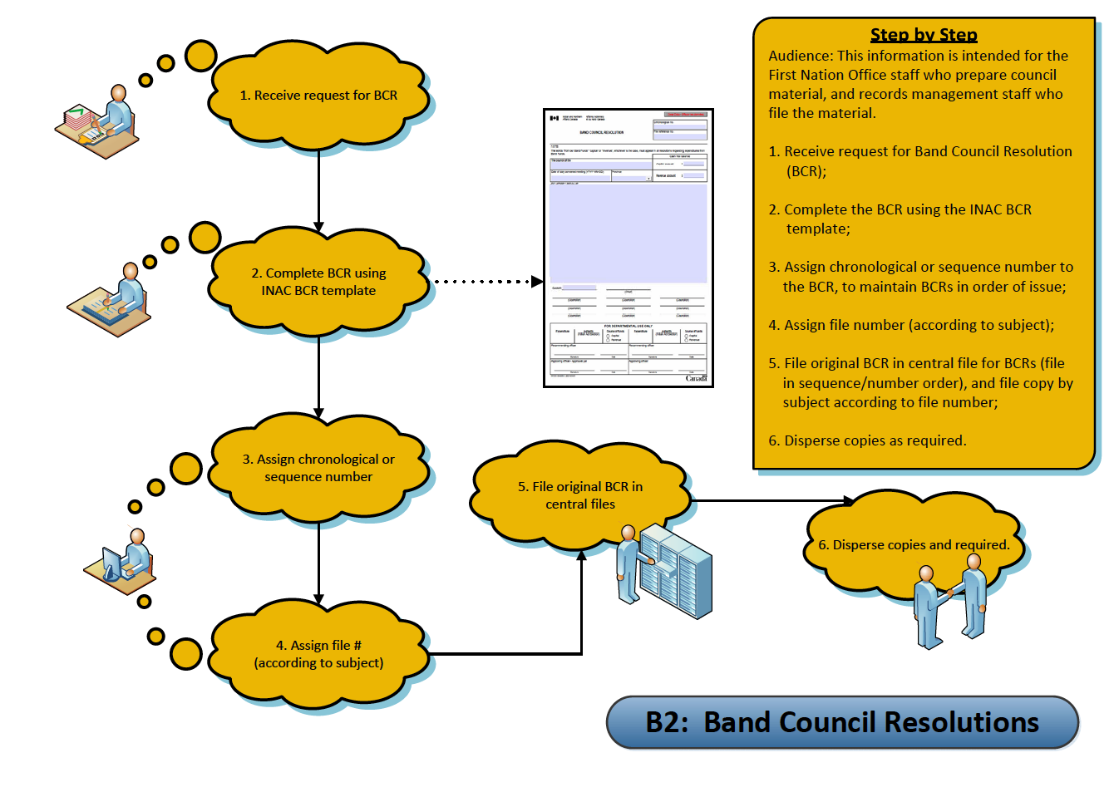

A template from Aboriginal Affairs and Northern Development Canada is included in this section as a form sample. – see Forms – BCR Form

It is recommended that you assign a sequence number to each band council resolution as it is passed. This sequence number can be a two-part number, with the year as the first part of the number, and then a sequential number as each one is passed. For example, 2011-15 would be the number for the 15th BCR passed in 2011. This sequence numbering tracks each BCR. Keep a listing in a registry or log, a list or spreadsheet by the sequence number, and add other important facts about the BCR, including the subject or topic of the BCR, department requesting, and additional notes you find useful. File one copy in a file called “Band Council Resolutions” in sequence number order.

File another copy by the subject of the BCR. This two copy filing system will enable you to later review what the BCR was about as well as find it in the sequence in which it was passed.

Example of BCR Registry:
BCR Registry Number | BCR File number | Date of BCR | Subject of BCR | Approval date | Original sent to | Subject File number
2011-15 | 2300-20 | 2011-03-15 | Funds for post secondary student travel | 2011-04-01 | Education Department | 5700-50
2011-16 | 2300-20 | 2011-05-29 | Approval for water study | 2011-06-29 | Capital Works Department | 6400-01

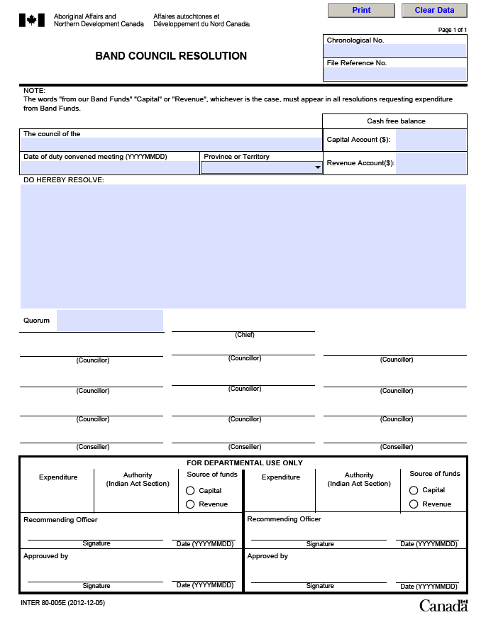

Letters to Chief and Council – see B3 – Letters to Chief and Council

Letters to Chief and Council are about many different subjects. They will be discussed at a meeting, and usually require decisions or actions for follow up by staff. They are similar to BCR’s, in that staff need to file these in several ways, first in the agenda file or meeting file by the date of the meeting when they were considered by the chief and council. However, they may also need to be filed by the subject of the letter, and also tracked by the staff member who is assigned to follow up on the matter raised. These different requirements will require copies of the letter to be filed in two locations within the filing system.

Here is an example of a registry of letters to chief and council:

Letter Registry number | Date Received | Chief and Council meeting date | Chief and Council File number | Author | Subject | Subject file number | Follow-up
2011 - 06 | 2011-01-20 | 2011-02-12 | 2340-20 | Bradley, Sandie | Dogs off leash | 2300-30 | Lands Administrator
2011-14 | 2011-06-22 | 2011-06-30 | 2340-20 | Jones, Bill | Housing repairs | 4120-20 | Housing Manager
2011-16 | 2011-06-23 | 2011-06-30 | 2340-20 | Smith, Sue | Medical travel | 8040-20 | Health Care Administrator

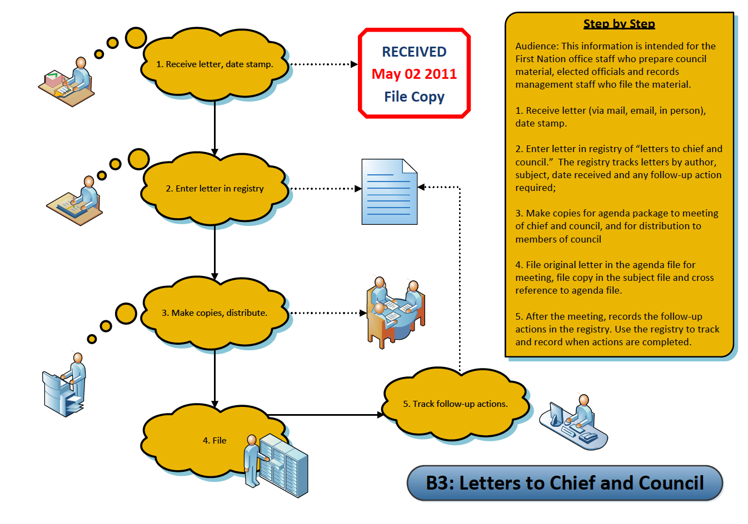

Reports to Chief and Council – see B4 – Reports to Chief and Council

Reports to Chief and Council cover many different subjects. They will be distributed as part of an agenda package for a meeting.

Like BCR’s and correspondence to Chief and Council, staff need to keep track of these by the date of the meeting when they were considered by the chief and council. However, they also need to be recorded by the subject of the report, particularly for the staff member who prepared the report or is responsible for the portfolio the report is about.

These different requirements will require copies of the report to be filed in the meeting file as well as in the subject file that the report is about. Depending on the size of the report, the report might also be treated as a “library” item, with a copy filed in a “Resources” or “Reference” Library on bookshelves or in a meeting room

Minutes of Chief and Council Meetings – see B5 – Minutes of Chief and Council Meetings

Minutes of Chief and Council are duplicated and distributed to many staff in the organization. They will be distributed as part of an agenda package for a meeting. Like BCR’s and correspondence to Chief and Council, staff need to file minutes by the date of the meeting that they record. The process for preparing and approving minutes is outlined in the diagram. Once minutes have been drafted and approved, they are filed with other materials from the meeting.

All records of Chief and Council meetings are considered “vital” or essential records, and should be backed up electronically and stored offsite. Signed original records should be stored in fire proof filing cabinets.

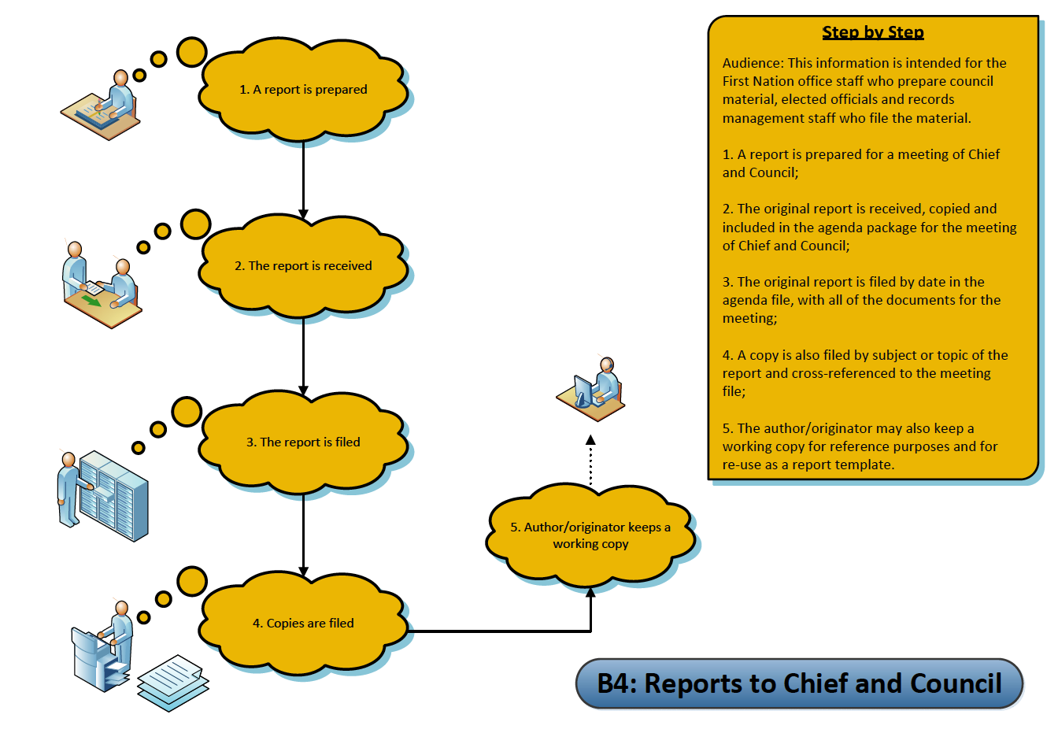
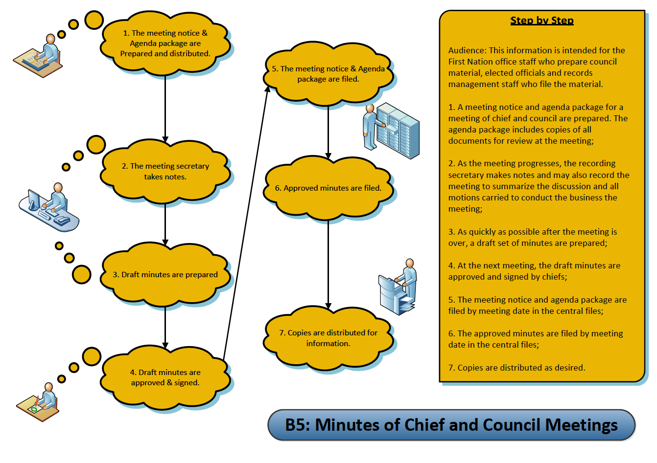
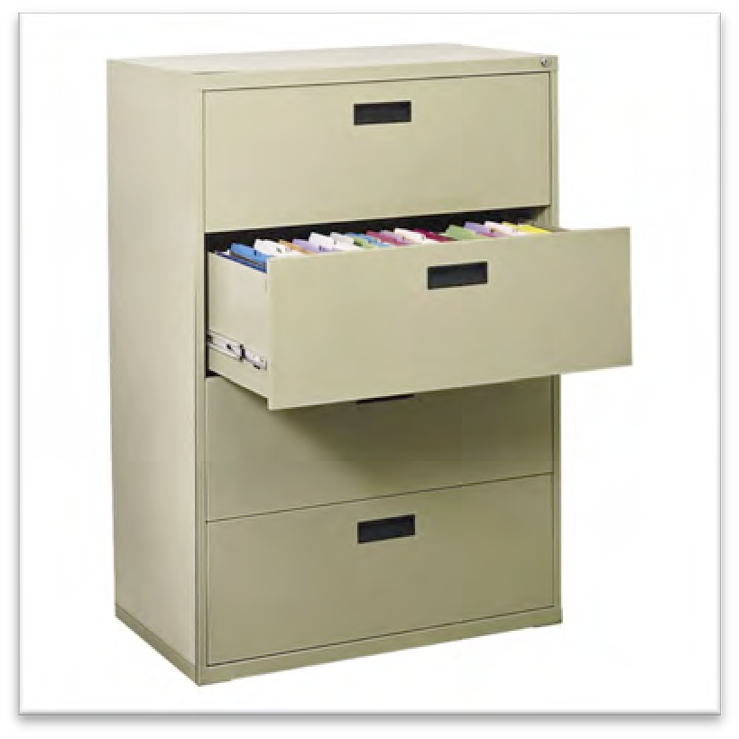
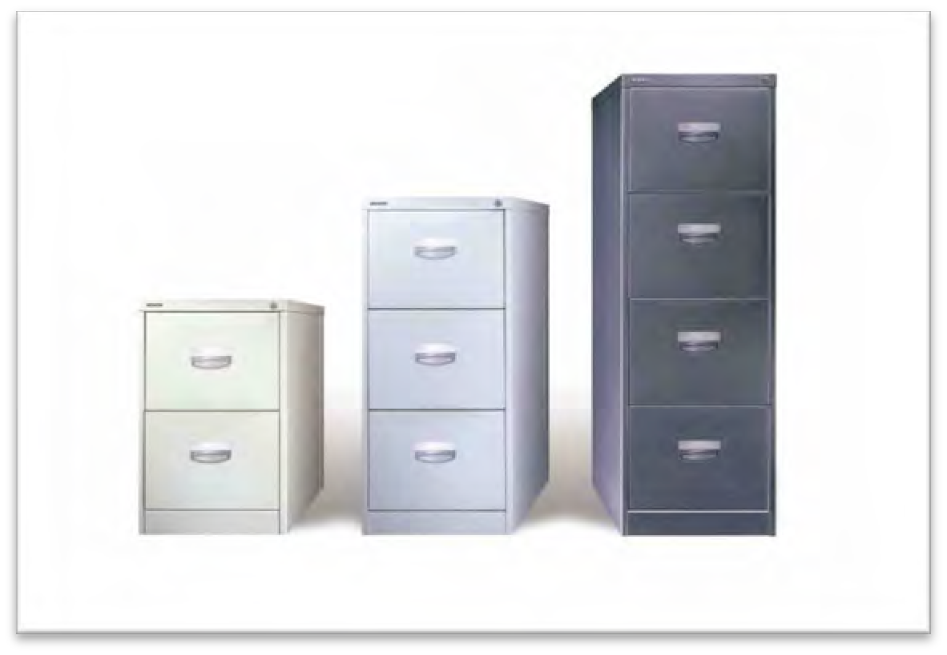

Filing Cabinets, folders and labels

- Cabinets

Drawer style, with roll-out drawers, continue to be purchased for paper filing. These are now called “Victorians” and are discouraged, because they do not provide the greatest storage capacity.

Lateral cabinets, while larger in size of drawer, are also inefficient for storage of large collections of records.

The recommended style for the centralized collections within the offices is a fixed shelf type, rather than a rollout style, to achieve the maximum storage capacity for the floor area available.

These should be made of heavy gauge steel, to support the weight of fully loaded drawers of records. These are dimensionally matched on the outside of the cabinet, and have two sizes of internal space – one designed for letter/legal correspondence filing, and the other for binder storage.

Vertical (“Victorian”) Filing Cabinet Lateral Filing Cabinet

The recommended
style for the centralized collections within the offices is a fixed
shelf type
Your chance to upgrade comes when new storage equipment is purchased. Always select the most efficient style of cabinet for the space available

Fixed Shelf Cabinets

If Storage of multimedia materials is required, it is recommended that modular or specialized cabinets be selected with configurations to hold different sizes of media, e,g. for computer disks

Modular Cabinet

All cabinets should have locks and all information should be locked at night.

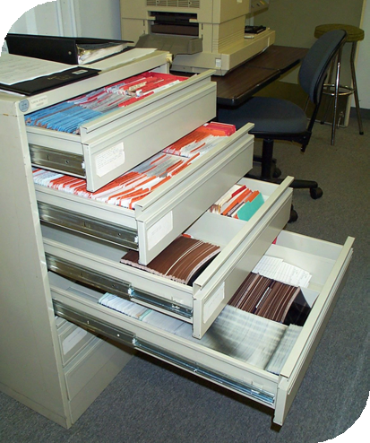
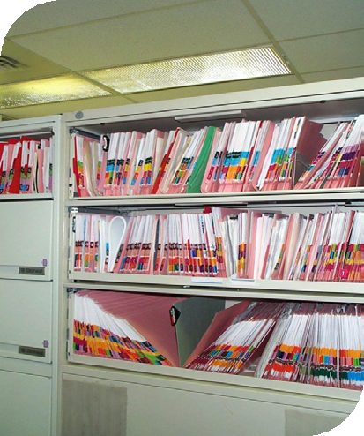

- Folders

- For file drawers, a top tab folder is required, to display labels across the top of the folder. Most staff will continue to use this style for the folders they retain in their office cabinets or credenzas.

- The file folder required for fixed shelf style cabinets is an "end tab" folder, which enables labels to be attached across the end of the folder.

- The preferred style is with a reinforced mylar fold to provide extra strength. The preferred colour for most categories of information is manila. In addition coloured folders may be used for designated types of records.

- Letter size rather than legal size folder are recommended, to save costs, and to reflect the current standardization of most paper records to letter size.

- Folders may be obtained through office suppliers, and/or specialty vendors.

- It is recommended that documents be fastened into the file on a post or filing clip, to save the loss of documents, and keep the documents in filing order. However, some organizations prefer to keep the documents loose in the folders, rather than mark them with a hole or risk tearing on a filing post.
End tab file folder

Letter size rather than legal size folder are recommended, to save costs, and to reflect the current standardization
Top tab file folder

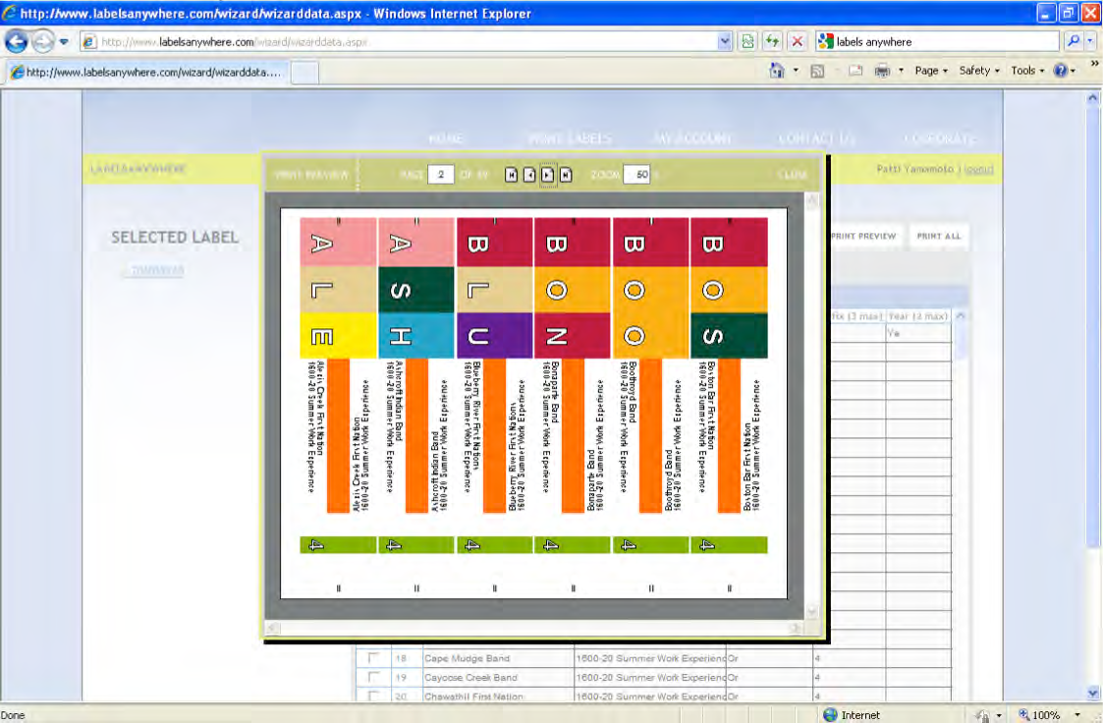

Colour coded labelling speeds up retrieval of records by 40 percent, and is highly recommended for the benefits it will provide. Where end tab folders are used, specialty colour coded labelling is employed as part of the labelling procedure

Labelling software and ink jet printing to produce labels

This illustration shows an alphabetic colour label, printed on label stock that can be attached to the top or the end tab folder by wrapping around the tab. The colour coding

will display on a shelf, enabling you to quickly locate files out of order, as well as to identify records in series.

Suppliers of labeling software and label stock enable you to produce your colour labels as you need them.

Label Template

Each file folder (top tab or side tab) must have a descriptive label affixed to the top right hand corner of the front of the folder (end tab) or on the tab (top tab). The sample here uses Avery 5163 or equivalent size label, to give enough type space for a detailed label.

The label template has been set up in MS Word as follows:

Left side:
Top line - Primary number; second line – secondary number or code; third line – tertiary number (if required)

Right side:
Top line folder name (bold, underlined)
2nd line Blank
3rd line Secondary Classification (Arial 12 pt.Capitals)
4th line Primary Classification (Arial 12 pt.)

Other lines if necessary for tertiary classification, otherwise blank space

7th line (Retention period /when approved retention schedule has been passed); Date file is opened – right justified

Sample:
2330-20  09/08/21 | Meeting – August 21, 2009
MEETINGS BY DATE
Chief and Council Committees – Finance Committee

 | SO-nil-P | 2009 -

Each sheet holds ten labels. Therefore, it is recommended that new folders be created in batches of ten. Save the label document as you prepare them, to help you track what new folders have been opened. Labels for other media will be configured as required.

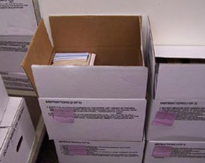
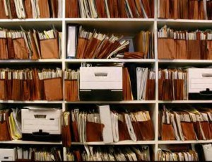

Filing Closing, Storage & Destruction Procedures

Records Activity Changes

When records are no longer referenced for daily work, they are deemed to be “inactive” or “semi-active”. This inactive time is provided in the Records Classification and Retention schedule for each subject heading. – see R5 – When do I remove Records?

Check the abbreviations and table at the beginning of the Records Classification and Retention Schedule to determine whether this change is based on a specific date, or based on a specific condition, such as the completion of a contract.

When this retention condition occurs, the files are closed and records are boxed up and removed to storage. The rationale for removing them is to free up filing space, and ensure the ongoing accessibility for those records still actively referenced for staff work.

Usually, there are still requirements to retain the records, and so the inactive records must continue to be accessible through indexes and available if needed. Consequently, controls are still exercised over these records, even when they are not close at hand.

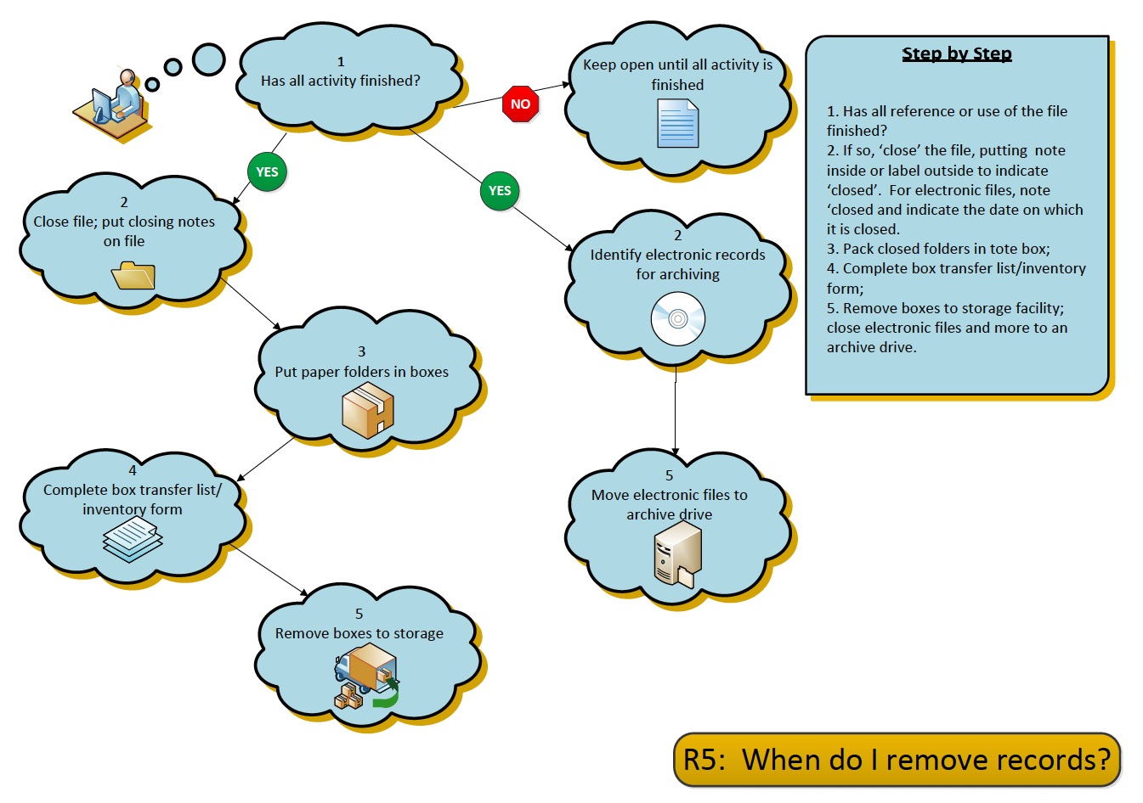
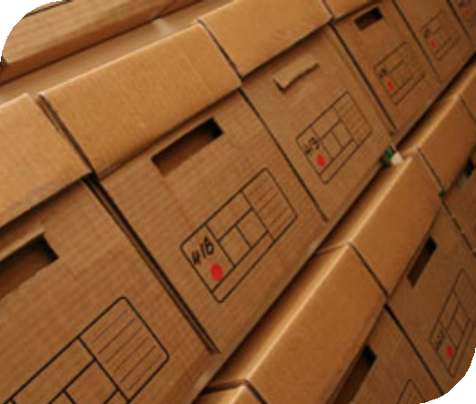

Closing files

Records are closed at a logical time, likely at year end. For some records, a conditional retention is required, such as “retain until employment ceases”. In this case, the inactive state begins when the condition of employment is completed. When records are closed, a formal file closure notice or label is placed in the folder, and the folder is removed from the active file area.

Boxing and storing paper records

Tote boxes are used for records storage. These boxes hold 1.5 cubic feet of paper records. These boxes are strong, contain no glue, have handles and may be stacked in the storage space.

The following instructions for boxing records must be followed, to enable rapid retrieval of stored records, and also enable the approved disposal of records. Copies of the box storage form (also know as the “records transfer” form, and box label form are included at the end of this section.

- Pack file folders into the box in their original filing order, and with other records of the same retention period.

- When the box is filled, complete an inventory listing (“records transfer list”) describing the contents of the box.

- The records management staff member issues records storage/transfer forms, and also issues box numbers, so that the boxes may be identified, placed on shelving, and be retrieved if necessary.

- Three copies of the inventory/transfer list are made. One copy goes into the box, to become an inventory of contents. The second copy stays with the department owning the box. The third copy goes into the master storage binder that is maintained by the records management staff.

- When a stored folder is required, staff may reference their departmental inventory list or consult with the records custodian to determine what box holds the information.

If no records management software application is available, it is recommended that staff create a spreadsheet with the information available in summary form. The spreadsheet is a searchable electronic tool that will help staff to later find files, and locate the boxes in which the files are stored.

See Forms – Records Transfer List; Box Label

Records Transfer List

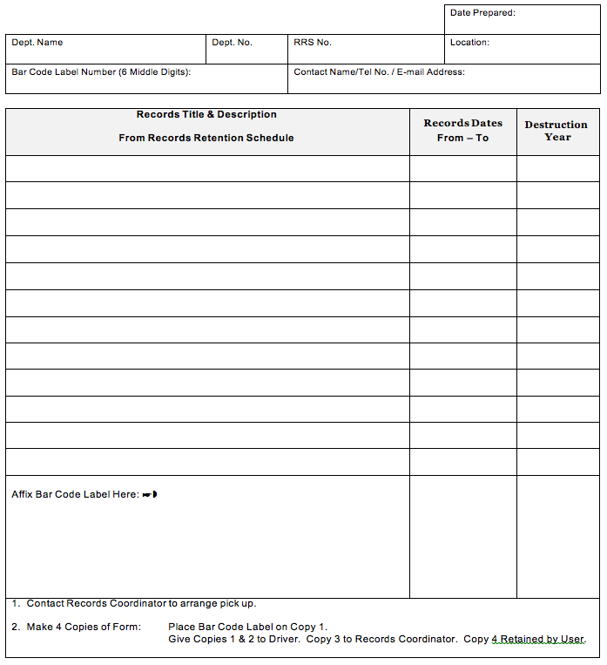

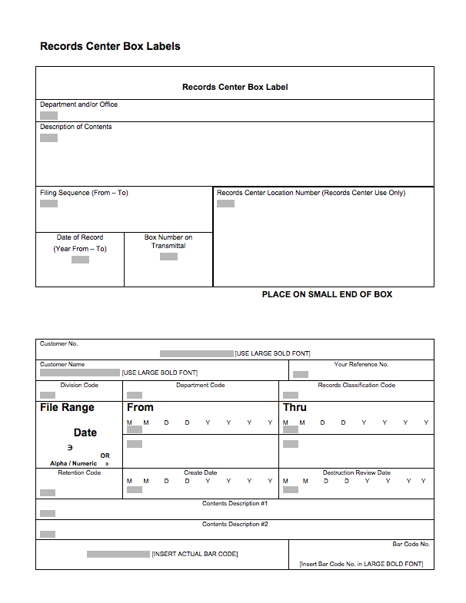

Records Storage Space

If appropriate storage space is available, staff can equip the space with industrial strength shelving to store records. Ensure that this space is safe from hazards such as flooding, mice, insects or other hazards that may damage the records. It is recommended that boxes never be stored directly on a floor, and that bottom shelves of storage racking be set at least two inches from the floor, to prevent moisture from the floor or any water leaks soaking into the storage boxes.

Two examples of records storage areas are shown: a basement facility, secure and dry, and a records storage centre, similar to a commercial records warehouse, purpose built for records storage.

Organizing the space bays (sections of shelving) and individual shelves of the shelving units are tagged with a number or letter, and the locations of the shelves and bays are coded according to the number or letter, so that boxes can be place in identified box storage locations, e.g. Bay 2, Shelf 2. The storage location of the box is then marked on the records transfer/inventory sheet.
Consequently, every box has a unique storage address and can quickly be located on the specific section and shelf where it has been placed.

The storage area is locked, and access is strictly controlled, to ensure that the order of storage of boxes is not disturbed.

Basement records storage area Purpose-built Records Storage Centre
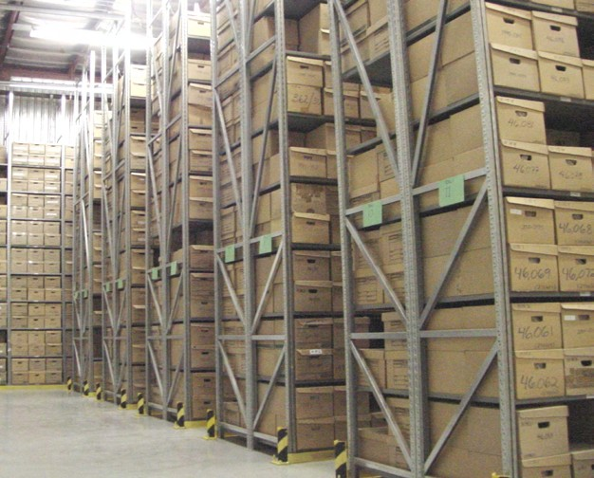
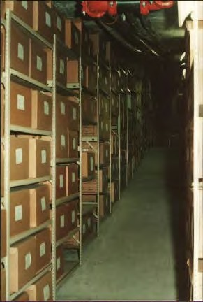

Records Destruction

The planned disposal of records

The final stage in the life cycle of information is the disposal or permanent preservation of records.
Records disposal occurs when there are no longer requirements for the information. For organizations with an approved recorded information management policy and within the policy, an approved retention schedule, the planned disposal of records is part of the “usual and ordinary course of business” of how organizations make and keep records.

The approval of the draft Records Retention Schedule included with the Records Classification System will provide First Nations governments with an approved and controlled method.

The Retention Schedule was created through the following steps:

Records were appraised for their value, including operational, legal, financial, historic and reference; and

Research was undertaken to assure that all requirements for the records are known.

It is the responsibility of each First Nations government to ensure that their policy environment encompasses retention and disposition as part of their working environment.

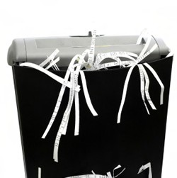
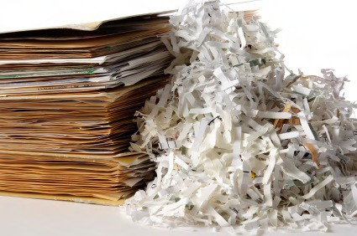

The Disposal Process – see R5 – When do I destroy records?

Once the Retention Schedule is approved

Records are flagged for disposal or preservation;

A final review is undertaken, and approvals provided by relevant managers;

Records are destroyed on a regular basis, using appropriate methods to preserve confidentiality of content;

A Destruction Register is maintained, indicating what records were destroyed and when; and

The processes are regularly reviewed, und updated when laws and regulations change.

Arbitrary and unplanned records destruction is considered to be a suspicious activity. Arbitrary and unplanned records destruction may be found by courts to be illegal destruction of evidence. Illegal destruction of evidence may bring serious legal sanctions against the organization, including court judgments, fines or imprisonment.

For further information
Further information and forms samples for records transfer, storage and disposal operation are found in:

ARMA International Standards Task Force. Retention Management for Records and Information. Lenexa, KS: ARMA International, 2005.

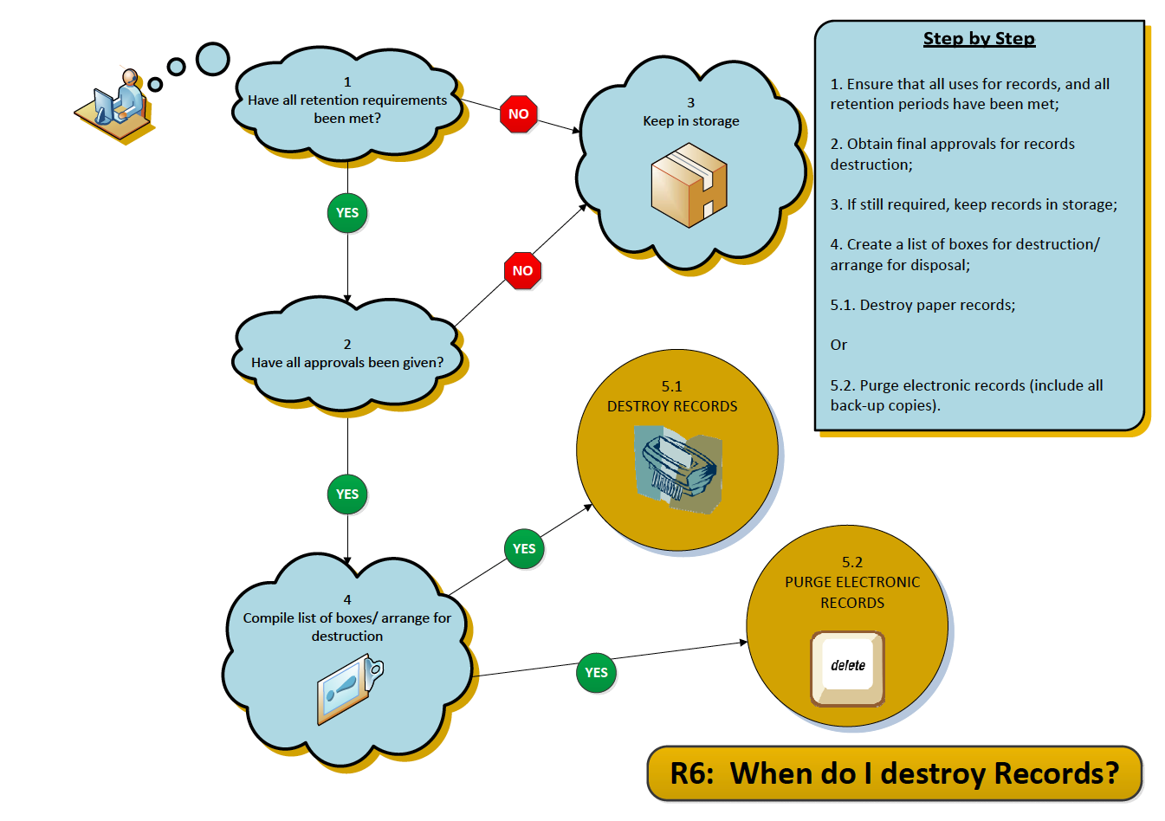

Transitory Records

Transitory records are defined as:

“Records of temporary usefulness that are not an integral part of an administrative or operational records series, that are not regularly filed with a standard classification system, and that are only required for a limited period of time for the completion of an action or the preparation of an ongoing record. Transitory records are not required to meet statutory obligations or to sustain administrative or operational functions”.

In non-government settings, these records are also sometimes referred to as “non- records”, implying that they have no value to an organization.
If these non-records are not managed, the volume can soon clutter up even the most organized information management systems and storage areas. Consequently, First Nations governments are encouraged to establish simple practices to identify transitory records, distinguishing them from the substantive business records, and provide mechanisms for the simple management and routine disposal of these transitory materials, without using the labour and supplies to formally file them or keep them for any longer than necessary. The following list is a sample list of typical transitory records. First Nations governments should confirm or add to this list, as well as to confirm or modify instructions for staff on how long to keep them.

Destroy these transitory records after use:

- Convenience copies – extra copies of records created or retained only for the convenience of reference, including photocopies;

- Stocks of publications, outdated forms, pamphlets, informational materials;

- Working materials and drafts, including rough notes, calculations, preliminary drafts, rough research notes and related materials used for the preparation of correspondence, reports, memoranda or other records, once the finished record has been produced, documented, approved, received and filed into the regular system;

- Transitory electronic data processing records of temporary usefulness that are not an integral part of an administrative or operational record or data file, and are only required for a limited period of time for the completion of a routine action or the preparation of an ongoing record or file. Transitory electronic records can include input source documents, processing records, and output records;

    - Input sources documents are forms or other records used to enter data into a master file, unless required for financial, legal, auditor or other purposes, and become transitory once the update or data entry is validated and back up procedures are completed. Other input records include input screens, input transactions and automated data collection processes used for the same purpose;

    - Transitory processing records include intermediate processing copies and transmittal copies used for transferring or sending copies of information from a master file to another location, that becomes obsolete when the update to the master file is complete;

    - Transitory output records are transitory if they are unnecessary duplicates, extra copies, working materials, drafts or research files used in the preparation of an ongoing record;

- Electronic mail messages, when they meet the definition of transitory records defined above; and

- Unsolicited records, including material in various media which has been forwarded to the First Nation government from external sources, including form letters, pamphlets, catalogues, newspapers, product bulletins, magazines, course and seminar announcements.

Managing Electronic Folders and Electronic Documents

Once the records classification system has been adopted by a First Nations organization, it is logical to organize all information according to the same classification. The next step is establishing the folders and subfolders within the information network environment with the same subjects/titles as the paper records in filing cabinets. However, in addition to setting up the folders, subfolders and documents, the network drives are generally established with specific functions and subjects.

- Network Drive Structure and Folders

Filing electronic documents follows the same logic as filing paper documents. You need work places to create documents, and filing spaces to keep, access and share documents. These work spaces can be created on a network so that staff can file and save documents in a logical manner. Computer technology staff can then manage the security and back up requirements to protect the network.

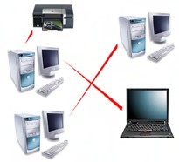

The following is an example of a network environment map and organization structure:

DRIVE | FUNCTION
C | The local hard drive on each computer  Individual staff stores files locally in the computer;  Files are not accessible to the network, and are not backed up by network procedures  NOT RECOMMENDED except when travelling with a lap top
H | The work area for individual staff  Staff members store files of work in progress;  Files are on the network, and are backed up by network procedures;  Files are organized by functions/subjects according to the Records Classification
P | Confidential files, for the specific use of designated staff  Files are on the network, and backed up by network processes  Files are organized by functions/subject folders according to the Records Classification  Files are READ ONLY, and not removed except by network administrator
S | The central filing area for electronic documents  ALL final copies & shared documents prepared by ALL staff  Files are on the network, and backed up by network processes  Files are organized by functions/subject folders according to the Records Classification  Documents are named according to a standard naming convention (see notes on Document Naming)  Files are READ ONLY, and not removed except by network administrator
X | The archived and historic directories  Files are on the network, and backed up by network processes  Files are organized by functions/subject folders according to the Records Classification  Files are accessible through the network administrator  Files are READ ONLY, and not removed except by network administrator
Z | The data files for applications  Files are organized by application name, and are backed up by network processes

Insert Print Screen

All files must be saved on the server, in the appropriate shared directory (network drive). This serves several purposes, namely to avoid multiple copies of files, to aid in backups, and to help quickly locate files. Documents in local hard drives can’t be shared; they are not secure; they will not be saved in the nightly backups, and desktop computers and their hard disks can generally be overwritten or replaced on very short notice.

For working documents that do not need to be shared with others in the office, or for a work space, staff use the H: drive, which points to a personal folder on the server

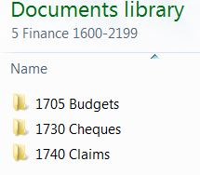
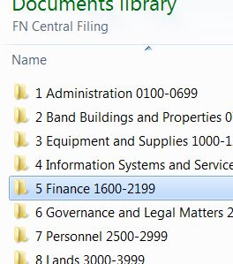
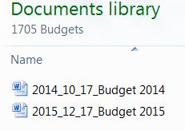

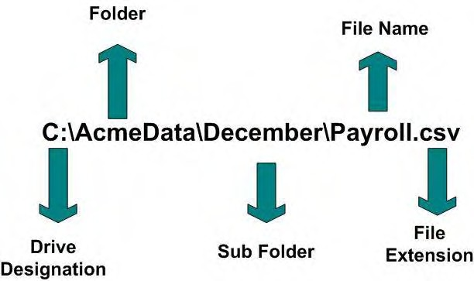
- Document Naming Conventions

The following recommended procedures for naming electronic documents are to be applied when electronic documents are created or received. These naming conventions will assist all staff to locate and retrieve electronic documents, and to make distinctions about different versions.

There are seven elements to be included in each name:

  - Title –word(s) that clearly describes the content of the document, and will be logical to the user for searching and retrieving;

  - Version – a two-digit version number to facilitate sorting and display of documents;

  - Date – YYYY_MM_DD – significant date relevant to the document, e.g. Version date or publication date;

  - Author – first initial and last name;

  - Business unit/program – name of business unit or program area;

  - Type – document type, e.g. AGD (agenda) AGR (agreement) PRC (procedures). should standardize lists of document types. The use of document types shortens the title of document; and

  - Extension – derived from the application in which the document has been created, e.g. .doc; .xls.

Examples of the naming convention include:

Using the full naming convention, the name of this document would be:

- Document Naming Conventions_V09_2011-0701_sb_fnps _PRC.doc;

- Elements are Title_Version_Date_Author_Organization_Type_extention;

Using the folder structure to include some of the document name, for example, for Chief and Council Meetings. Within the folder there is another folder for minutes by date. The folder structure is thus Chief and Council\Meetings\Minutes. The naming convention may consist of:

- Meeting Date_Version_Author.doc;

- 2010-07-01_V01_sbradley.doc;

- 2010-07-01_V02_sbradley.doc;

The title of the document is the meeting date, but because part of the name is dependent upon the folder structure, the context of the folders is also important, and if the document is moved to another folder, the name must be expanded to include the Chief and Council Meeting portion of the name.

Where there is the capability to search on metadata elements, the name of the document can be simplified to:

- Document Naming Conventions_V09_2010-07-01.doc; and

- Other elements, such as author, will be captured in the document metadata.

Version number and date are still required to distinguish between versions for those persons who may not know or remember the date when searching for the document.

The Alberta government provides much guidance in all aspects of electronic information management at their Information Management website. Information in this manual was derived from their document naming specification:

Alberta. Information Management Branch. “Naming Conventions for Electronic Documents.” Electronic Information Management. August 2005. https://www.alberta.ca/assets/documents/IM-Naming-Conventions.pdf

- This page left intentionally blank -

