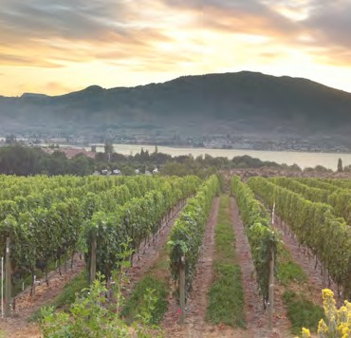
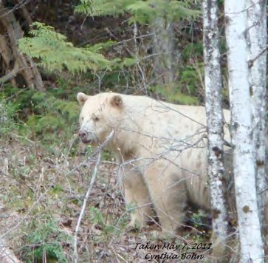
SECTION 8: LANDS

Primary Numbers: 3000 - 3999

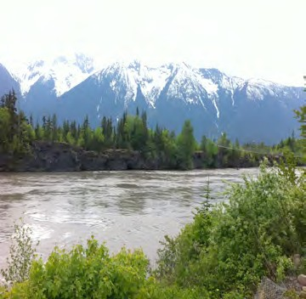

Section 8 includes records relating to the processes of land management and land development within the First Nation organization area. Includes design and mapping, specific types of development, environmental management, land claims and referrals.
For records relating to forestry and natural resources, see Section 13 – Forestry Management.

PRIMARY NUMBERS AND PRIMARY SUBJECTS

3010 Land Administration - General

3120 Crown Land

3180 Demographic Data

3200 Design and Mapping

3240 Development - General
3280 - Commercial/Industrial
3300 - Residential
3320 - Waterfront

3400 Development Permits

3440 Easements and Rights of Way

3500 Environmental Management - General

3600 Land - Preliminary Review

3620 Land Claims

3700 Land Records

3800 Referrals

3850 Restrictive Covenants

3900 Zoning and Rezoning

A SA FD
3010 LAND ADMINISTRATION – GENERAL

Includes records relating to the administration of land relating matters which are not found elsewhere in this section. Land administration covers the management of all land-relating matters within the First Nation organization jurisdiction.

-01 General CY + 1 6y D

3120 CROWN LAND

Includes records relating to crown land in or adjacent to the First Nation organization jurisdiction.

-01 General CY + 1 6y D
-20 Individual crown parcels, by number SO* nil P
(*SO = until no longer crown land)

3180 DEMOGRAPHIC DATA

Includes records relating to demographic data and statistics about the First Nation organization jurisdiction.

-01 General CY + 1 6y D
-02 Census data (Statistics Canada) SO nil P

3200 DESIGN AND MAPPING

Includes records relating to design and survey services and procedures, in house design, design standards and specifications. Also includes GIS mapping, aerial photographs and topographical maps.

-01 General CY + 1 6y D
-02 Design Standards and specifications SO* 6y P
(*SO = until updated or replaced)
-20 Mapping projects SO* nil P
- Fire Protection Mapping

3240 DEVELOPMENT – GENERAL

Includes records relating to the general development activities, functions and proposals for the community.

-01 General CY + 1 6y D

3280 DEVELOPMENT – COMMERCIAL/INDUSTRIAL

Includes general records relating to commercial and/or industrial development of properties.

-01 General CY + 1 6y D
-20 Projects, by name SO* nil P
(*SO = until completed)

A SA FD

3300 DEVELOPMENT – RESIDENTIAL

Includes general records relating to residential development of properties.

-01 General CY + 1 6y D
-20 Projects, by name SO* nil P
(*SO = until completed)

3320 DEVELOPMENT – WATERFRONT

Includes general records relating to planning and development of waterfront properties.

-01 General CY + 1 6y D
-20 Projects, by name SO* nil P
(*SO = until completed)

3400 DEVELOPMENT PERMITS

Includes records relating to the application, issuance and management of development permits and variance permits within the First Nation organization area jurisdiction.

-01 General CY + 1 6y D
-20 Permits (individual) arranged by year and permit number SO* + 1 6y P
(*SO = until completion of permit)
-30 Development variance permits arranged by year and permit SO + 1 6y P
number

3440 EASEMENTS AND RIGHTS OF WAY

Includes records relating to the granting of easements and rights of way.

-01 General CY + 1 6y D
-20 Easements, by address SO* nil P
-30 Rights of way, by address SO* nil P
(*SO = filing of quit claim, otherwise permanent)

3500 ENVIRONMENTAL MANAGEMENT – GENERAL

Includes records relating to environmental control issues, assessments, functions and activities. Also includes environmental management issues, by type (e.g. air quality control, pesticides and herbicides, oil spills, gas spills, etc.

-01 General CY + 1 6y D
-02 Environmental Sustainability Plan SO nil P
-03 Ecosystems CY + 1 6y P
-20 Incidents, by date, location CY + 1 6y P
-30 Environmental issues, by type CY + 1 6y P
- Species at Risk
- Archeological sites

A SA FD

3600 LAND – PRELIMINARY REVIEW

Includes records relating to application and analysis of proposed changes for any community development, such as building, rezoning, sub-division, etc.

-01 General CY + 1 6y D
-20 Projects, by title, applicant, date SO* nil P
(*SO = until completion of review; approved reviews move to project file)

3620 LAND CLAIMS

Includes records relating to land claims, including specific claims.

-01 General CY + 1 6y D
-20 Specific claims, by name, location SO* 6y P
(*SO = upon expiry and settlement of outstanding claims)

3700 LAND RECORDS

Includes records relating to individual lots within the First Nation organization jurisdiction. Also includes information from the INAC Land Registry.

-01 General CY + 1 6y D
-02 Land records, by lot number

3800 REFERRALS

Includes records relating to referrals from the Provincial Government of British Columbia, Regional District and other parties. This primary subject includes all referrals to the First Nation organization and is retained after the completed referral). For the forestry component of referrals, see primary 6250.

-01 General CY + 1 6y D
-20 Referrals, by number SO* nil P
(*SO = until processed)

3850 RESTRICTIVE COVENANTS

Includes records relating to the granting of restrictive covenants.

-01 General CY + 1 6y D
-20 Restrictive covenants SO* nil P
(*SO = upon completion)

3900 ZONING AND REZONING -?

Includes records relating to the application and process for zoning and rezoning properties within the First Nation organization jurisdiction.

-01 General CY + 1 6y D
-20 Applications by year, application SO*+ 1 6y P
(*SO = when completed)

