SECTION 2: BUILDINGS, FACILITIES
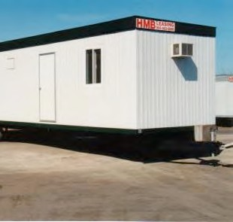
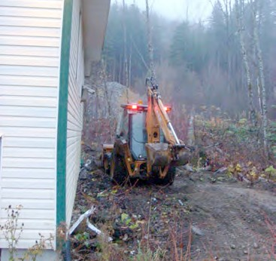
AND PROPERTIES

Primary Numbers: 0700 – 0999

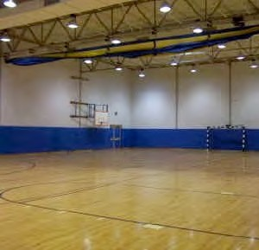

Section 2 is concerned with subjects involving the acquisition of accommodation for First Nation organization administration and operations through the purchase or rental of existing buildings and land, or through the construction of new buildings and facilities. These properties are altered, developed and maintained according to the particular needs of the First Nation organization administration.

For housing of First Nation organization members, see Section 9, Housing. For fire prevention, see Section 17, Protective Services.

PRIMARY NUMBERS AND PRIMARY SUBJECTS

0710 Buildings, Facilities and Properties – General

0730 Buildings – General
0810 – Individual

0890 Properties – General

0970 Utilities – General

A SA FD
0710 BUILDINGS, FACILITIES AND PROPERTIES – GENERAL

Includes records relating to buildings, facilities and properties for the First Nation administration and operations, which are not found elsewhere in this section.
For physical security of buildings, facilities and properties see primary 0680.

-01 General CY + 1 1y D

0730 BUILDINGS – GENERAL

Includes records relating to buildings and facilities, activities and programs, including acquisition, alterations and repairs, construction, damages, disposal and maintenance for the First Nation administration and operations.
Includes building directories, addresses, locations, etc. For individual buildings, see primary 0810.

-01 General CY + 1 3y D

0810 BUILDINGS – INDIVIDUAL

Includes records for individual buildings, facilities and structures owned by the First Nation administration and operations.

File records by standard building number, using the following secondary categories:
-01 General
-02 Land acquisition
-03 Planning, design and construction
-04 Modifications and alterations
-05 Maintenance
-06 Parking
-07 Disposal

-01 General CY + 1 5y SR*
-20 Individual buildings, by name SO 7y P
(*SR = retain precedents and statistics permanently)

0890 PROPERTIES – GENERAL

Includes records relating to the properties owned by the First Nation organization for administration or operating purposes. For individual properties occupied by First Nation organization members or tenants see primary 3700.

-01 General CY + 1 6y D
-20 Individual properties, by address SO nil P

For a further breakdown within an individual property by name, use the following categories:
-01 General
-02 Land acquisition
-03 Planning, design and construction
-04 Modifications and alterations
-05 Maintenance
-06 Parking
-07 Disposal

A SA FD

0970 UTILITIES – GENERAL

Includes records relating to the various building utilities: environmental controls such as air conditioning, ventilation and heating, garbage disposal, gas, lighting and electrical systems and facilities, and water and plumbing facilities.

-01 General CY + 1 6y D
-02 Heating systems CY + 1 6y D
-03 Air conditioning/ventilation CY + 1 6y D
-04 Garbage disposal CY + 1 6y D
-05 Gas CY + 1 6y D
-06 Lighting and electrical systems CY + 1 6y D
-07 Water and plumbing systems CY + 1 6y D
-08 Energy Management CY + 1 6y D

