SECTION 19: CULTURE AND
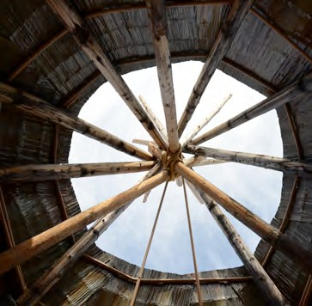
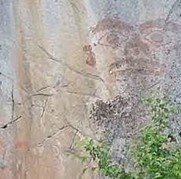
HISTORY

Primary Numbers: 9000 – 9399

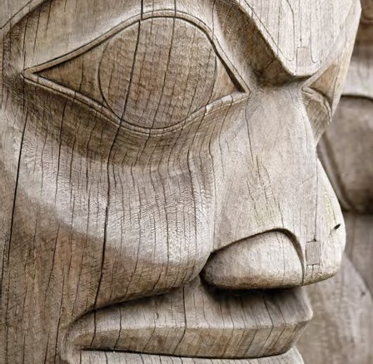

Section 19 includes subjects relating to the preservation of traditional knowledge and culture of the First Nation organization. Includes relationships with committees and activities to collect and map traditional territories, and liaison with other First Nations and tribal councils for the preservation of language, culture and traditions.

PRIMARY NUMBERS AND PRIMARY SUBJECTS

9010 Culture and History - General

9020 Archives

9050 Cultural Activities

9100 Heritage Conservation

9120 Historic and Heritage Sites

9200 Language Use and Studies

9300 Traditional Use and Studies

A SA FD
9010 CULTURE AND HISTORY – GENERAL

Includes records of a general nature relating to the culture and history of the First Nation organization community, which are not found elsewhere in this section.

-01 General CY + 1 6y D

9020 ARCHIVES

Includes records relating to the administration, operations and functions of community archives. For records relating to the internal Band office archives, see primary 1320.

-01 General CY + 1 6y D

9050 CULTURAL ACTIVITIES

Includes records of a general nature relating to arts and cultural activities.

-01 General CY + 1 6y D

9100 HERITAGE CONSERVATION

Includes records relating to the identification, regulation and preservation of heritage properties within the First Nation organization jurisdiction. Community heritage properties are located in primary 0810.

-01 General CY + 1 6y D

9120 HISTORIC AND HERITAGE SITES

Includes records relating to the identification, regulation and preservation of archaeological sites.

-01 General CY + 1 6y D
-20 Projects, by name SO* nil P
(*SO + until completed)

9200 LANGUAGE USE AND STUDIES

Includes records relating to the study and use of the First Nation organization language.

-01 General CY + 1 6y D
-20 Programs, by name SO* nil P
(*SO = until program is completed)

A SA FD

9300 TRADITIONAL USE STUDIES

Includes records relating to the development and completion of traditional use studies within the First Nation organization jurisdiction.

-01 General CY + 1 6y D
-20 Programs, by name SO* nil P
(*SO = until program is completed)

