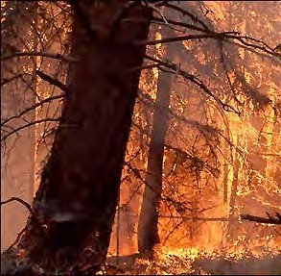
SECTION 18: PROTECTIVE SERVICES

Primary Numbers: 8500 – 8999

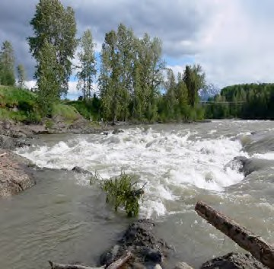

Section 18 includes subjects relating to the protective services provided by the First Nation organization. Emergency programs, fire protection and police protection are included in this section.

PRIMARY NUMBERS AND PRIMARY SUBJECTS

8510 Protective Services – General

8600 Ambulance Services

8630 Emergency Measures - General

8700 Fire Protection - General
8780 - Volunteer Fire Department

8900 Police Services - General
8920 - Issues
8940 - Community Relations

A SA FD

8510 PROTECTIVE SERVICES – GENERAL

Includes records of a general nature relating to the protection of persons in the First Nation organization jurisdiction, which are not found elsewhere in this section.

-01 General CY + 1 6y D

8600 AMBULANCE SERVICES

Includes records relating to the monitoring and liaison of ambulance services/Lifeboat Services with the First Nation organization.

-01 General CY + 1 6y D

8630 EMERGENCY MEASURES – GENERAL

Includes records relating to policies and plans for provision of assistance in emergency situations, for plans for the continuation of operations of the First Nation organization in case of emergency, civil defense planning actions and precautions, etc.

-01 General CY + 1 6y D
-02 Provincial SO P
-01 General
-02 Provincial Emergency Plan
-03 Regional
-03 First Nation organization SO P
-01 General
-02 Emergency Operational Plan
-04 Evacuation Routes
-05 Mutual Aid
-06 Floods
-07 Emergency relief
-08 Contact personnel

8700 FIRE PROTECTION – GENERAL

Includes records relating to provision of fire protection services offered within the First Nation organization jurisdiction, which are not found elsewhere in this section.

-01 General CY + 1 6y D

8750 FIRE PROTECTION – VOLUNTEER FIRE DEPARTMENT

Includes records relating to the provision of the volunteer fire department to the First Nation organization jurisdiction.

-01 General CY + 1 6y D

A SA FD

8800 POLICE SERVICES – GENERAL

Includes records of a general nature relating to the provision of police services to the First Nation organization jurisdiction, which are not found elsewhere in this section.

-01 General CY + 1 6y D
-02 RCMP CY + 1 6y D

8820 POLICE SERVICES – ISSUES

Includes records relating to crime relating issues such as vandalism, etc.

-01 General CY + 1 6y D

8840 POLICE SERVICES – COMMUNITY RELATIONS

Includes records relating to the relationships between the police department and the community. Includes information on individual community programs.

-01 General CY + 1 6y D
-20 Programs, by name CY + 1 6y SR*
(*SR = retain policy and program information)

