SECTION 17: MEMBERSHIP/
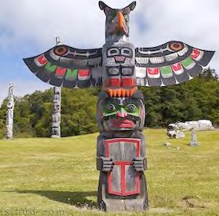
CITIZENSHIP

Primary Numbers: 8300 - 8699

Section 17 includes subjects relating to Membership/Citizenship of the First Nation organization.

PRIMARY NUMBERS AND PRIMARY SUBJECTS

8320 Membership – General
8400 – Applications
8440 – Members

A SA FD
8320 MEMBERSHIP – GENERAL

Includes records relating to the general membership matters which are not found elsewhere in this section.

-01 General CY + 1 6y D

8400 MEMBERSHIP – APPLICATIONS

Includes records relating to the applications for membership in the First Nation organization. Includes application forms and individual applications.

-01 General CY + 1 6y D
-02 Application forms SO* nil D
-20 Applications, by last name of applicant SO** nil P
(*SO = until revised)
(**SO = until accepted or rejected)

8440 MEMBERSHIP – MEMBERS

Includes records relating to the current members of the First Nation organization. Includes the member registry as well as records of individual members. For individual members, each record includes application, birth certificate other identification and supporting documents. Upon death and receipt of the death certificate, active member records become deceased member records.

-01 General CY + 1 6y D
-02 Member registry SO* nil P
-03 Status cards SO* nil P
-20 Individual members, A-Z by last name SO** nil P
-30 Deceased members, A-Z by last name SO*** nil P
(*SO = until updated)
(**SO = until death)
(***SO = when death certificate is received)

