SECTION 15: FISHERIES
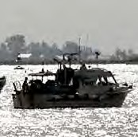
MANAGEMENT

Primary Numbers: 7000 – 7799

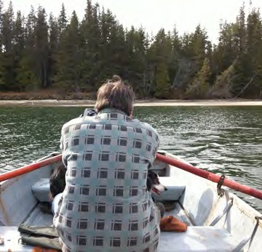

This section includes records relating to the management of fisheries, shellfish and watershed resources within First Nations jurisdiction. Subjects include the administration of licenses and permits, the management of the food fish program, the various watershed management programs, the maintenance of the docks and floats, the maintenance of the boats, and the various rivers and creeks.

PRIMARY NUMBERS AND PRIMARY SUBJECTS

7010 Fisheries Management – General

7100 Boats – General
7120 – Individual

7200 Docks and Floats

7300 Food Fish – General
7320 – Coho/Chinook/Chum
7340 – Halibut
7360 – Herring Roe
7380 – Sockeye

7400 Kelp Program

7500 Licensing, Permits

7600 Shellfish Nursery System

7700 Watershed Management
7720 – Individual

A SA FD
7010 FISHERIES MANAGEMENT – GENERAL

Includes records relating to the general administration of fisheries, including shellfish and watershed management activities, which are not found elsewhere in this section.

-01 General CY + 1 6y D

7100 BOATS - GENERAL

Includes records relating to the general administration and operation of boats which are not found elsewhere in this section.

-01 General CY + 1 6y D

7120 BOATS – INDIVIDUAL

Includes records relating to the operation and maintenance of the individual boats in the First Nations fleet.

-01 General SO* nil P
-20 Individual boats, by name SO* nil P
(*SO = when no longer owned)

7200 DOCKS AND FLOATS

Includes records relating to the docks and floats, including operation, maintenance and repairs.

-01 General CY + 1 6y D
-20 Docks, by location SO* + 1 6y D
-30 Floats, by location SO* + 1 6y D
(*SO = until updated or replaced)

7300 FOOD FISH – GENERAL

Includes records of a general nature relating to the food fish programs, including food fish processing.

-01 General CY + 1 6y D
-20 Processing, by year CY + 1 6y D

7320 FOOD FISH – COHO, CHINOOK, CHUM SALMON

Includes records relating to the food fishery, including coho, chinook and chum salmon.

-01 General SO* nil P
-02 Reports SO* nil P
-20 Chinook food fish, by year SO* nil P
-30 Coho food fish, by year SO* nil P

A SA FD

7340 FOOD FISH – HALIBUT

Includes records relating to the halibut food fishery.

-01 General SO* nil P
-02 Reports SO* nil P
-20 Halibut food fish, by year SO* nil P

7360 FOOD FISH – HERRING ROE

Includes records relating to the herring roe food fishery.

-01 General SO* nil P
-02 Reports SO* nil P
-20 Herring roe food fish, by year SO* nil P

7380 FOOD FISH – SOCKEYE

Includes records relating to the herring roe food fishery.

-01 General SO* nil P
-02 Reports SO* nil P
-20 Sockeye food fish, by year SO* nil P

7400 KELP PROGRAM

Includes records relating to the kelp program.

-01 General SO* nil P
-02 Reports SO* nil P
-20 Program, by year

7500 LICENSES AND PERMITS

Includes records relating to fishing licenses and permits.

-01 General CY + 1 6y D
-02 Reports SO* nil D
-20 Permits, by year SO* + 1 10y D
-30 Licenses, by year SO* + 1 6y D

7600 SHELLFISH NURSERY SYSTEM

Includes records relating to the shellfish nursery system.

-01 General SO* nil P
-20 Individual nurseries, by location SO* nil P
(*SO = until company is closed or sold)

A SA FD

7700 WATERSHED MANAGEMENT

Includes records of a general nature relating to the watershed management system, including watershed restoration.

-01 General CY + 1 6y D

7720 WATERSHED MANAGEMENT – INDIVIDUAL

Includes records relating to the individual watershed management systems, including watershed restoration.

-01 General SO* nil P

