SECTION 13: PUBLIC WORKS AND
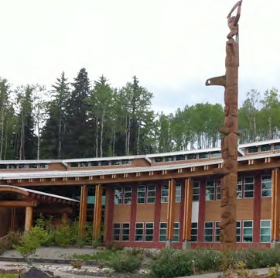
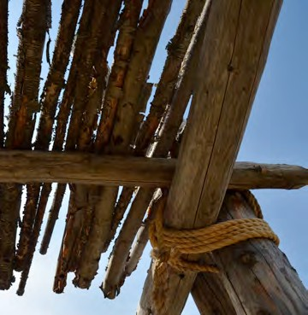
COMMUNITY INFRASTRUCTURE

Primary Numbers: 6000 – 6499

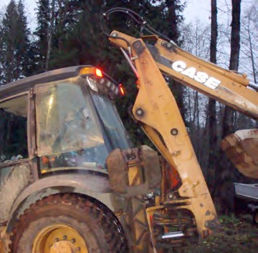

Section 13 includes subjects relating to the engineering, construction and maintenance of First Nation community infrastructure, including streets and roads, water service, septic systems, solid waste removal, etc.

PRIMARY NUMBERS AND PRIMARY SUBJECTS

6010 Public Works and Community Infrastructure - General

6025 Drainage and Flood Control

6100 Inspection and Testing

6130 Public Works Projects

6200 Septic Systems

6250 Solid Waste Disposal

6300 Streets and Roads

6350 Utilities - General

6400 Water Supply and Distribution

SECTION 14: FORESTRY
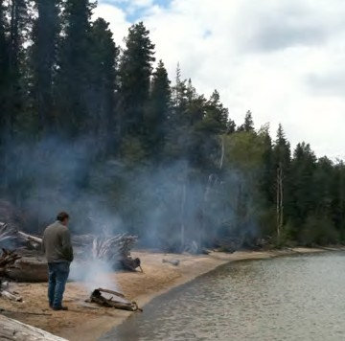
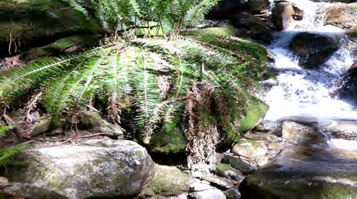
MANAGEMENT

Primary Numbers: 6500 – 6999

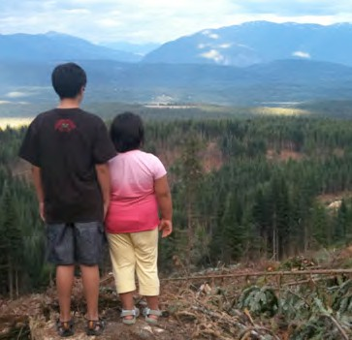

Section 14 includes the subjects relating to the administration and management of forestry.

PRIMARY NUMBERS AND PRIMARY SUBJECTS

6510 Forestry Management - General
6550 - Certification
6600 - Contracts
6700 - Permits
6800 - Plans and Projects
6900 - Mill
6960 - Sales

A SA FD
6510 FORESTRY MANAGEMENT – GENERAL

Includes records relating to the administration, development and management of forestry resources within the First Nation organization jurisdiction.

-01 General CY + 1 6y D
-02 Forestry management issues CY + 1 6y P
-20 Forestry areas, by location CY + 1 6y P

6550 FORESTRY MANAGEMENT – CERTIFICATION

Includes records relating to WorkSafe and Green Certification of forestry operations and employees of the First Nation organization.

-01 General CY + 1 6y D
-02 Green Certification CY + 1 6y P
-03 WorkSafe Certification CY + 1 6y P

6600 FORESTRY MANAGEMENT – CONTRACTS

Includes records relating to contracts for forestry resources of the First Nation organization jurisdiction.

-01 General CY + 1 6y D

6700 FORESTRY MANAGEMENT – PERMITS

Includes records relating to various forestry permits within the First Nation organization jurisdiction. Includes cutting and road permits as well as timber permits issued through INAC.

-01 General CY + 1 6y D
-02 Cutting Permits CY + 1 6y P
-03 Road Permits CY + 1 6y P
-04 Timber Permits – INAC CY + 1 6y _

6800 FORESTRY MANAGEMENT – PLANS AND PROJECTS

Includes records relating to the administration, development and management of forestry plans and projects, including site plans, logging plans, silviculture, forest management plans and salvage – fall and burn projects.

-01 General CY + 1 6y D
-02 Site plans CY + 1 6y D
-03 Logging plans CY + 1 6y D
-04 Silviculture CY + 1 6y D
-05 Forest management plans CY + 1 6y D
-06 Salvage – Fall and Burn projects CY + 1 6y D

A SA FD

6900 FORESTRY MANAGEMENT – MILLS

Includes records relating to the operations and functions of mills operated by the First Nation organization.

-01 General CY + 1 6y D

6960 FORESTRY MANAGEMENT – SALES

Includes records relating to the administration, development and management of forestry resource sales within the First Nation organization jurisdiction.

-01 General CY + 1 6y D

