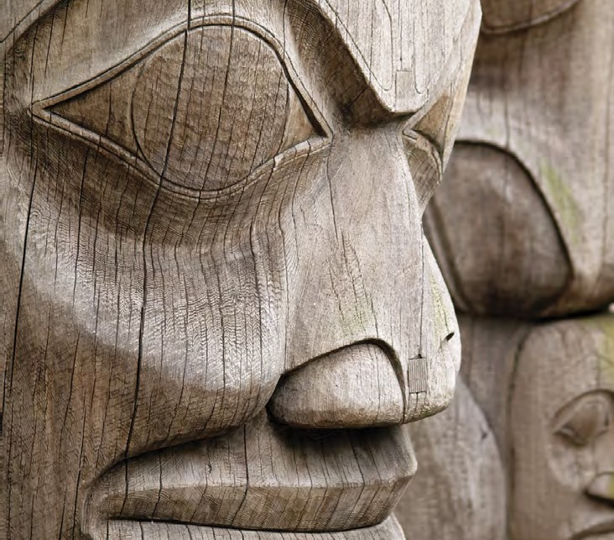

FNS
First Nations Summit

Information Management Toolkit
Information for First Nations Government in BC
Filing Toolkit | Volume 2 – Procedures Manual | 2011

Cataloguing In Publication Data
Will be updated for FNS – new ISBN and copyright
ISBN 0-9781701-0-5

© 2011 First Nations Summit. All rights reserved. No part of this publication may be stored, reproduced, transcribed, translated or transmitted into any other form without the prior written permission of the First Nations Summit.

Without restricting the generality of the foregoing, no one may make commercial use of any content of this publication whatsoever, including selling any information, software, produces or services or displaying or otherwise using any content of this publication on any website.

Disclaimer

The contents of this publication are for general information purposes only and are not intended to provide legal advice or opinion of any kind. The contents of this publication should not be relied upon. The contents of this publication should not be seen as a substitute for obtaining competent legal counsel or advice or other professional advice. If legal advice or counsel or other professional advice is required, the services of a competent professional person should be sought. While the First Nations Summit has made reasonable efforts to ensure that the contents of this publication are accurate, the First Nations Summit does not warrant or guarantee the accuracy, currency or completeness of the contents of this publication. The First Nations Summit expressly disclaims all representations, warranties, conditions and endorsements. In no event shall the First Nations Summit, its directors, agents, consultants or employees be liable for any loss, damages or costs whatsoever, including (without limiting the generality of the foregoing) any direct, indirect, punitive, special, exemplary or consequential damages arising from, or in connection to, any use of any of the contents of this publication.

TABLE OF CONTENTS

Disclaimer Page 3

- Introduction Page 6
  - What are records? Page 7
  - Information Survey or Inventory Page 10
- Daily Operations with Active Records Page 10
  - Introduction Page 13
  - Filing Procedure Page 13
  - Key Records to be Managed Page 13
  - Daily Routine Page 14
  - Creating Cross-References Page 16
  - Creating New Volumes/Folders Page 16
  - File House-keeping tips Page 16
  - Opening new files Page 17
  - Creating new Subject Headings Page 17
  - Outgoing Information Page 18
  - Maintaining File Lists Page 20
  - Duplication of Records and Offices of Primary Responsibility (OPR) Page 20
  - Circulating Files Page 20
  - Records Security Page 21
- Key Records to be Managed Page 22
  - The components of a clear business document Page 22
  - The key records series Page 22
    - Agreements and Contracts Page 24
    - Band Council Resolutions Page 24
    - Letters to Chief and Council Page 31
    - Reports to Chief and Council Page 31
    - Minutes of Chief and Council Meetings Page 32

- Filing cabinets, folders and labels Page 34

  - Cabinets Page 34

  - Folders Page 34

  - Label Template Page 36

- File Closing, Storage and Destruction Procedures Page 37

  - Records activities cease Page 37

  - Closing files Page 39

  - Boxing and storing paper files Page 39

  - Records storage space Page 42

  - Records destruction Page 42

  - The Disposal Process Page 43

- Transitory Records Page 45

- Managing Electronic Folders and Electronic Documents Page 47

  - Network Drive Structure and Folders Page 47

  - Document Naming Conventions Page 49

Appendix 1 – Records Classification and Retention Schedule
- Introduction to the Records Classification System

and Retention Schedule Page 8

- Structure and Logic of the Classification System and

Retention Schedule Page 8

  - Sections Page 8

  - Primary and Secondary Subjects Page 9

  - Retention Periods Page 9

- Records Classification and Retention Schedule Page 10

Appendix 2 – Legal Citations

Introduction

The information in this volume of the Information Management Toolkit is provided for the designated records management staff member, who will have daily responsibility for the records of the First Nations government.

The contents of this volume were originally created by the First Nations Public Service (FNPS) of BC in 2011. The FNPS ceased operations in 2012, and the First Nations Summit has since assumed responsibility for the content and updating of this volume.

This section includes information on:

  - Conducting an information survey, to determine what information exits in the office and related organizations.

  - What is a record

  - How to file records using the model records classification and records retention system (included as Appendix 1)

  - How to manage records for daily work

  - The type of filing equipment and supplies to select

  - Closing files when they are no longer referenced

  - Storing records until their useful life is over, and

  - Destroying or saving records for future reference, including obtaining the appropriate approvals

A model records retention schedule is included with the classification system. First Nations should confirm that the recommendations for retention are suitable for their requirements.

In addition, research was undertaken in 2011 to locate any regulations for retention of records. With the passage of time, organizations should undertake their own research to ensure current retention requirements.

There is also a section about electronic records that includes information on:

- Organizing electronic records in directories

- A model electronic document naming convention.

Finally, this tool kit as a whole is intended to be the “Records Management Manual” that is referenced in the Information Management Resolution and Policies, and also in the Canadian standards for maintaining records as evidence. As such, the procedures manual serves as the eyewitness to the credibility of the First Nations records keeping processes, and will support the use of records as evidence.

- What are records?

Records= emails, BCRs, mail, letters, maps, documents, reports, etc.

Records are defined as “information created, received or maintained as evidence and information by an organization or person, in pursuance of legal obligations or in the transaction of business”.

Depending upon regulations or legal definitions, any document in any format within a First Nations government can be considered a “record”, e.g. paper document, e-mail, map.
Each staff member and elected official must understand this definition, and support the processes that are explained in this volume for collecting, filing and maintaining the records of the organization.

The diagram, “R1 – Is it a record?” shows the step-by-step questions that help to define what a record is. See also diagram “R1a – When is email a Record”.

Once you have defined what records are, your next step is to see what records you have in your organization

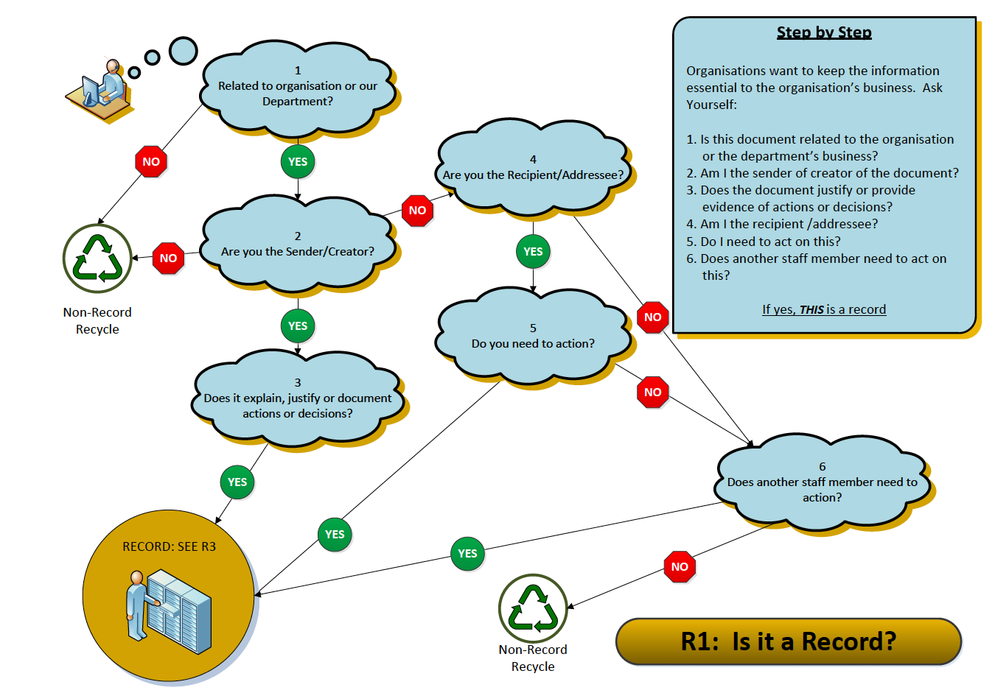
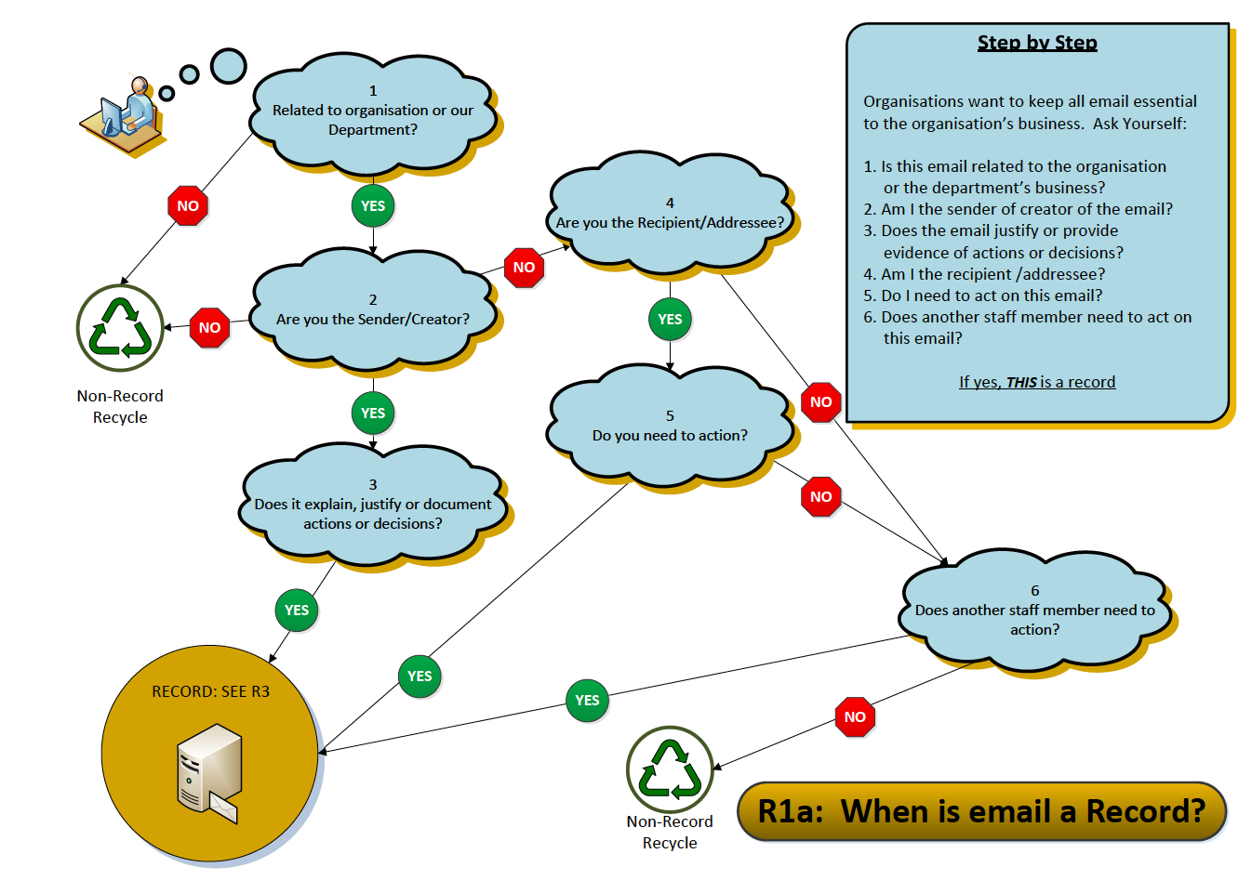
- Information Survey or Inventory

Generally, if you understand what records have been collected in various locations over time, and that there may be mixed collections (e.g. they include a variety of different subjects), then a records survey is a good idea, to get a clearer picture of the amount and subject matter that you will be organizing.

The keys to completing a survey are:

- Be organized about what you want to find out. Use a form to collect the same information for every collection that you identify, and make sure to create a listing of all of the locations. See Form 1 – Information Survey that is included in this section, to show the kinds of details you want to know about your records.

- Set a timetable, and try to complete the survey quickly. This will ensure that you have up to date information, and that you can finish this activity as quickly as possible. If you can, get other staff to help with this survey. Review your form with them and explain that they need to be accurate and clear in describing what they find.

- When you have finished, create a spreadsheet with columns to match the various categories of information you collect from the form. Fill in a line of data for each survey form. When you have all the forms compiled into the spreadsheet, you will have a snapshot of how much information you have, where it is located, and what subject matters are included.

Now, set your priorities for action!

ORGANIZATION X

RECORDS AND INFORMATION SURVEY

DEPT. NAME: DATE:

COMPLETED BY:

RECORDS SERIES TITLE:

DEPARTMENT OR WORK GROUP (If applicable):

DESCRIPTION: Types of documents, how arranged. Note any personal information.
DATE RANGE: (from yr/mo to yr/mo)
VOLUME: (how many inches of files)
FORMAT: (non-paper)
RETENTION PERIOD: (if known)
Note: Attach a file list if one is available.

TYPE OF STORAGE EQUIPMENT: (type of cabinet, or storage method, e.g. tote box)

USE OF SECURITY DEVICES: (locks, passwords, restricted access)

LOCATION: (office, storage room, offsite)

The following information will be obtained from the records custodian, or designated caretaker of the records:

USES OF INFORMATION

Who uses these records? How often are records referenced?

Is information confidential?

Who has access to confidential information?

Is this a vital records series, e.g. what would happen if this information is lost?

Does this information have long term or permanent value to the organization?

Other facts or features of these records?

Information Management Toolkit / Form 1 - Information Survey.doc

