Transitory Records

Transitory records are defined as:

“Records of temporary usefulness that are not an integral part of an administrative or operational records series, that are not regularly filed with a standard classification system, and that are only required for a limited period of time for the completion of an action or the preparation of an ongoing record. Transitory records are not required to meet statutory obligations or to sustain administrative or operational functions”.

In non-government settings, these records are also sometimes referred to as “non- records”, implying that they have no value to an organization.
If these non-records are not managed, the volume can soon clutter up even the most organized information management systems and storage areas. Consequently, First Nations governments are encouraged to establish simple practices to identify transitory records, distinguishing them from the substantive business records, and provide mechanisms for the simple management and routine disposal of these transitory materials, without using the labour and supplies to formally file them or keep them for any longer than necessary. The following list is a sample list of typical transitory records. First Nations governments should confirm or add to this list, as well as to confirm or modify instructions for staff on how long to keep them.

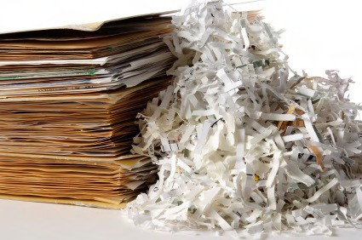

Destroy these transitory records after use:

- Convenience copies – extra copies of records created or retained only for the convenience of reference, including photocopies;

- Stocks of publications, outdated forms, pamphlets, informational materials;

- Working materials and drafts, including rough notes, calculations, preliminary drafts, rough research notes and related materials used for the preparation of correspondence, reports, memoranda or other records, once the finished record has been produced, documented, approved, received and filed into the regular system;

- Transitory electronic data processing records of temporary usefulness that are not an integral part of an administrative or operational record or data file, and are only required for a limited period of time for the completion of a routine action or the preparation of an ongoing record or file. Transitory electronic records can include input source documents, processing records, and output records;

    - Input sources documents are forms or other records used to enter data into a master file, unless required for financial, legal, auditor or other purposes, and become transitory once the update or data entry is validated and back up procedures are completed. Other input records include input screens, input transactions and automated data collection processes used for the same purpose;

    - Transitory processing records include intermediate processing copies and transmittal copies used for transferring or sending copies of information from a master file to another location, that becomes obsolete when the update to the master file is complete;

    - Transitory output records are transitory if they are unnecessary duplicates, extra copies, working materials, drafts or research files used in the preparation of an ongoing record;

- Electronic mail messages, when they meet the definition of transitory records defined above; and

- Unsolicited records, including material in various media which has been forwarded to the First Nation government from external sources, including form letters, pamphlets, catalogues, newspapers, product bulletins, magazines, course and seminar announcements.

