Filing Cabinets, folders and labels

- Cabinets

Drawer style, with roll-out drawers, continue to be purchased for paper filing. These are now called “Victorians” and are discouraged, because they do not provide the greatest storage capacity.

Lateral cabinets, while larger in size of drawer, are also inefficient for storage of large collections of records.

The recommended style for the centralized collections within the offices is a fixed shelf type, rather than a rollout style, to achieve the maximum storage capacity for the floor area available.

These should be made of heavy gauge steel, to support the weight of fully loaded drawers of records. These are dimensionally matched on the outside of the cabinet, and have two sizes of internal space – one designed for letter/legal correspondence filing, and the other for binder storage.

Your chance to upgrade comes when new storage equipment is purchased. Always select the most efficient style of cabinet for the space available

Fixed Shelf Cabinets

If Storage of multimedia materials is required, it is recommended that modular or specialized cabinets be selected with configurations to hold different sizes of media, e,g. for computer disks

Modular Cabinet

All cabinets should have locks and all information should be locked at night.

- Folders

For file drawers, a top tab folder is required, to display labels across the top of the folder. Most staff will continue to use this style for the folders they retain in their office cabinets or credenzas.

The file folder required for fixed shelf style cabinets is an "end tab" folder, which enables labels to be attached across the end of the folder.

The preferred style is with a reinforced mylar fold to provide extra strength. The preferred colour for most categories of information is manila. In addition coloured folders may be used for designated types of records.

Letter size rather than legal size folder are recommended, to save costs, and to reflect the current standardization of most paper records to letter size.

Folders may be obtained through office suppliers, and/or specialty vendors.

It is recommended that documents be fastened into the file on a post or filing clip, to save the loss of documents, and keep the documents in filing order. However, some organizations prefer to keep the documents loose in the folders, rather than mark them with a hole or risk tearing on a filing post.

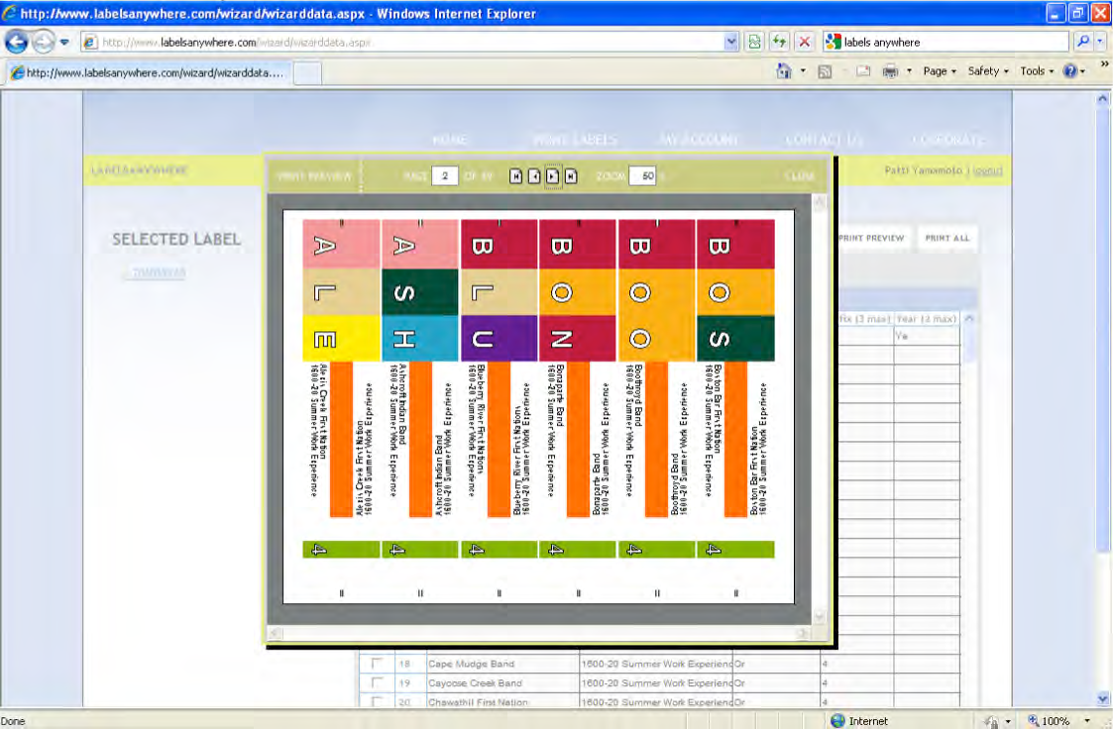

Colour coded labelling speeds up retrieval of records by 40 percent, and is highly recommended for the benefits it will provide. Where end tab folders are used, specialty colour coded labelling is employed as part of the labelling procedure

Labelling software and ink jet printing to produce labels

This illustration shows an alphabetic colour label, printed on label stock that can be attached to the top or the end tab folder by wrapping around the tab. The colour coding

will display on a shelf, enabling you to quickly locate files out of order, as well as to identify records in series.

Suppliers of labeling software and label stock enable you to produce your colour labels as you need them.

Label Template

Each file folder (top tab or side tab) must have a descriptive label affixed to the top right hand corner of the front of the folder (end tab) or on the tab (top tab). The sample here uses Avery 5163 or equivalent size label, to give enough type space for a detailed label.

The label template has been set up in MS Word as follows:

Left side:
Top line - Primary number; second line – secondary number or code; third line – tertiary number (if required)

Right side:
Top line folder name (bold, underlined)
2nd line Blank
3rd line Secondary Classification (Arial 12 pt.Capitals)
4th line Primary Classification (Arial 12 pt.)

Other lines if necessary for tertiary classification, otherwise blank space

7th line (Retention period /when approved retention schedule has been passed); Date file is opened – right justified

Sample:
2330-20  09/08/21 | Meeting – August 21, 2009
MEETINGS BY DATE
Chief and Council Committees – Finance Committee

 | SO-nil-P | 2009 -

Each sheet holds ten labels. Therefore, it is recommended that new folders be created in batches of ten. Save the label document as you prepare them, to help you track what new folders have been opened. Labels for other media will be configured as required.

