Key Records To Be Managed

The components of a clear business document

In order for business correspondence to be considered reliable and authentic, it should be created in a consistent manner, with the date, author and other elements of the letter clearly expressed. Use the following template as a model to ensure that the required components are present so that the letter will be considered authentic, and useful as evidence in the future.

The “essential” or mandatory items are circled in red, and the optional items are enclosed in blue boxes.

See - B1 – Basic Document Creation Procedure

The key records series

Within the First Nations government, there are several sets of record types that are duplicated, and then sometimes lost. These records include:

  - Agreements and contracts
  - Band Council Resolutions,
  - the meetings of Chief and Council,
  - correspondence with Chief and Council, and
  - reports to Chief and Council

The following section provides a series of recommended steps to ensure that all staff receive the necessary information to do their work, and the original or signed documents, as evidence of decisions made, are sent for filing.

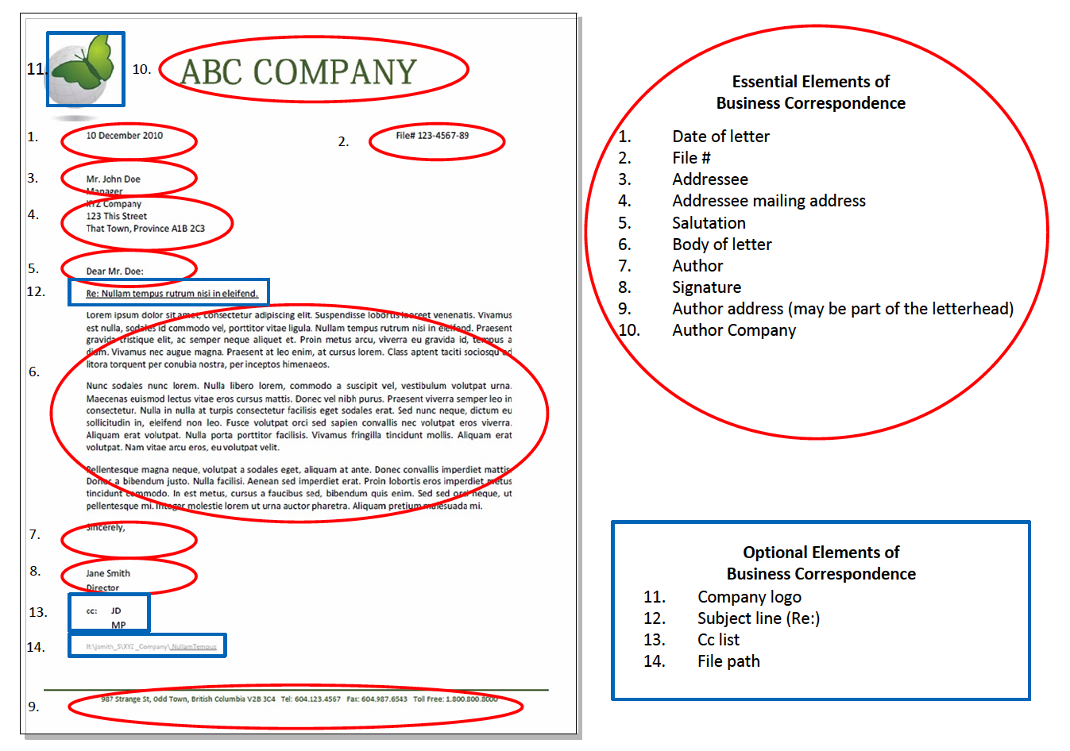

Agreements and Contracts – see B6 – Agreements & Contracts

There can be disagreement about where to file signed agreements, contracts and similar documents. Management staff are responsible for overseeing programs, where the supervision of services provided under terms in contracts and agreements are a key component. However, it is easy to misfile an original agreement with working papers, and then have the working papers be removed, stored or lost. Auditors will always request a review of signed contracts and agreements as part of their annual review of First Nations government operations.

Consequently, it is recommended that all original signed agreements be filed centrally, or with the Director of Finance, for safekeeping, and that copies of agreements are filed within the relevant subject file along with the working papers and reports associated with the agreement. If necessary, staff may also keep reference copies of these documents to track their daily work. As with minutes of Chief and Council, it is recommended that all agreements and contracts be filed in fireproof filing cabinets for safekeeping.

Band council resolutions – see B2 – Band Council Resolutions

Band council resolutions (BCRs) are essential documents that provide evidence of decision making, particularly about financial matters. Frequently, original BCRs are required for outside organizations, and it is easy to lose track of the sequence and location of these documents. The following diagram provides recommendations for the creation, distribution and filing of these documents.

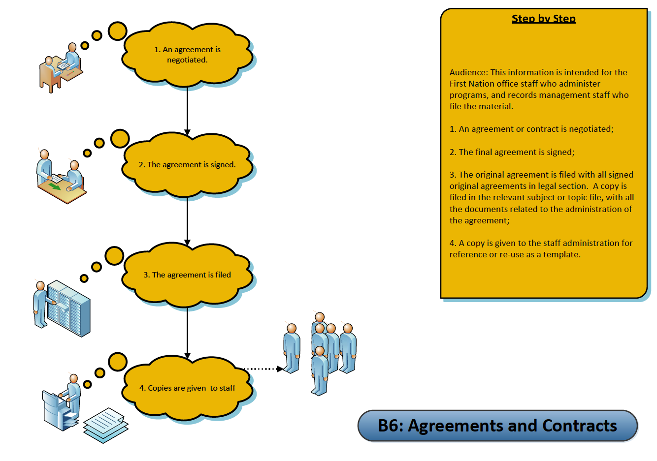

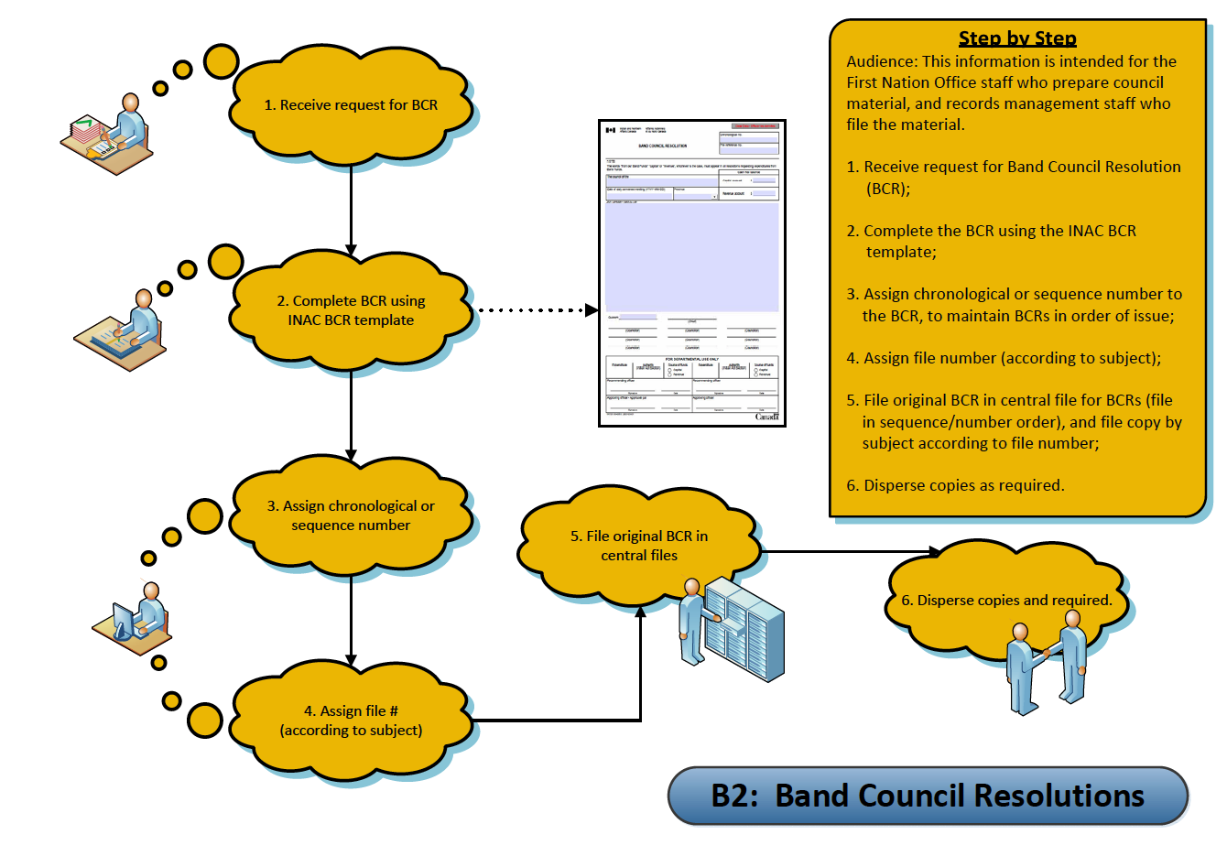

A template from Aboriginal Affairs and Northern Development Canada is included in this section as a form sample. – see Forms – BCR Form

It is recommended that you assign a sequence number to each band council resolution as it is passed. This sequence number can be a two-part number, with the year as the first part of the number, and then a sequential number as each one is passed. For example, 2011-15 would be the number for the 15th BCR passed in 2011. This sequence numbering tracks each BCR. Keep a listing in a registry or log, a list or spreadsheet by the sequence number, and add other important facts about the BCR, including the subject or topic of the BCR, department requesting, and additional notes you find useful. File one copy in a file called “Band Council Resolutions” in sequence number order.

File another copy by the subject of the BCR. This two copy filing system will enable you to later review what the BCR was about as well as find it in the sequence in which it was passed.

Example of BCR Registry:
BCR Registry Number | BCR File number | Date of BCR | Subject of BCR | Approval date | Original sent to | Subject File number
2011-15 | 2300-20 | 2011-03-15 | Funds for post secondary student travel | 2011-04-01 | Education Department | 5700-50
2011-16 | 2300-20 | 2011-05-29 | Approval for water study | 2011-06-29 | Capital Works Department | 6400-01

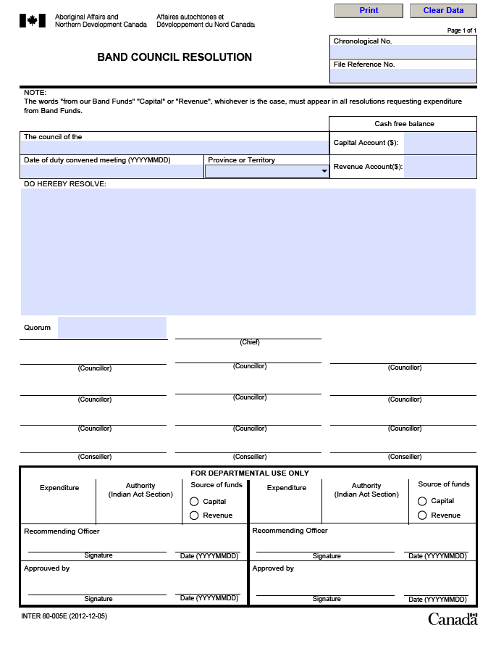

Letters to Chief and Council – see B3 – Letters to Chief and Council

Letters to Chief and Council are about many different subjects. They will be discussed at a meeting, and usually require decisions or actions for follow up by staff. They are similar to BCR’s, in that staff need to file these in several ways, first in the agenda file or meeting file by the date of the meeting when they were considered by the chief and council. However, they may also need to be filed by the subject of the letter, and also tracked by the staff member who is assigned to follow up on the matter raised. These different requirements will require copies of the letter to be filed in two locations within the filing system.

Here is an example of a registry of letters to chief and council:

Letter Registry number | Date Received | Chief and Council meeting date | Chief and Council File number | Author | Subject | Subject file number | Follow-up
2011 - 06 | 2011-01-20 | 2011-02-12 | 2340-20 | Bradley, Sandie | Dogs off leash | 2300-30 | Lands Administrator
2011-14 | 2011-06-22 | 2011-06-30 | 2340-20 | Jones, Bill | Housing repairs | 4120-20 | Housing Manager
2011-16 | 2011-06-23 | 2011-06-30 | 2340-20 | Smith, Sue | Medical travel | 8040-20 | Health Care Administrator

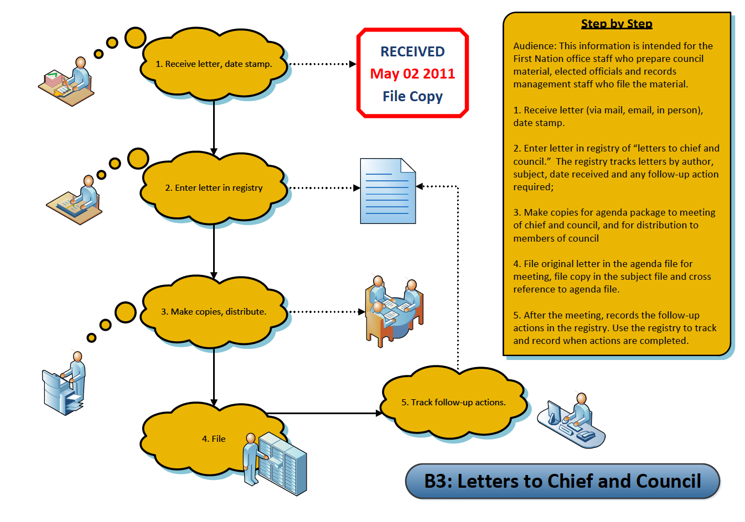

Reports to Chief and Council – see B4 – Reports to Chief and Council

Reports to Chief and Council cover many different subjects. They will be distributed as part of an agenda package for a meeting.

Like BCR’s and correspondence to Chief and Council, staff need to keep track of these by the date of the meeting when they were considered by the chief and council. However, they also need to be recorded by the subject of the report, particularly for the staff member who prepared the report or is responsible for the portfolio the report is about.

These different requirements will require copies of the report to be filed in the meeting file as well as in the subject file that the report is about. Depending on the size of the report, the report might also be treated as a “library” item, with a copy filed in a “Resources” or “Reference” Library on bookshelves or in a meeting room

Minutes of Chief and Council Meetings – see B5 – Minutes of Chief and Council Meetings

Minutes of Chief and Council are duplicated and distributed to many staff in the organization. They will be distributed as part of an agenda package for a meeting. Like BCR’s and correspondence to Chief and Council, staff need to file minutes by the date of the meeting that they record. The process for preparing and approving minutes is outlined in the diagram. Once minutes have been drafted and approved, they are filed with other materials from the meeting.

All records of Chief and Council meetings are considered “vital” or essential records, and should be backed up electronically and stored offsite. Signed original records should be stored in fire proof filing cabinets.

